A PRACTICAL REPORT ON

SECURITY BREACHES & COUNTERMEASURES

SUBMITTED BY

Mr. Khopkar Ayush Umesh

UNDER THE GUIDANCE OF

Mrs. Shabana Ansari

Submitted in fulfillment of the requirements for qualifying M.Sc.IT Part-1 Semester-1 Examination 2024-2025

University of Mumbai

Department of Information Technology

University of Mumbai

**Institute of Distance and Open Learning** (IDOL)

Dr. Shankardayal Sharma bhavan, Vidyanagari, Santacruz(E)

PCP CENTER: RIZVI COLLEGE, BANDRA (W)

**Certificate**

*This is to certify that* ***Data Science Practical*** *performed at RIZVI COLLEGE, BANDRA (W) by Mr.* ***Khopkar Ayush Umesh*** *holding Seat No/Application No. 1316010 /6719 studying Masters of Science in Information Technology Semester – 1 has been satisfactorily completed as prescribed by the University of Mumbai, during the year 2024 – 2025.*

**Subject In-Charge Coordinator In-Charge External Examiner**

|  |
| --- |
| **Use the following tools to perform footprinting and reconnaissance.** |
| Aim: Recon -ng |
| Aim:- Use of FOCA Tools. |
| USING TRACE ROUTE |
| 5. Ping |
| TraceRoute using Ping |
| NSLookup |
| Scan the network using the following tools: |
| Hping2 / Hping3 |
| Advanced IP Scanner |
| Angry IP Scanner |
| Masscan |
| Masscan |
| CurrPorts |
| Colasoft Packet Builder |
| The Dude |
| A:Perform Enumeration using the following tools: |
| Nmap |
| NetBIOS Enumeration Tool |
| SuperScan |
| Hyena |
| SoftPerfect Network Scanner Tool |
| OpUtils |
| SolarWinds Engineer’s Toolset |
| Wireshark |
| B:Perform the vulnerability analysis using the following tools: |
| Nessus |
| OpenVAS |
| a. Perform mobile network scanning using NESSUS |
| B:Perform the System Hacking using the following tools: |
| Winrtgen |
| PWDump |
| Ophcrack |
| Flexispy |
| NTFSStream Manipulation |
| Quickstego |
| clearing logs |
| A:Use wireshark to sniff the network. |
| B:Use SMAC for MAC Spoofing. |
| C:Use Caspa Network Analyser. |
| A.Use Social Engineering Toolkit on Kali Linux. |
| B:Perform the DDOS attack using the following tools |
| C:Using Burp Suite to inspect and modify traffic between the browser and target application |
| A Perform Web App Scanning using OWASP Zed Proxy. |
| B Zonealarm and analyse using Firewall Analyzer. |
| Comodo Firewall: |
| Microsoft Baseline Security Analyzer |
| Syhunt Hybri |

**Practical-1**

**A] AIM: Use the following tools to perform footprinting and reconnaissance.**

**Aim: Recon -ng**

Commands:

1. marketplace search
2. --marketplace search ssl
3. --marketplace info ssltools
4. marketplace install hackertarget
5. modules load hackertarget
6. show options
7. options set SOURCE tesla.com
8. run

**Step 1:** Open Recon-ng in the Kali linux, enter below command to search the library. Command “marketplace search”

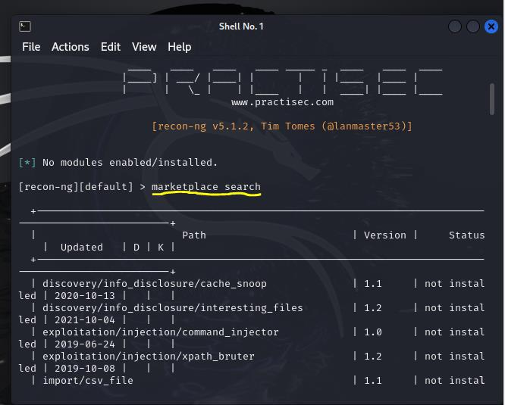

**Step2:** Use the command to install the package “marketplace install hackertarget”

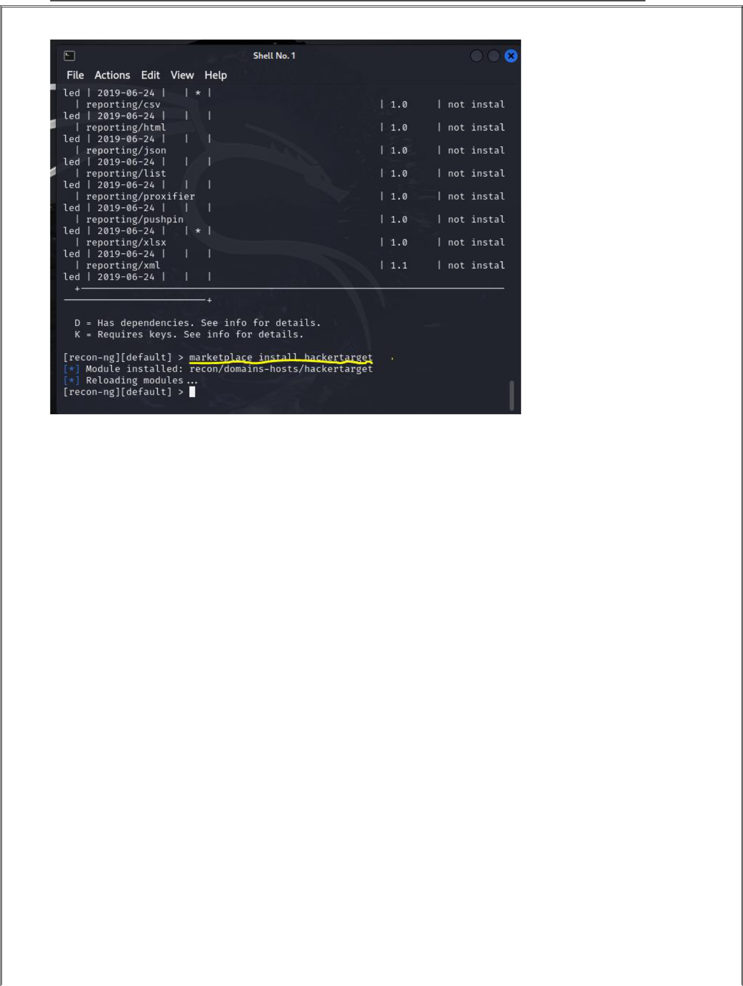

**Step 3 : Now load the package using command “**modules load hackertarget” and run next command “options set SOURCE tesla.com” to set the address we desire scan.



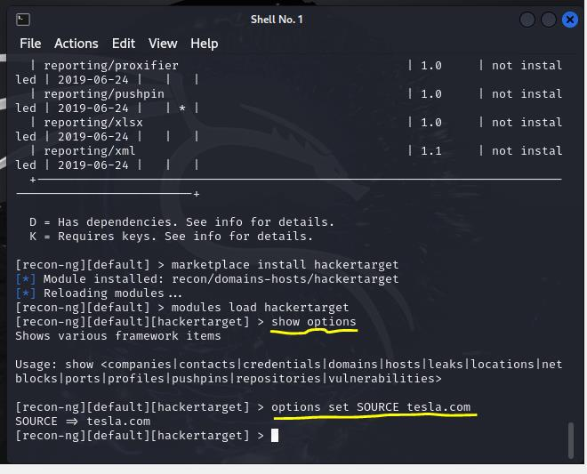

2

**Step 6: Use command run to execute the scan.**

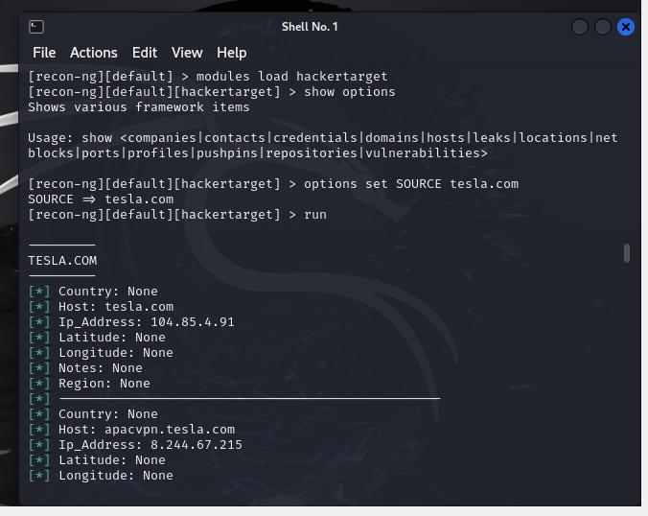

3

**Aim:-** Use of **FOCA Tools**.

**Step 1**: Open FOCA Tool, goto project -> select new project.



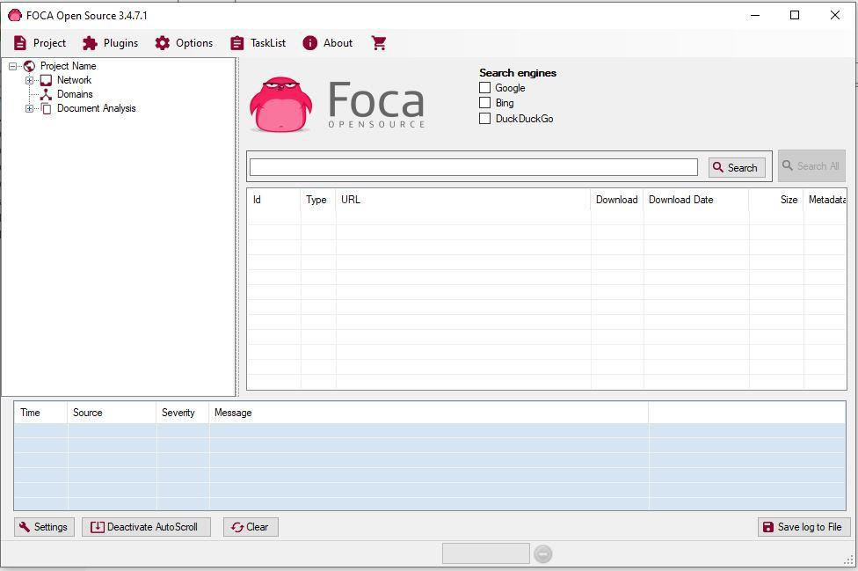

**Step 2:** Enter the URL then click the “Create” button.



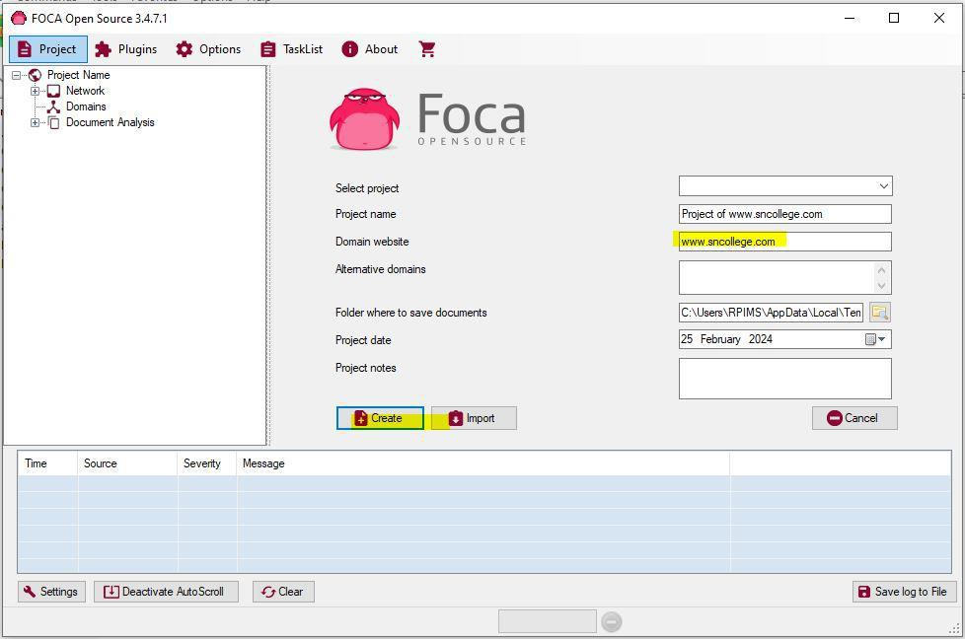

**Step 3:** Select the search engine and add the extension. Click on the “Search all” button.

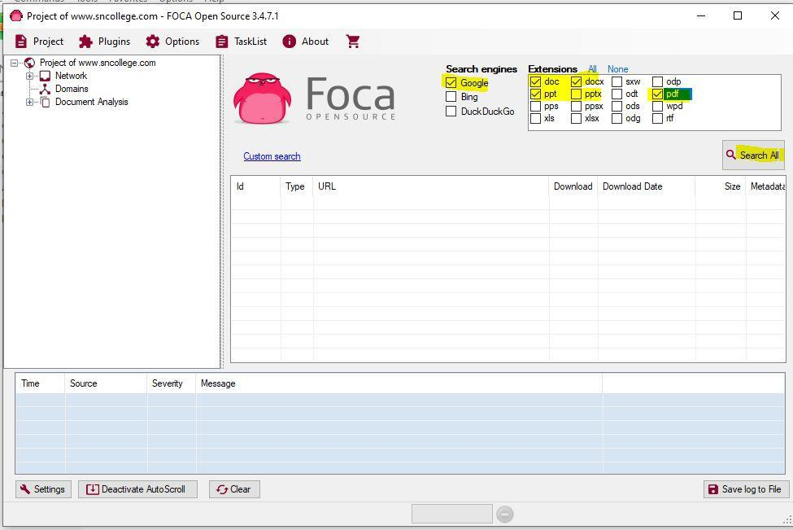

**Step 4:** You will find the document getting the download.

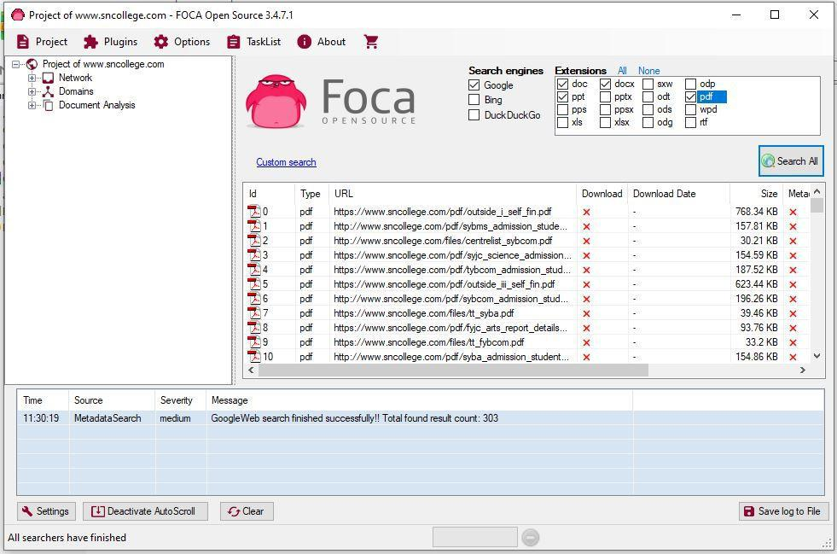

**AIM: To use the following tools to perform footprinting and reconnaissance.**

**Step 1:** Open the WHOis website. **&** Enter the website name and hit the “enter button”.

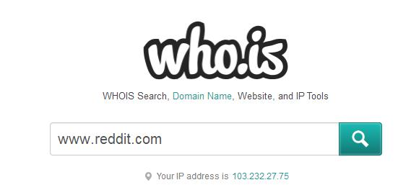

**Step 2:** Show you information about reddit.com in whois tab.

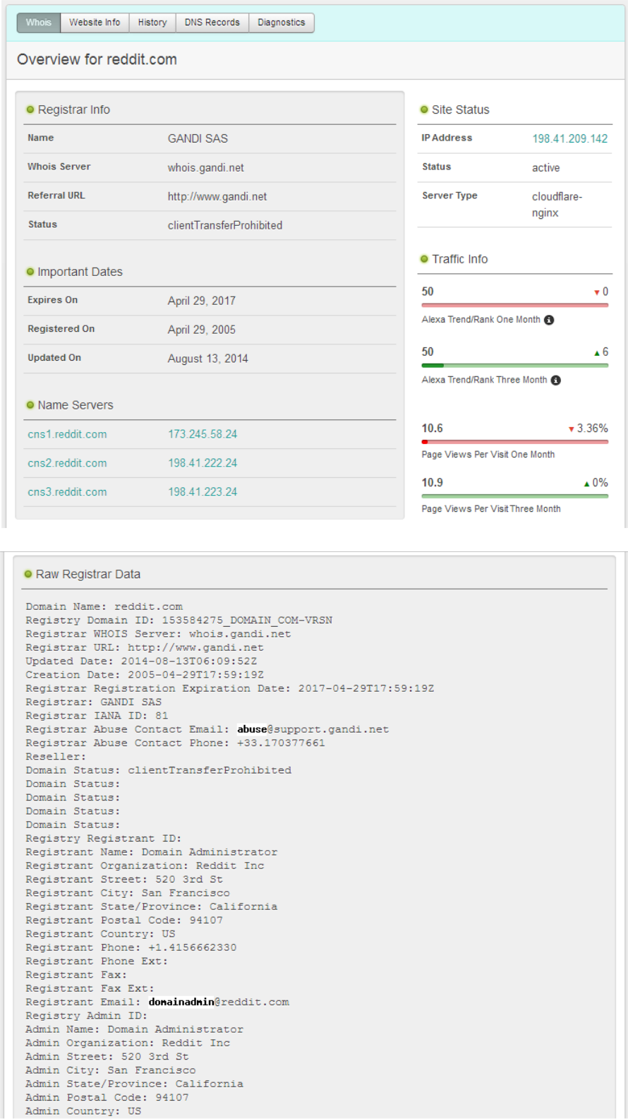

**Step 3:** Show you information about reddit.com in website information tab

1

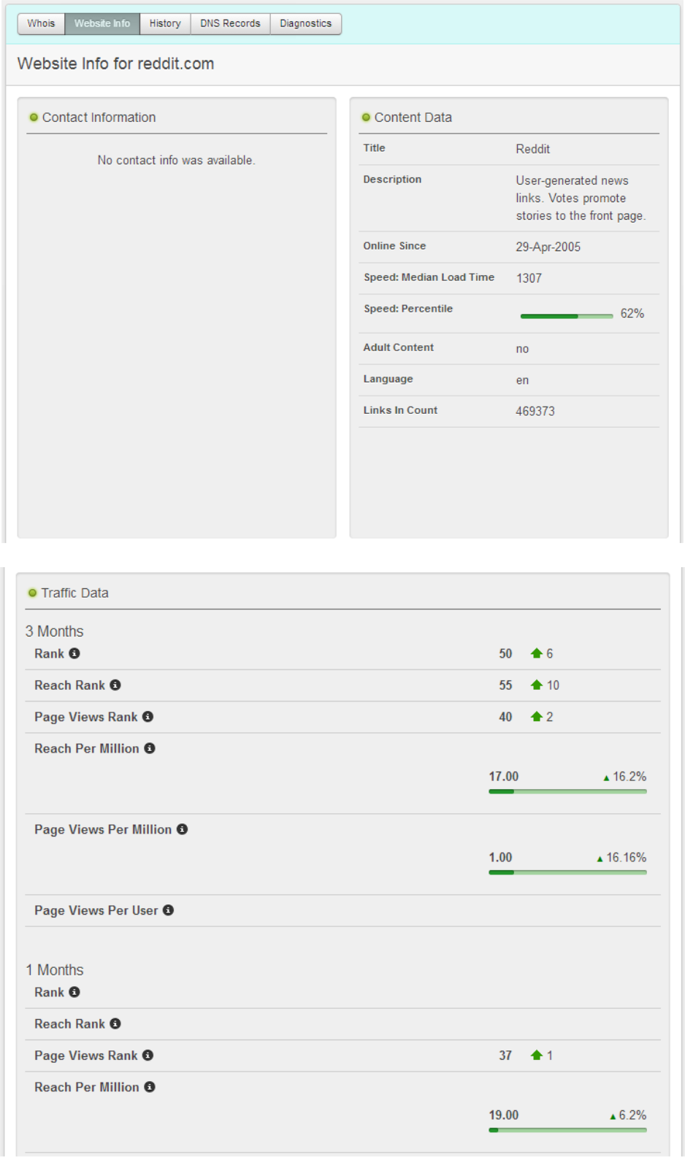

6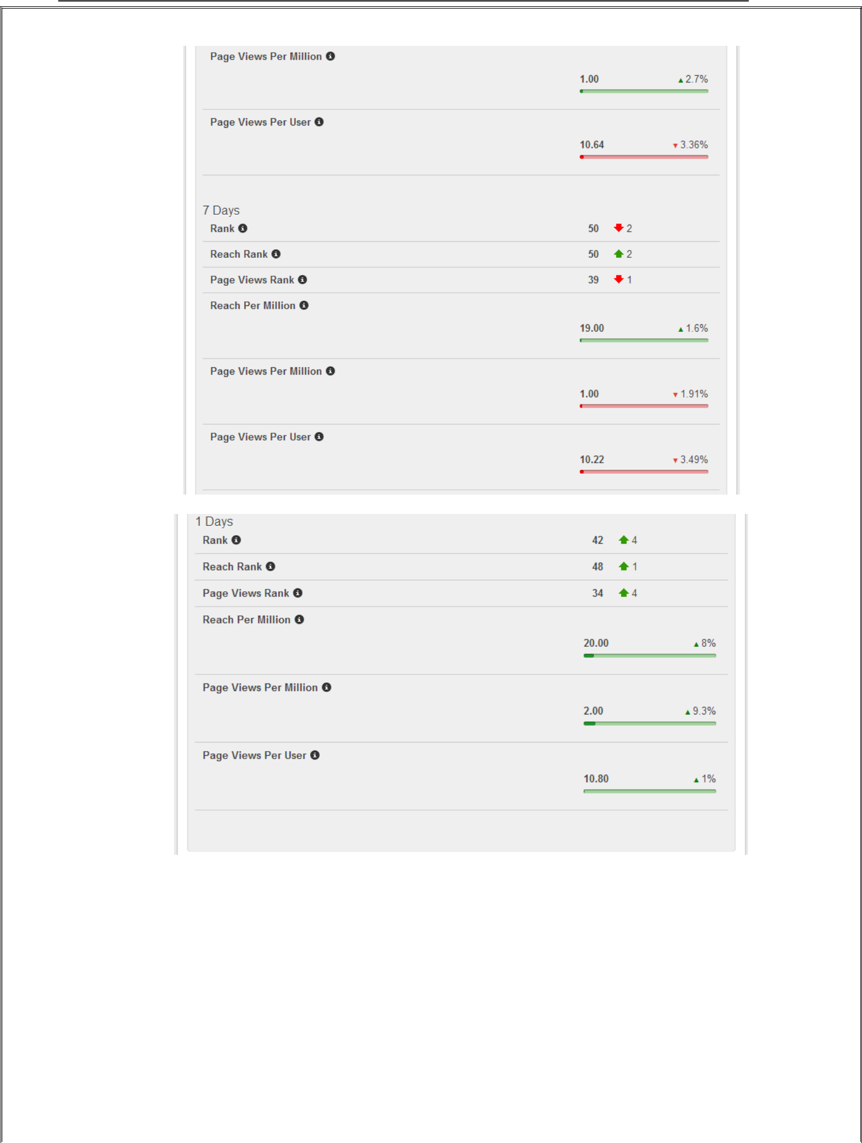

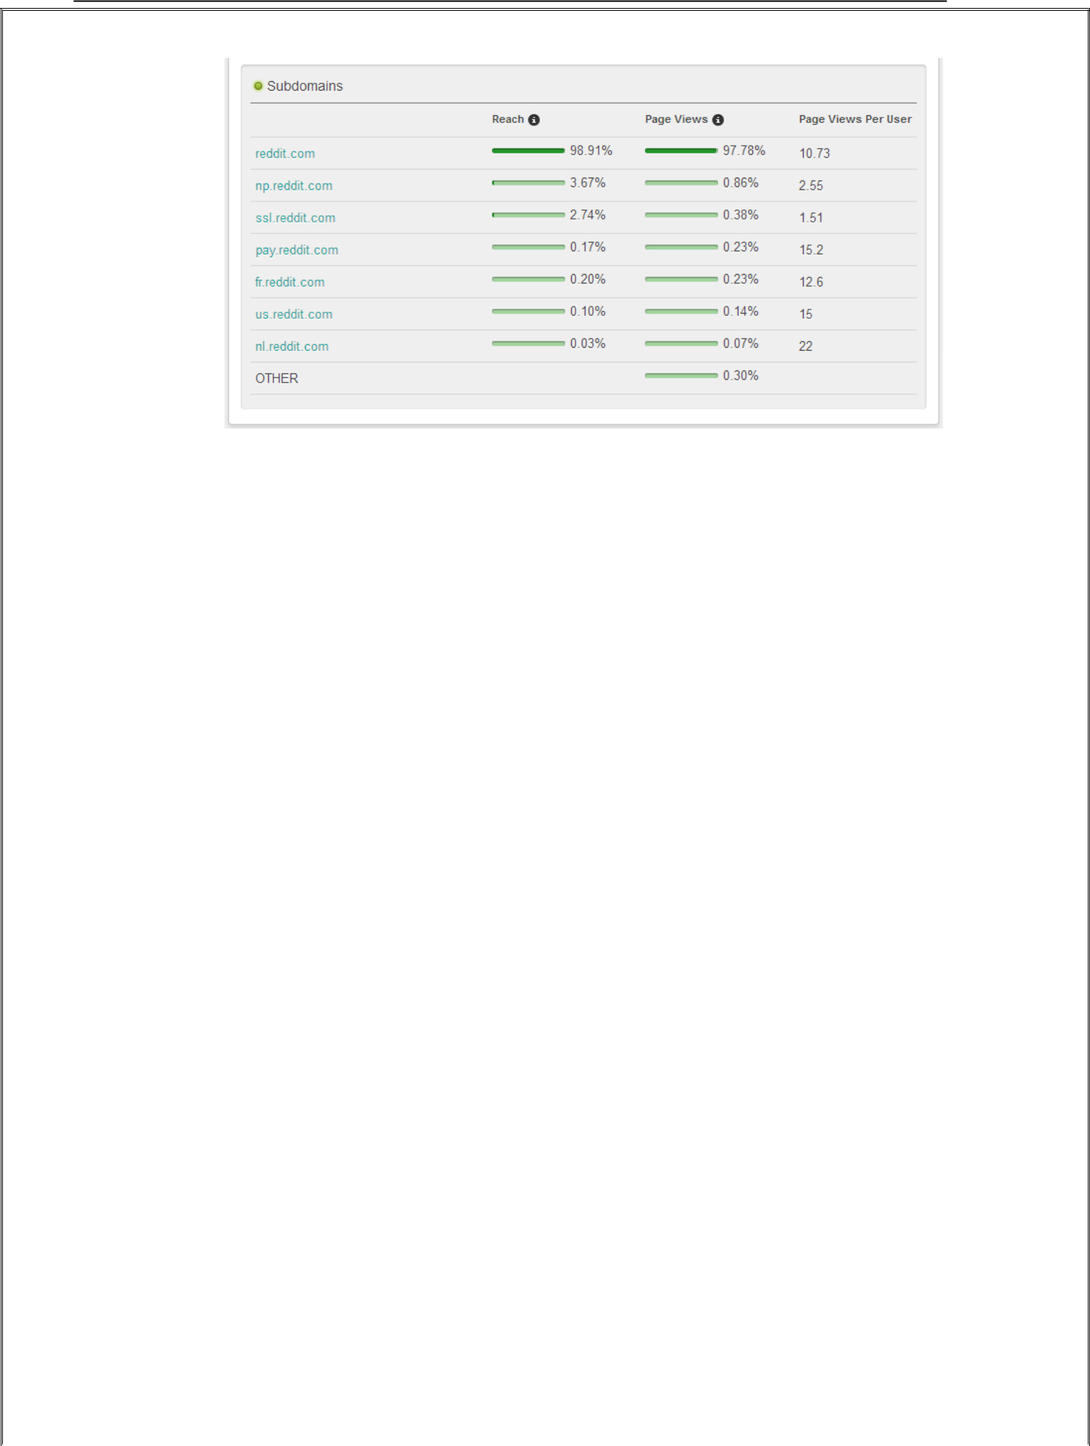

**Step 4:** Show you information about reddit.com in history tab.

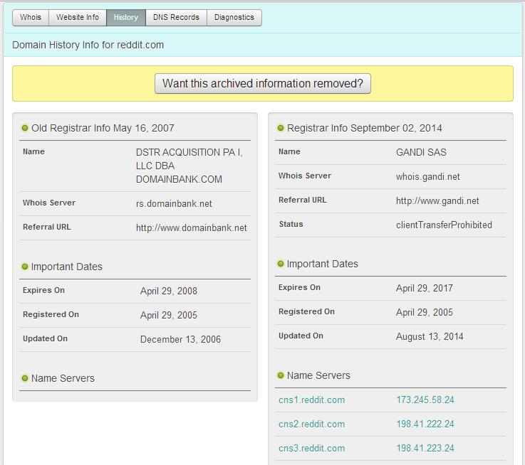

7

**Step 5:** Show you information about reddit.com in dns records tab.

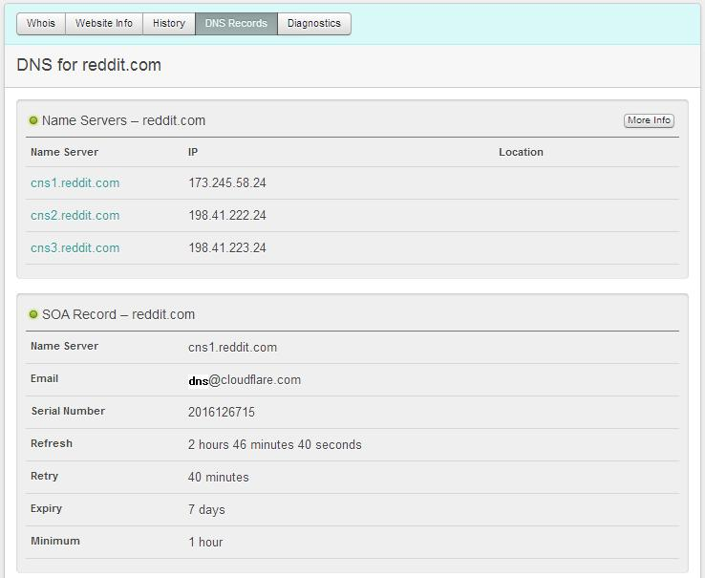

**Step 6:** Show you information about reddit.com in diagnosis tab.

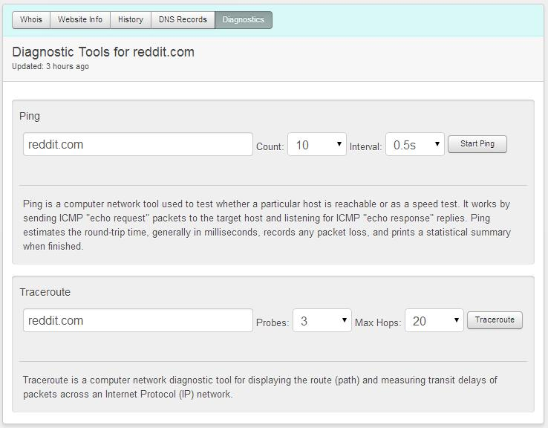

**USING TRACE ROUTE**

**Step 1:** Open cmd prompt.

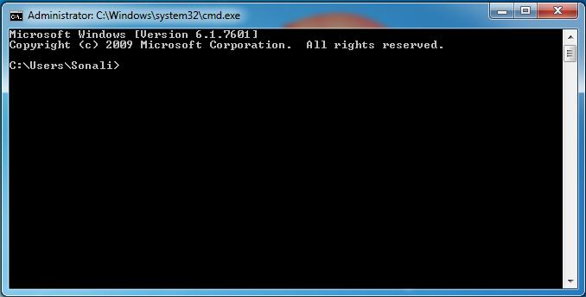

**Step 2:** Type cd\ and enter it will redirect to “C/directory”.

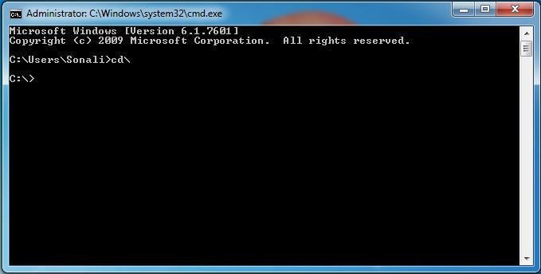

**Step 3:** Type tracert command and type [www.reddit.com](http://www.reddit.com/) and press “Enter”.

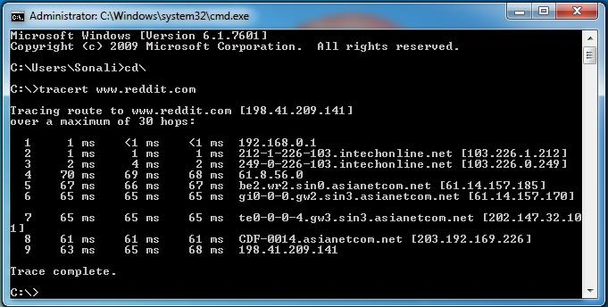

**Step 4:** Type tracert command and type [ipaddress](http://www.reddit.com/) **of** reddit.com and press “Enter”.

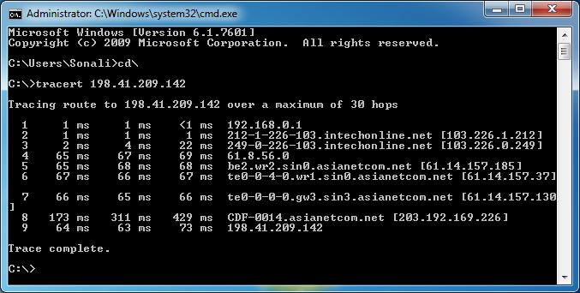

**5. Ping**

**This practical is used to find out the MTU of the destination machine. **

* We ping a computer using the ‘p
* To specify the data length in bytes we use –lswitch 
* To specify that the packet should not be fragmented we use –f

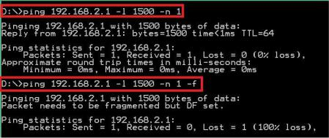

* We now have to adjust the –lvalue till we get a reply. The border where the reply is received is said to be its MTU

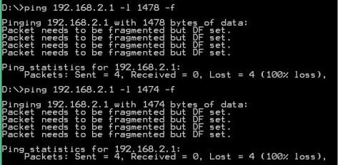

* Response is received at –l1472, hence the MTU size is 1472 Bytes

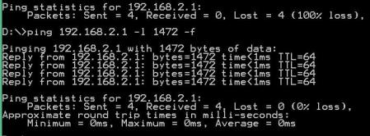

**TraceRoute using Ping**

* We can perform traceroute by using the –n and –Iswitches.
* -n means number of replies to show and –Imeans obtain reply from the machine in the next hop
* Open command prompt 
* Ping certifiedhacker.com –n 1 –I1
* Above, the local router replies back.
* Keep on increasing the I value until the certiedhacker.com site directly replies to the ping.
* At each I value, the device in the route will reply back
* At i=4, reply comes back from 121.241.80.6
* At i=14, the reply comes from the server hosting the certifiedhacker site

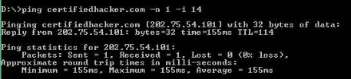

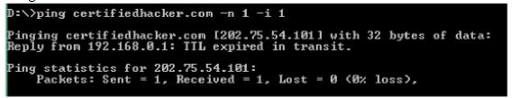

|  |  |
| --- | --- |
| Node | IP |
| 1 | 192.168.0.1 |
| 2 | 219.91.185.1 |
| 3 | 203.187.223.1 |
| 4 | 121.241.80.6 |
| 5 | 172.17.169.202 |
| 6 | Timed Out |
| 7 | 180.87.12.53 |
| 8 | 180.87.12.2 |
| 9 | 180.87.112.1 |
| 10 | 116.0.67.174 |
| 11 | 10.55.208.148 |
| 12 | 1.9.244.26 |
| 13 | Timed Out |
| 14 | 202.75.54.101 |
|  | (Destination) |

**NSLookup**

* NSLookup is used to perform DNS Foorprinting by using the windows command **nslookup**
* When we type nslookup, it shows us our current DNS Server

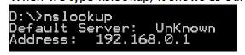

* To specify the DNS query type we want, we use the command

**set type = <recordname>** followed by the website name on the next line **Set type = mx Certifiedhacker.com**

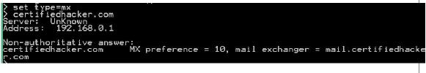

* We can set the **query type** as A, ANY, CNAME, MX, NS, PTR, SOA, SRV

**A Record**

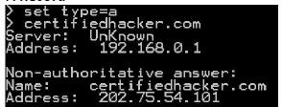

**SOA Record**

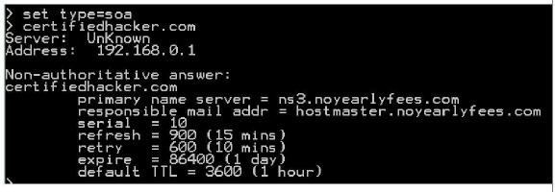

**NameServer (NS) Record**

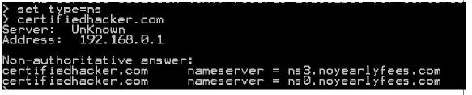

**Aim:HTTrack Website Copier**

Start > Programs >

* HTTrack Website Copier
* Click on 'Next' to create Project
* Give a name to project Click on 'Next'

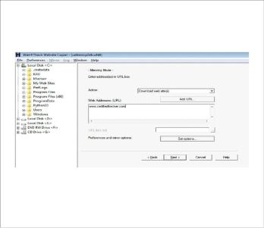

* Click on ‘Add URL’ and give the UR
* Any additional options that need t
* Then click 'Next'
* By default, the radio button will be selected for Please adjust connection parameters if necessary, then press FINISH to launch the mirroring operation.



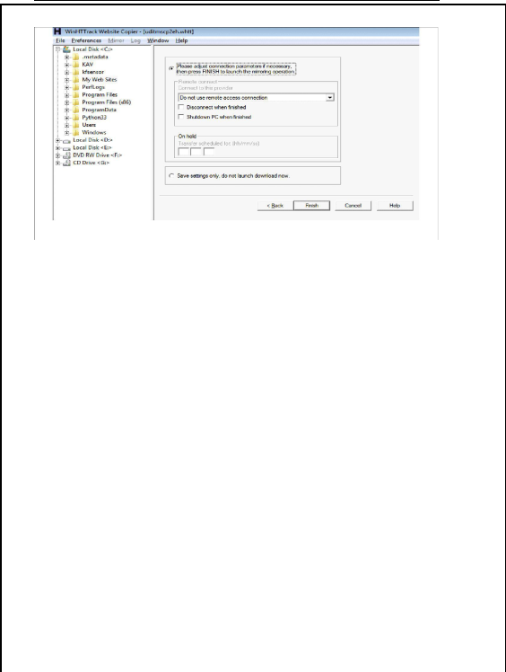

The mirroring of the site now begins. The site will be downloaded and be saved in the C:\My Web Sites\<Project Name> 

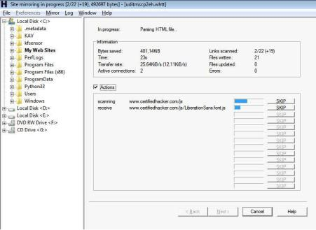

Process of mirroring the website.

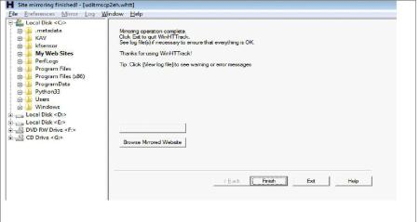

**WHOis**

* SmartWHOis is used to perform WHOIS Footprinting against an entered IP Address or a Domain Name
* Run it from, Start > Programs > SmartWhois

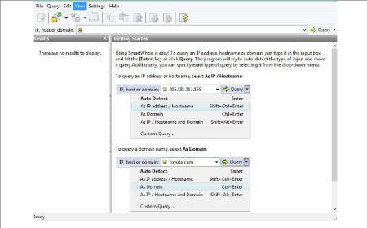

Type an IP address, hostname, or domain name in the address bar

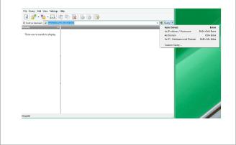

* Different queries will return different results.
* IP Address / Hostname Query results

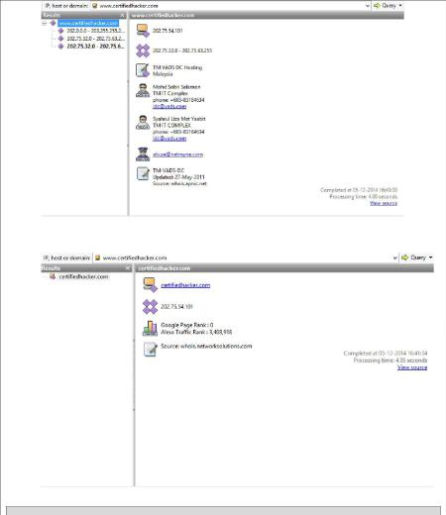

**USING EMAIL TRACKER**

**Step 1:** Open emailTracker.

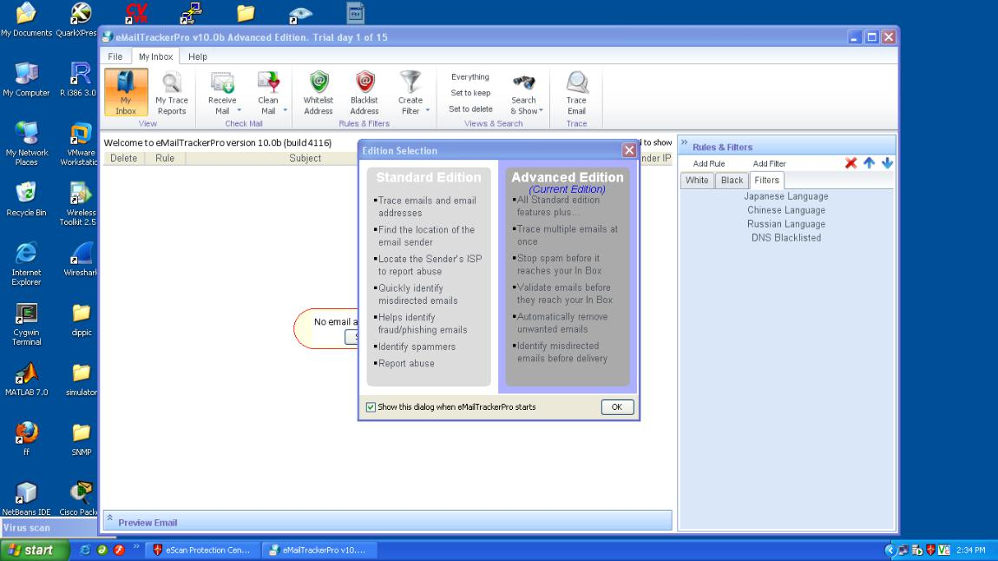

**Step 2:** Check if there are any reports generated previously.

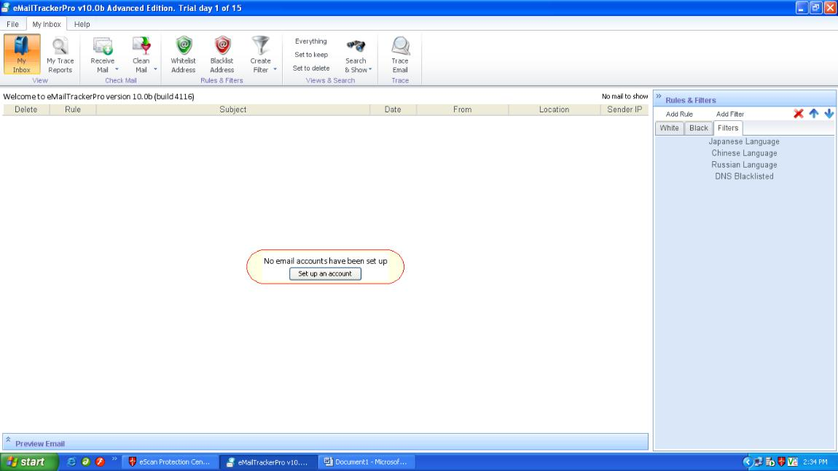

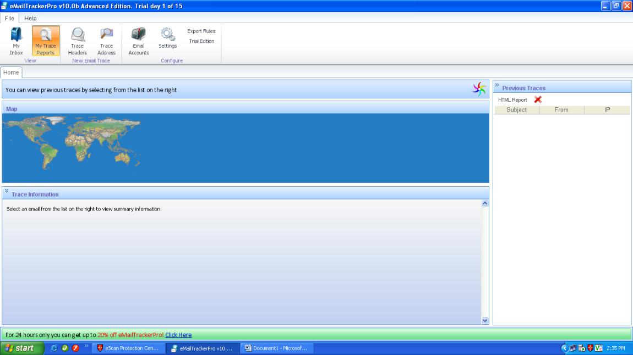**Step 3:** Check for My trace Reports.

**Step 4:** Click on Trace address, a new window will open.

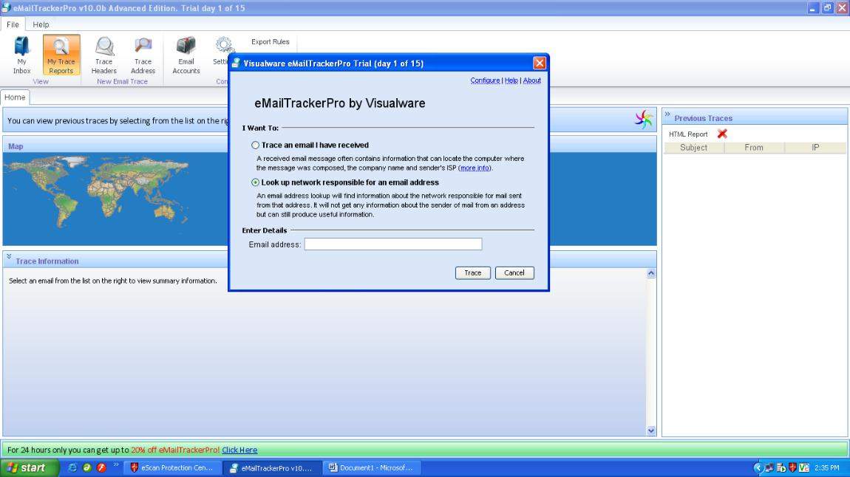

**Step 5:** Click on second option and enter email address you want to trace and click on trace button.

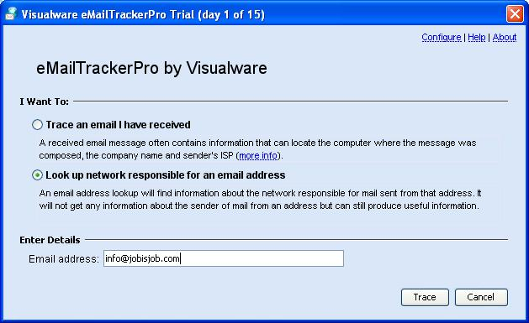

**Step 6:** The eMailTracker will search for the location and information about the email address entered.

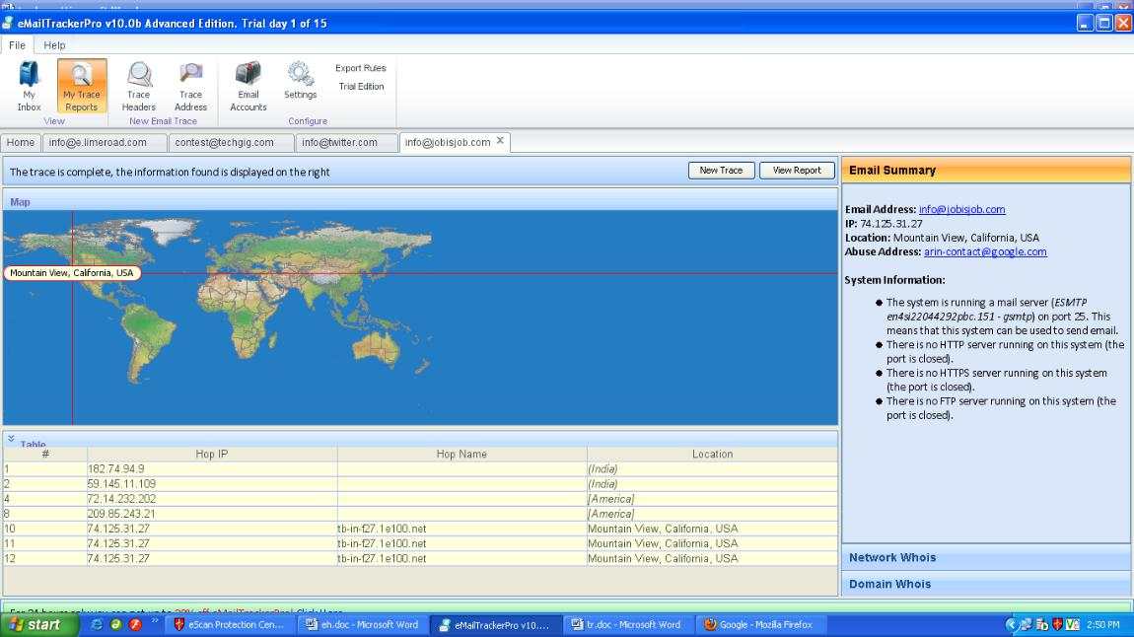

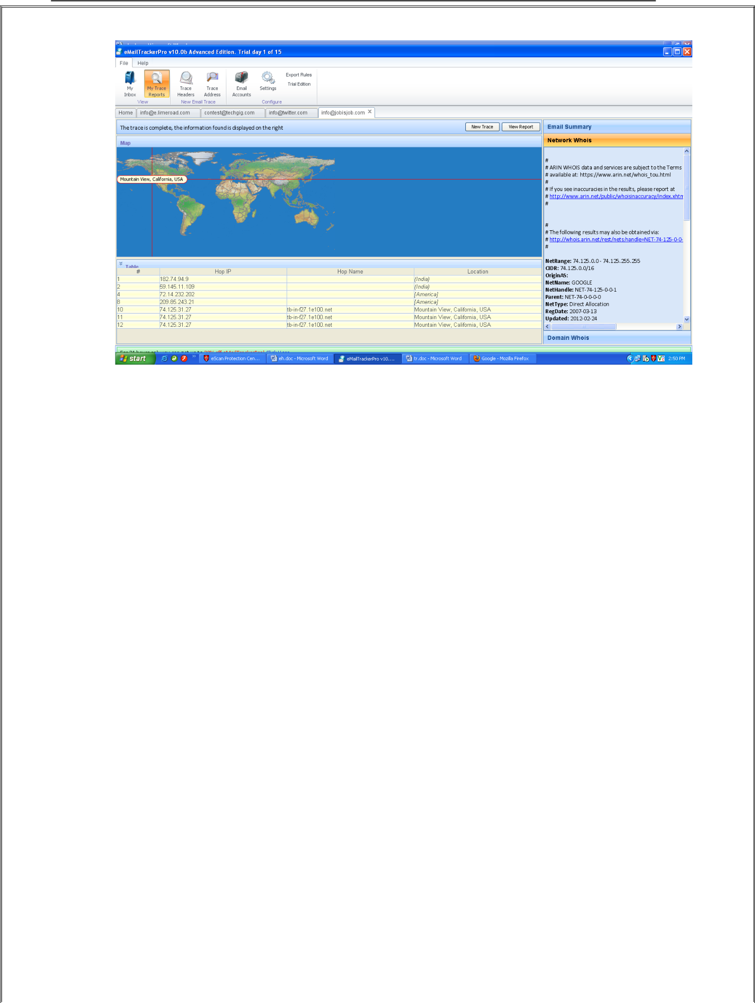

Figure: Location details and network summary.

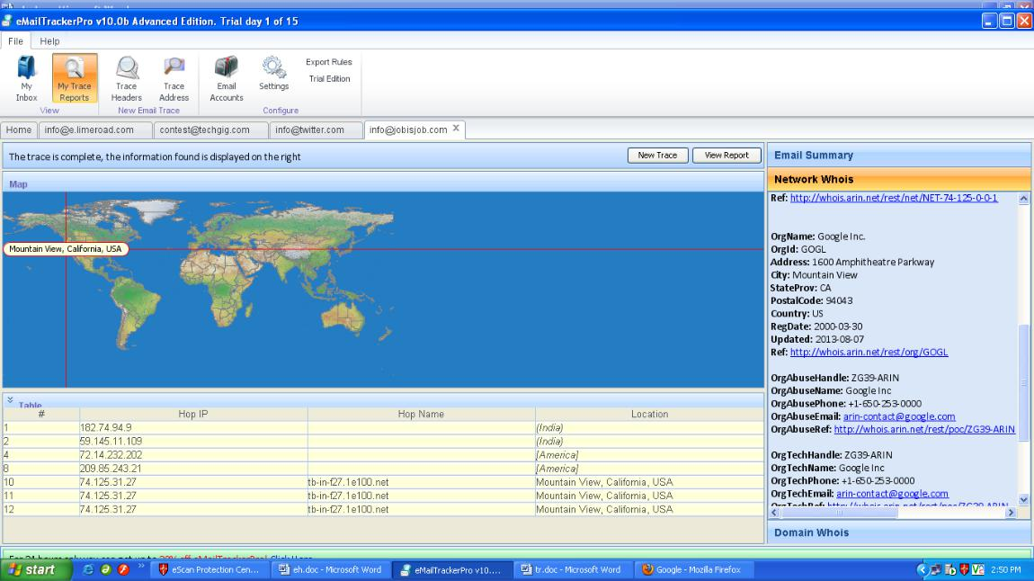

Figure: Location details and network summary.

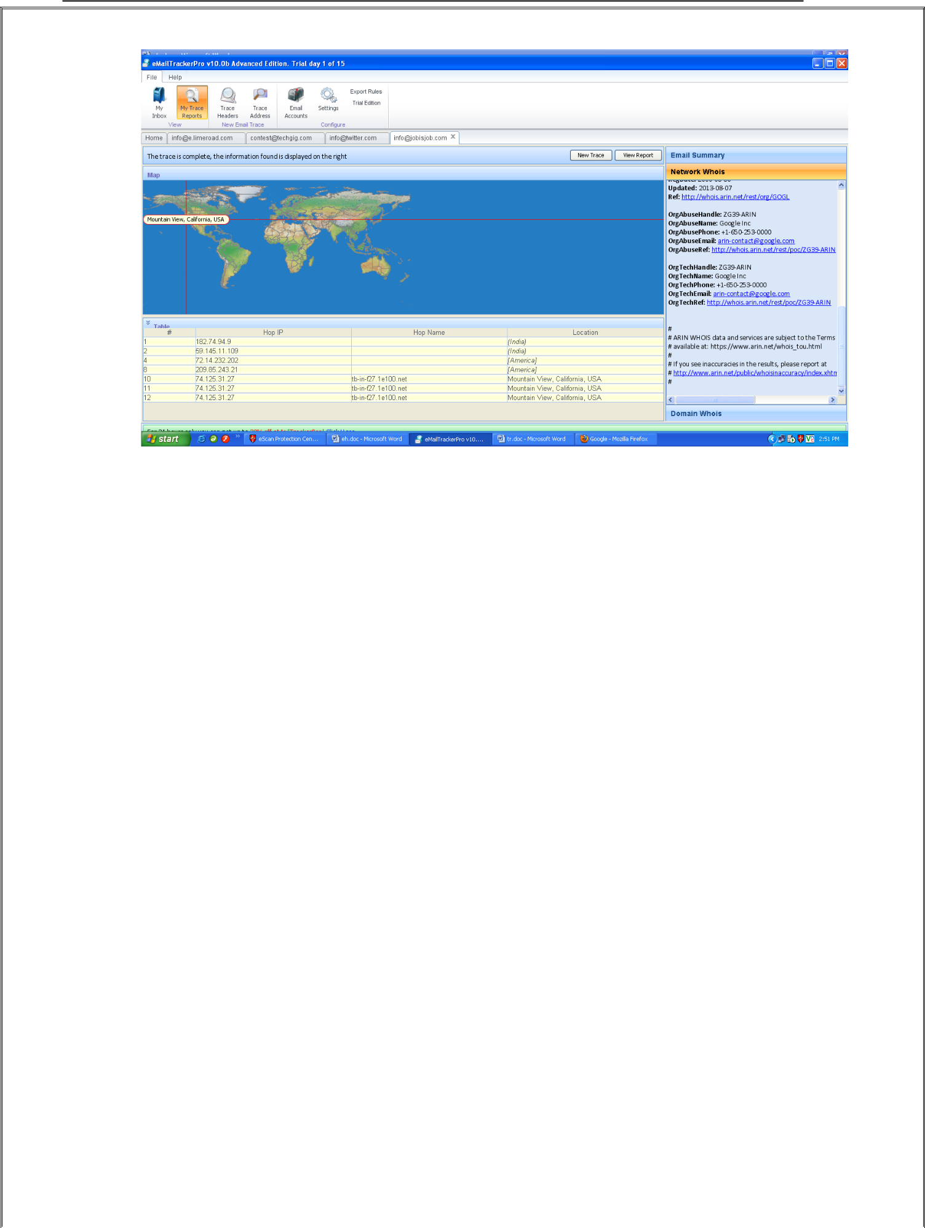

Figure: Location details and network summary

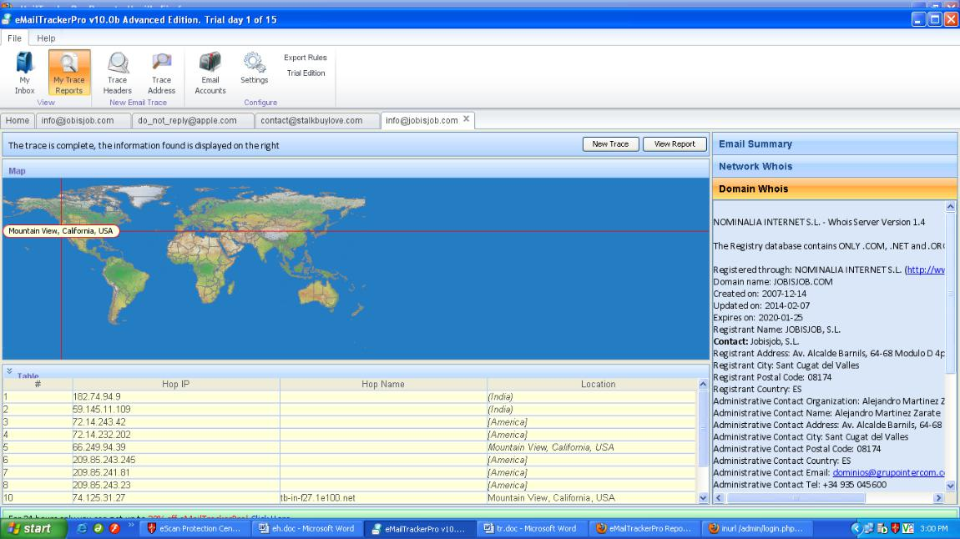

Figure: Location details and domain summary.

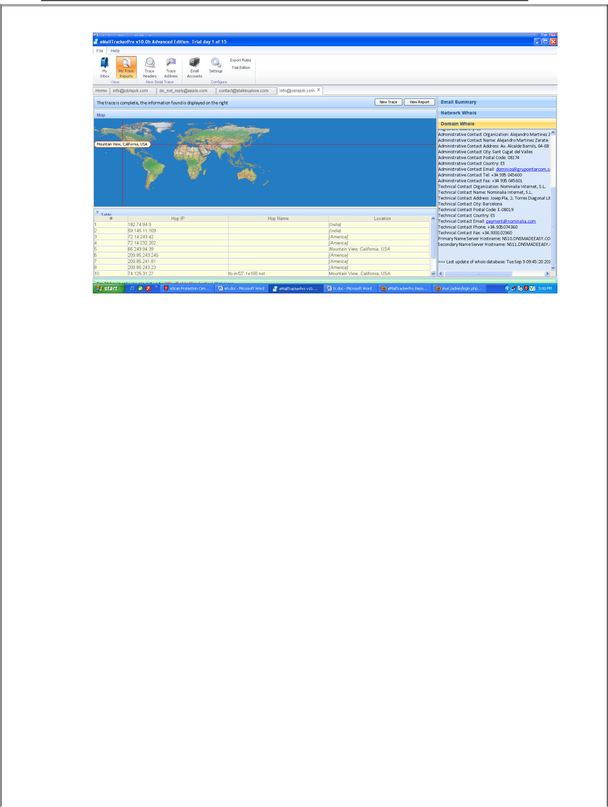

Figure: Location details and domain summary.

**Step 7:** Now click on View report and the following report will be generated in browser.

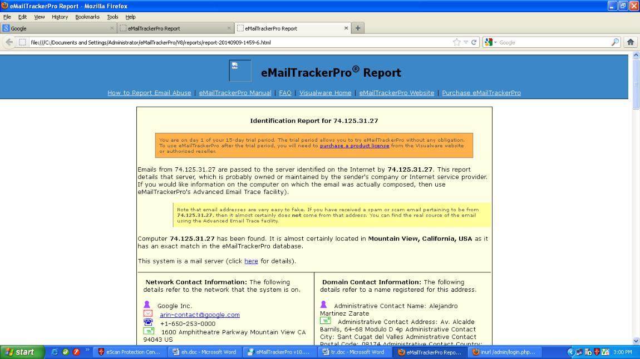

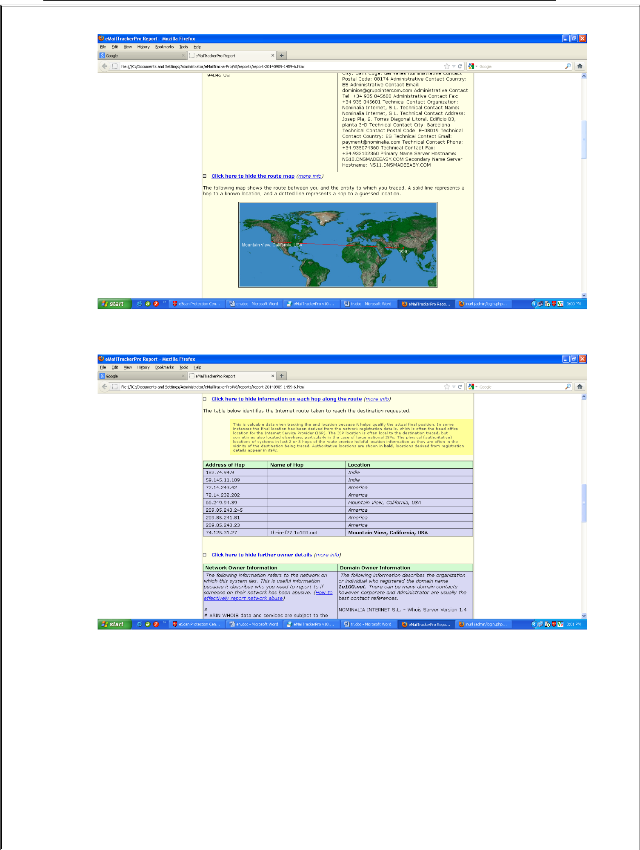



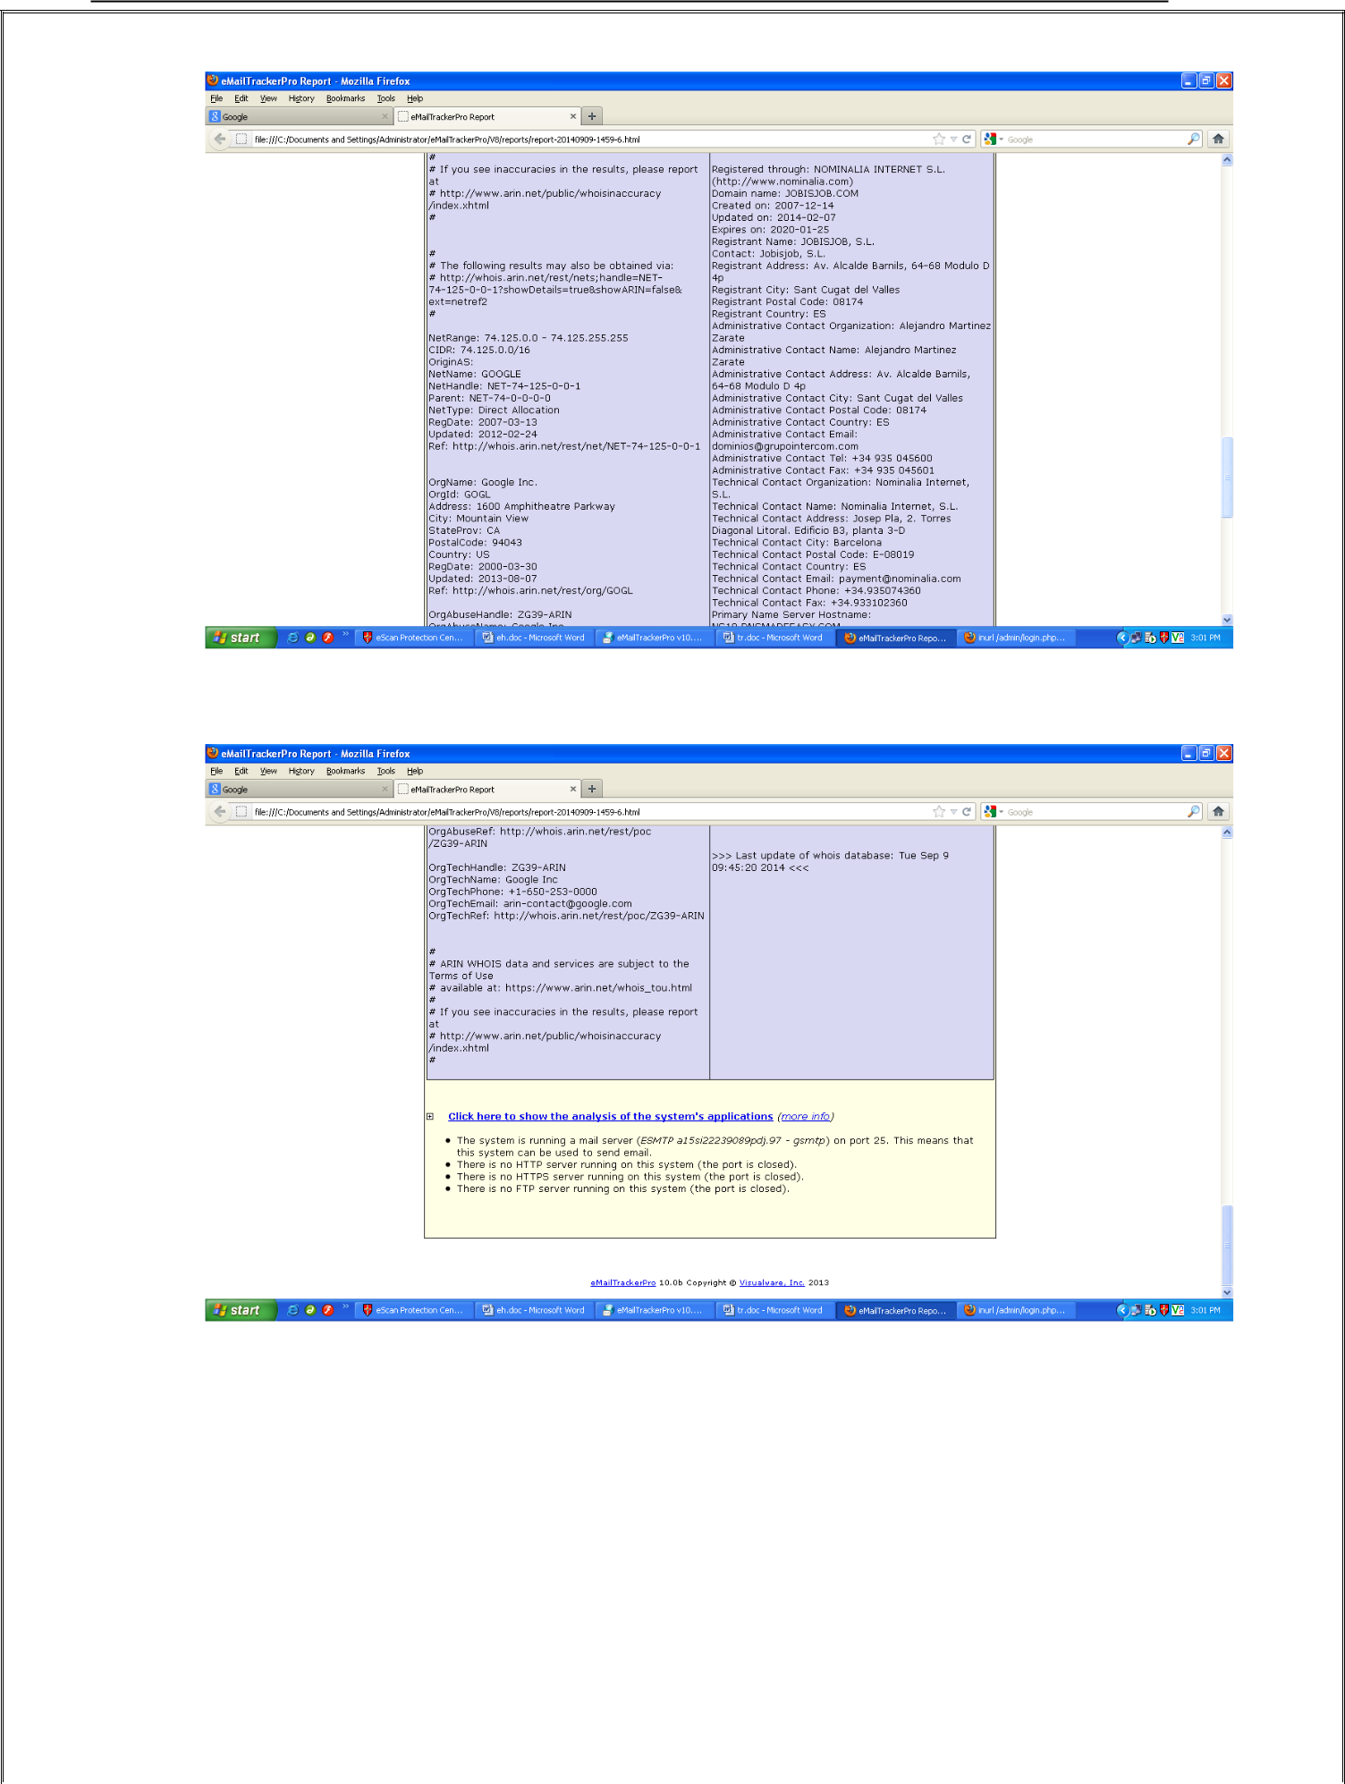



**Practical No:2**

**Aim: Scan the network using the following tools:**

1. **Hping2 / Hping3**

Hping is a command-line TCP/IP packet assembler and analyzer tool that is used to send customized TCP/IP packets and display the target reply as ping command display the ICMP Echo Reply packet from targeted host. Hping can also handle fragmentation, arbitrary packets body, and size and file transfer. It supports TCP, UDP, ICMP and RAW-IP protocols. Using Hping, the following parameters can be performed: -

 Test firewall rules.

 Advanced port scanning.

 Testing net performance.

 Path MTU discovery.

 Transferring files between even fascist firewall rules.

 Traceroute-like under different protocols.

 Remote OS fingerprinting & others

Using Hping commands on Kali Linux, we are pinging a Window 7 host with different customized packets in this lab.

* To create an ACK packet: root@kali:~# **hping3 –A 192.168.0.1**

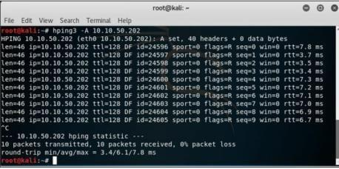

* To create SYN scan against different ports: root@kali:~# **hping3 -8 1-600 –S 10.10.50.202**

39

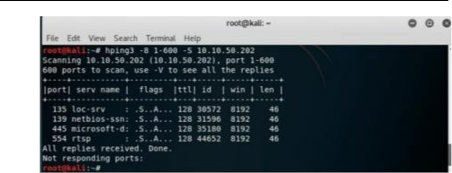

* To create a packet with FIN, URG, and PSH flags sets root@kali:~# **hping3 –F –P -U 10.10.50.202**

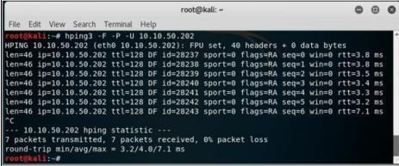

1. **Advanced IP Scanner**

Advanced IP Scanner is **a fast and powerful network scanner with a user-friendly interface**.In seconds, Advanced IP Scanner can locate all computers on your wired or wireless local network and scan their ports. The program provides easy access to various network resources such as HTTP, HTTPS, FTP, and shared folders.

40

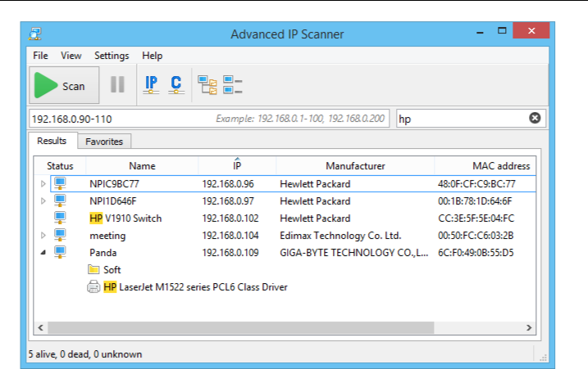

1. **Angry IP Scanner**

Angry IP Scanner (or simply ipscan) is an open-source and cross-platform network scanner designed to be fast and simple to use. It scans IP addresses and ports as well as has [many](https://angryip.org/about/) [otherfeatures.](https://angryip.org/about/)

It is widely used by network administrators and just curious users around the world, including large and small enterprises, banks, and government agencies.

It runs on Linux, Windows, and Mac OS X, possibly supporting other platforms as well.

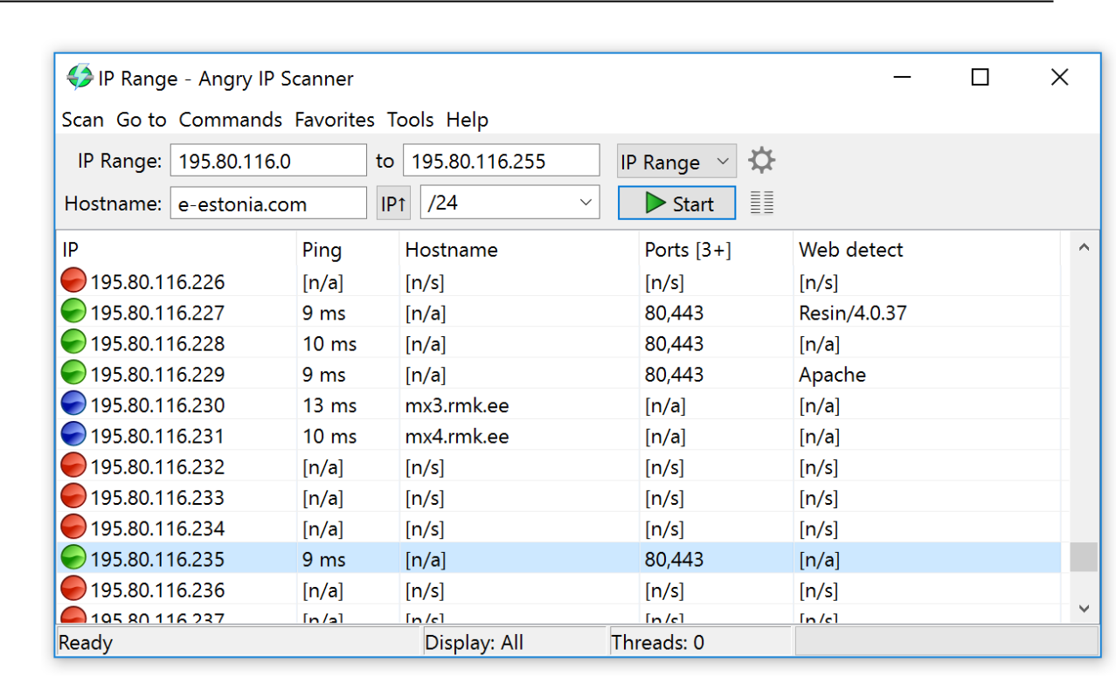

1. **Masscan**

MASSCAN is **TCP port scanner which transmits SYN packets asynchronously and produces results similar to nmap, the most famous port scanner**. Internally, it operates morelikescanrand, unicornscan, and ZMap, using asynchronous transmission. It's a flexible utility that allows arbitrary address and port ranges.

Scan for a selection of ports (-p22,80,445) across a given subnet (192.168.1.0/24):

root@kali:~# masscan -p22,80,445 192.168.1.0/24

Starting masscan 1.0.3 [(http://bit.ly/14GZzcT)](http://bit.ly/14GZzcT)) at 2014-05-13 21:35:12 GMT

* + forced options: -sS -Pn -n --randomize-hosts -v --send-eth Initiating SYN Stealth Scan

Scanning 256 hosts [3 ports/host]

Discovered open port 22/tcp on 192.168.1.217 Discovered open port 445/tcp on 192.168.1.220 Discovered open port 80/tcp on 192.168.1.230

1. **Masscan**

Neet is a flexible, multi-threaded tool for network penetration testing. It runs on Linux and co-ordinates the use of numerous other open-source network tools, with the aim of gathering as much network information as possible in clear, easy-to-use formats. The core scanning engine finds and identifies network services, the modules test or enumerate those services, and the Neet Shell provides an integrated environment for processing the results and exploiting known vulnerabilities.

As such, it sits somewhere between manually running your own port scans and subsequent tests, and running a fully automated vulnerability assessment (VA) tool. It has many options which allow the user to tune the test parameters for network scanning in the most efficient and practical way.

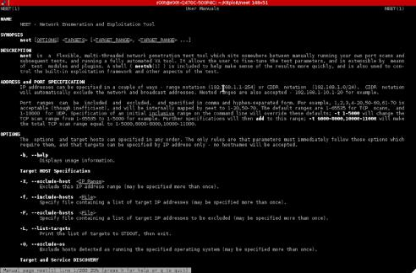

1. **CurrPorts**

**Case Study:** Using the Previous lab, we are going to re-execute HTTP Remote Access Trojan (RAT) on Windows 12 machine (10.10.50.211) and observed the TCP/IP connections to detect and kill the connection.

**Topology:**

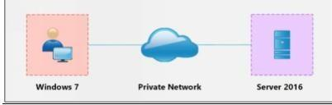

**Configuration:**

1. Run the application **Currports** on Windows Server 2016 and observe theprocesses.

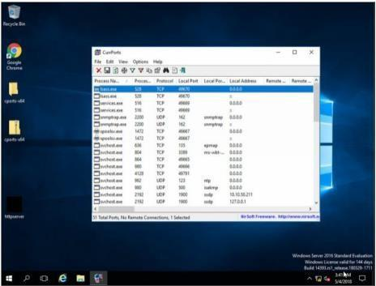

2. Run the HTTP Trojan created in the previous lab

The new process is added to the list.

You can observe the process name, Protocol, Local and remote port and IP address information.

1. For more detail, right click on httpserver.exe and go to properties

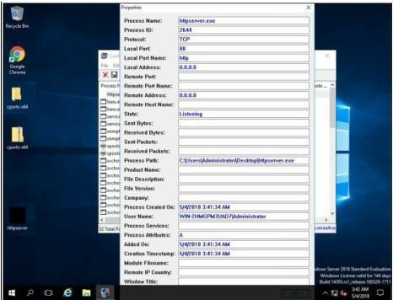

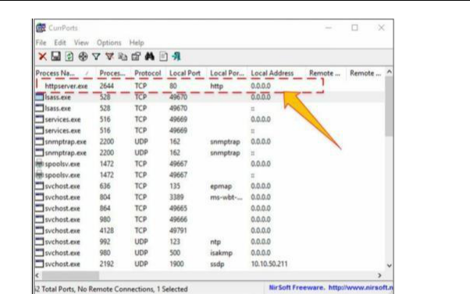

Properties are showing more details about tcp connection.

1. Go to Windows 7 machine and initiate the connection as mentioned in the previous lab using aweb browser.

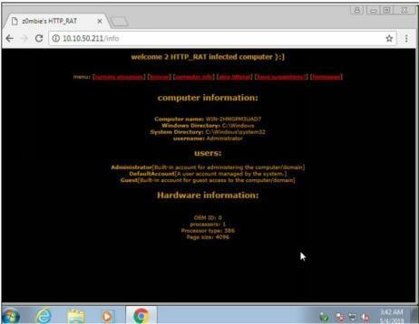

1. **Colasoft Packet Builder**

Colasoft Packet Builder software enables to create the customized network packets. These Customized Network packets can penetrate the network for attacks. Customization can also useto create fragmented packets. You can download the software from [www.colasoft.com.](http://www.colasoft.com/)

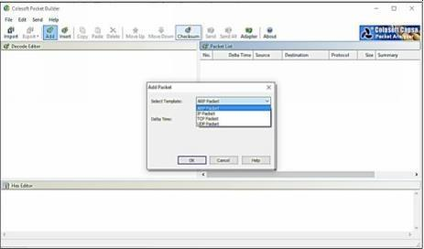

Colasoft packet builder offers Import and Export options for a set of packets. You can also adda new packet by clicking **Add**/button. Select the Packet type from the drop-down option.

Available options are: -

* ARP Packet
* IP Packet
* TCP Packet
* UDP Packet

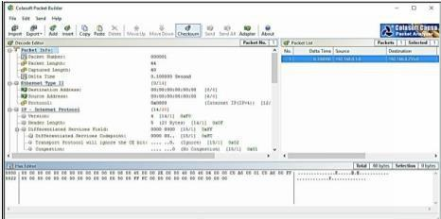

After Selecting the Packet Type, now you can customize the packet, Select the Network Adapter and Send it towards the destination.

1. **The Dude**

The Dude network monitor is a new application by MikroTik which can dramatically improve the way you manage your network environment. It will automatically scan all devices within specified subnets, draw and layout a map of your networks, monitor services of your devices and alert you in case some service has problems.

**Main Features:**

* Auto network discovery and layout
* Discovers any type or brand of device
* Device, Link monitoring, and notifications
* Includes SVG icons for devices, and supports custom icons and backgrounds
* Easy installation and usage
* Allows you to draw your own maps and add custom devices
* Supports SNMP, ICMP, DNS and TCP monitoring for devices that support it
* Individual Link usage monitoring and graphs
* Direct access to remote control tools for device management
* Supports remote Dude server and local client

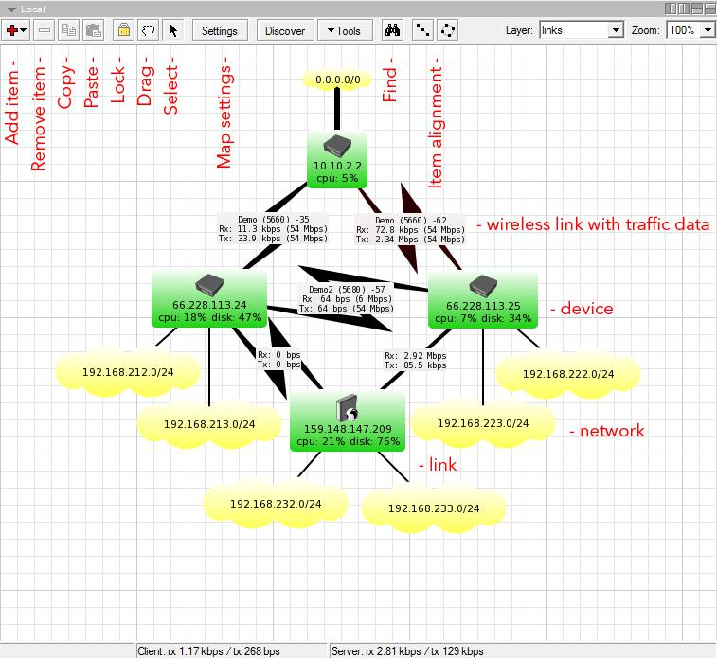

Advance ip scanner:

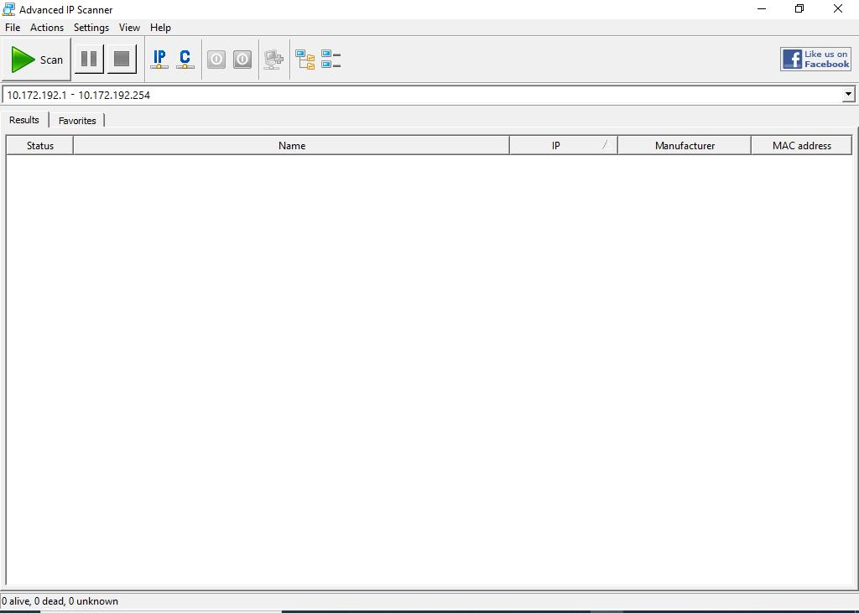

Insert ihte desired ip to be scan:

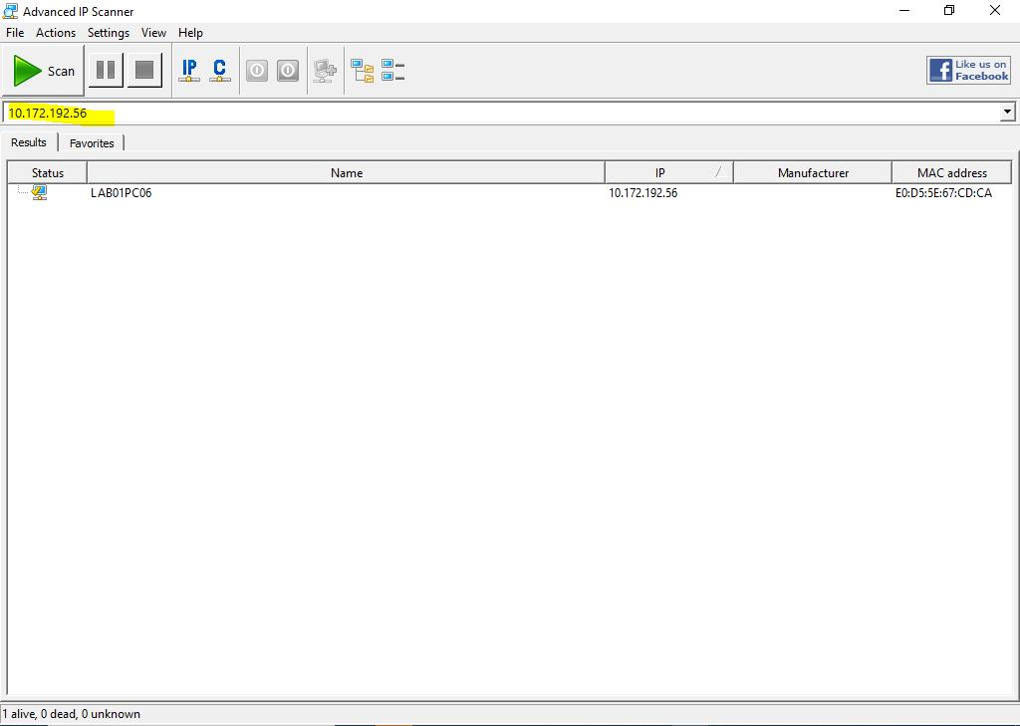

The clisk o the turnoff icon to shutdown the system:

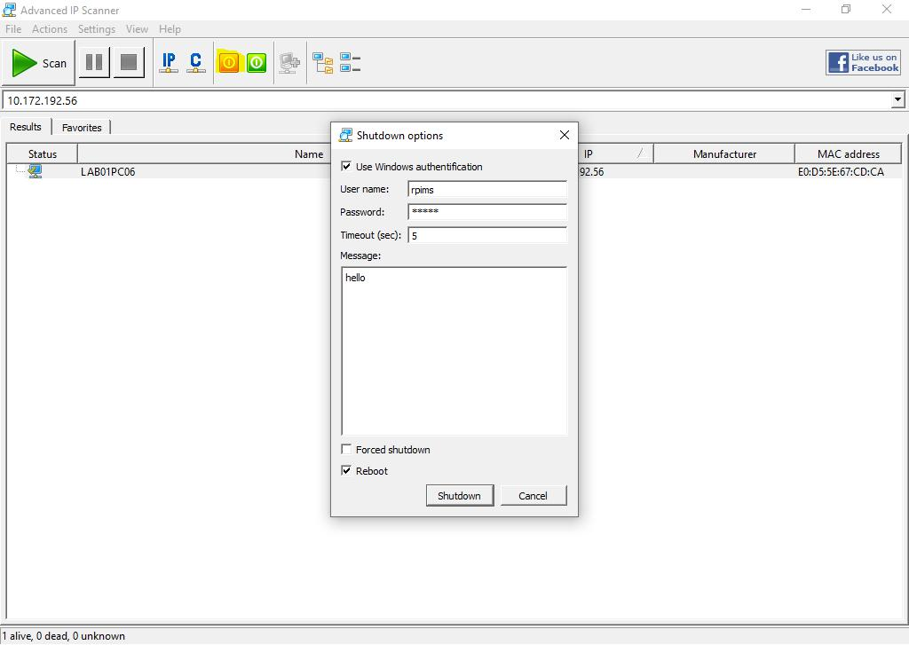

CurrPorts:

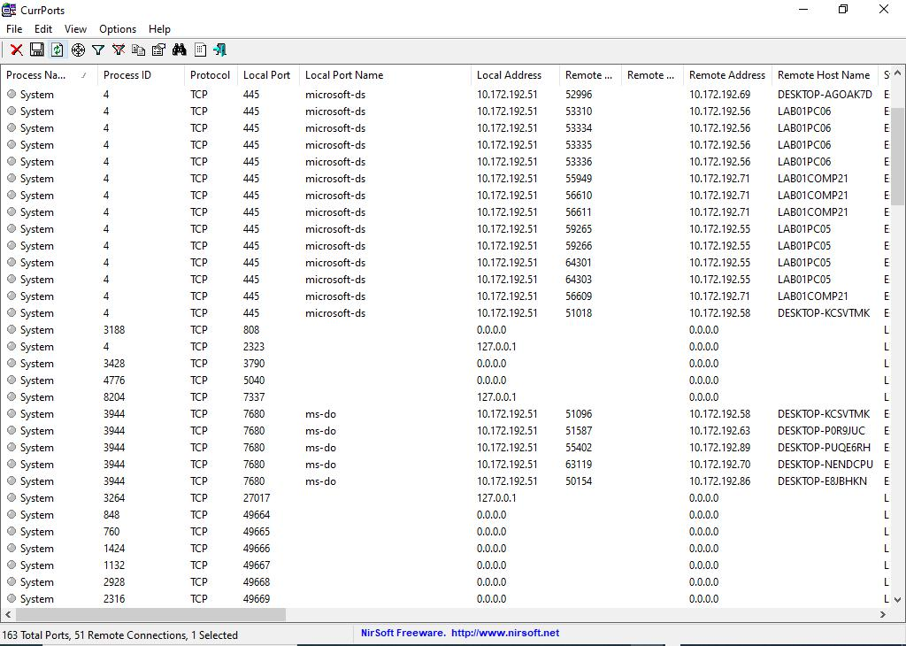

Print the repot form _> view then HTML Report-All Items

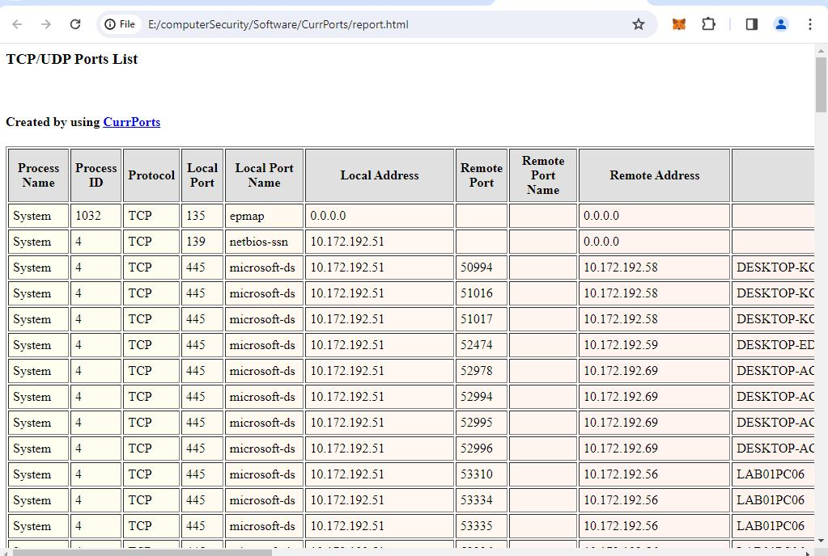

**Section 2:**

**Practical No 3.**

**A] Aim: Perform Enumeration using the following tools:**

1. **Nmap**

NMAP, as we know, is a powerful networking tool which supports many features and commands. Operating System detection capability allows to send TCP and UDP packet and observe the response from the targeted host. A detailed assessment of this response bring someclues regarding nature of an operating system disclosing the type an OS. To perform OS detection with nmap perform the following: nmap -O<ip address>

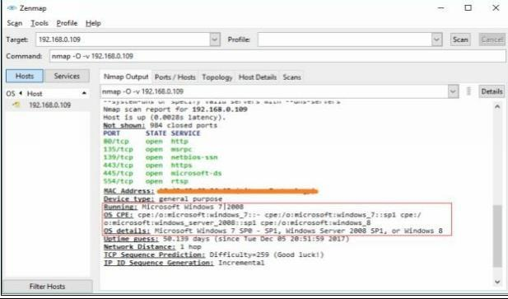

1. **NetBIOS Enumeration Tool**

NetBIOS stands for Network Basic Input Output System. It **Allows computer communicationover a LAN and allows them to share files and printers**. NetBIOS names are used to identifynetworkdevices over TCP/IP (Windows).

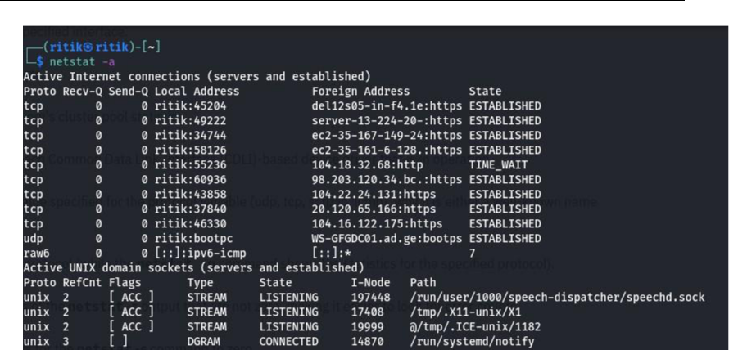

1. **SuperScan**

**SuperScan** is a multi-functional tool that will help you manage your network and make sure your connections and TCP ports are working as well as they should be. One of the best features or advantages of this tool is just how quickly it works. The scans are made very rapidly and faster than with most other scanning tools out there.

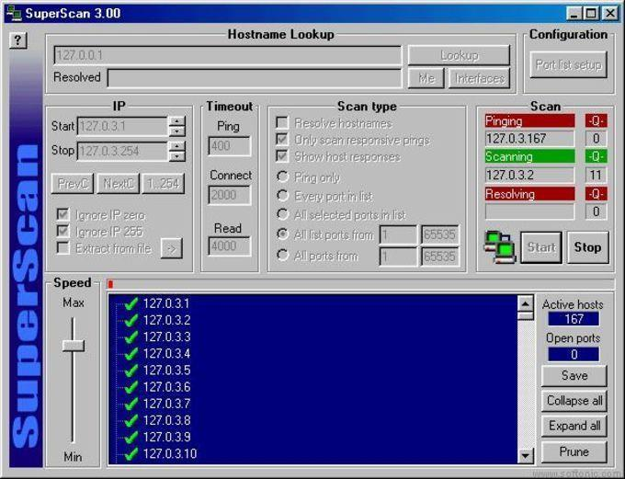

1. **Hyena**

Hyena is GUI based, NetBIOS Enumeration tool that shows Shares, User login information and other related information

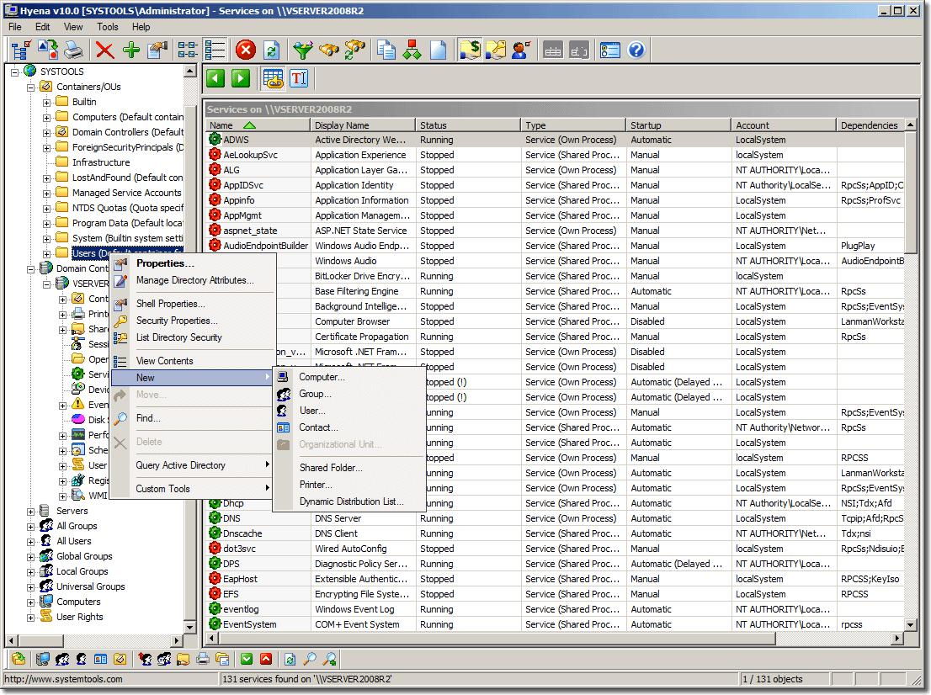

1. **SoftPerfect Network Scanner Tool**

SoftPerfect Network Scanner can ping computers, scan ports, discover shared folders and retrieve practically any information about network devices via WMI, SNMP, HTTP, SSH and PowerShell.

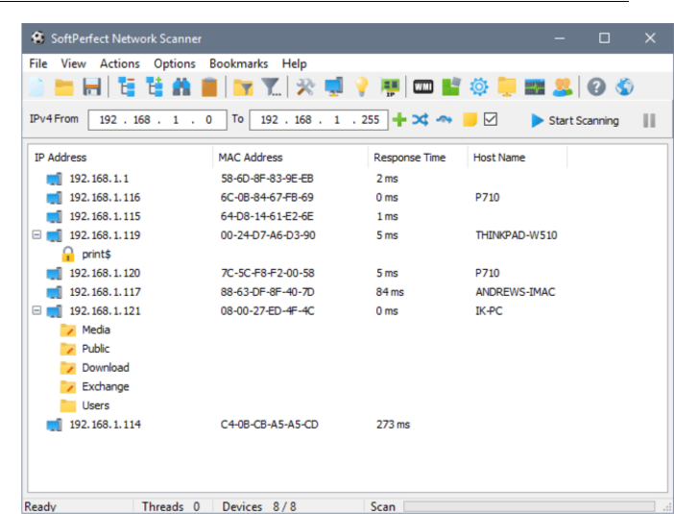

1. **OpUtils**

OpUtils is **a IP address and Switch port management software that is geared towards helping engineers efficiently monitor, diagnose and troubleshoot IT resources**. OpUtils

complements existing management tools by providing trouble shooting and real-time monitoring capabilities.

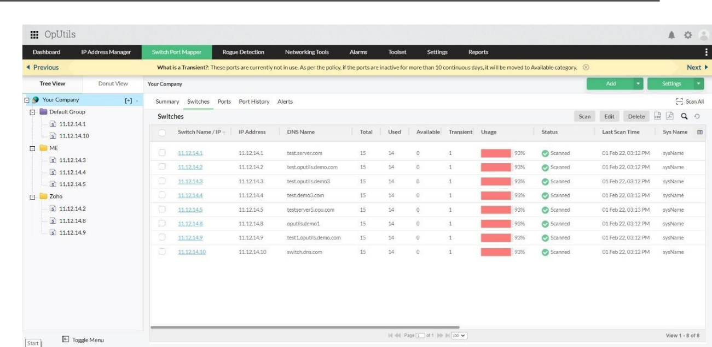

1. **SolarWinds Engineer’s Toolset**

Engineer's Toolset **provides the tools you need as a network engineer or consultant to get your**

**job done**. Toolset includes solutions that provide diagnostic, performance, and bandwidth measurements.

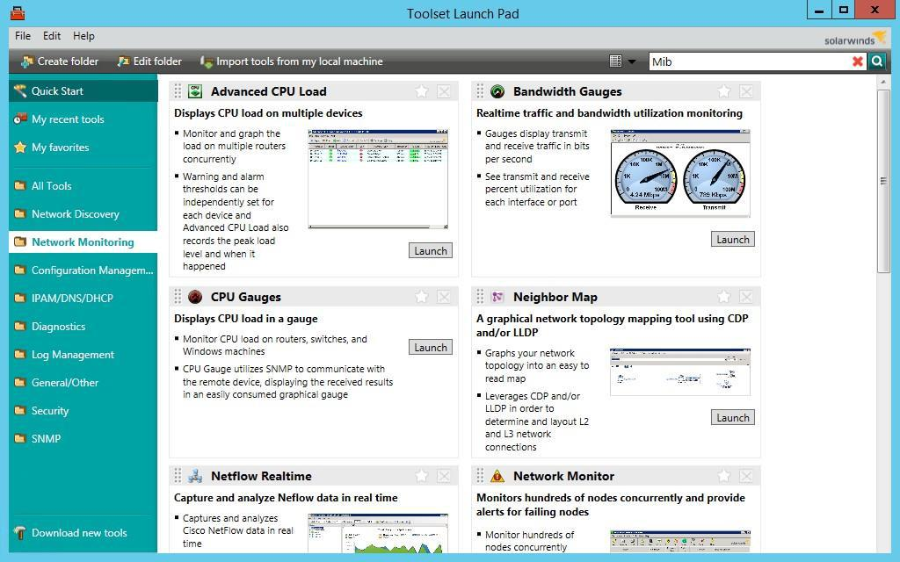

1. **Wireshark**

Wireshark is a free and open-source packet analyzer. It is used for network troubleshooting, analysis, software and communications protocol development, and education. Originally namedEthereal, the project was renamed Wireshark in May 2006 due to trademark issues

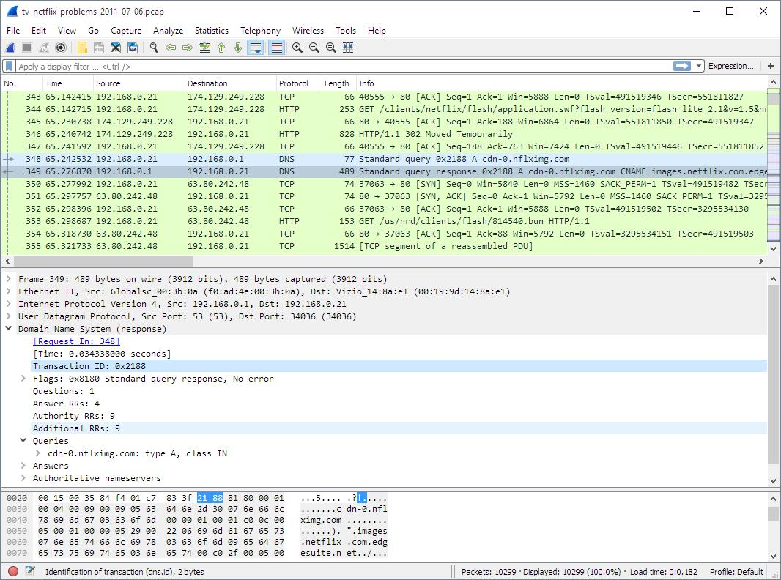

**B] Perform the vulnerability analysis using the following tools:**

1. **Nessus**

Nessus is a proprietary [vulnerability scanner](https://www.itperfection.com/network-security/network-monitoring/what-is-network-vulnerability-scanning/) developed by [Tenable, Inc.](https://www.tenable.com/) Tenable.io is a subscription-based service. Tenable also contains what was previously known as Nessus Cloud, which used to be Tenable’s Software-as-a-Service solution. Nessus is an open-source network vulnerability scanner that uses the Common Vulnerabilities and Exposures architecture for easy cross-linking between compliant security tools. In fact, Nessus is one of the many [vulnerability](https://www.itperfection.com/network-security/network-monitoring/vulnerability-scanning-tools-solarwinds-msp-openvas-nikto-nexpose-community-edition-manageengine-vulnerability-manager-plus-immuniweb/) [scanners](https://www.itperfection.com/network-security/network-monitoring/vulnerability-scanning-tools-solarwinds-msp-openvas-nikto-nexpose-community-edition-manageengine-vulnerability-manager-plus-immuniweb/) used during vulnerability assessments and penetration testing engagements, including malicious attacks. Nessus is a tool that checks computers to find vulnerabilities that hackers COULD exploit

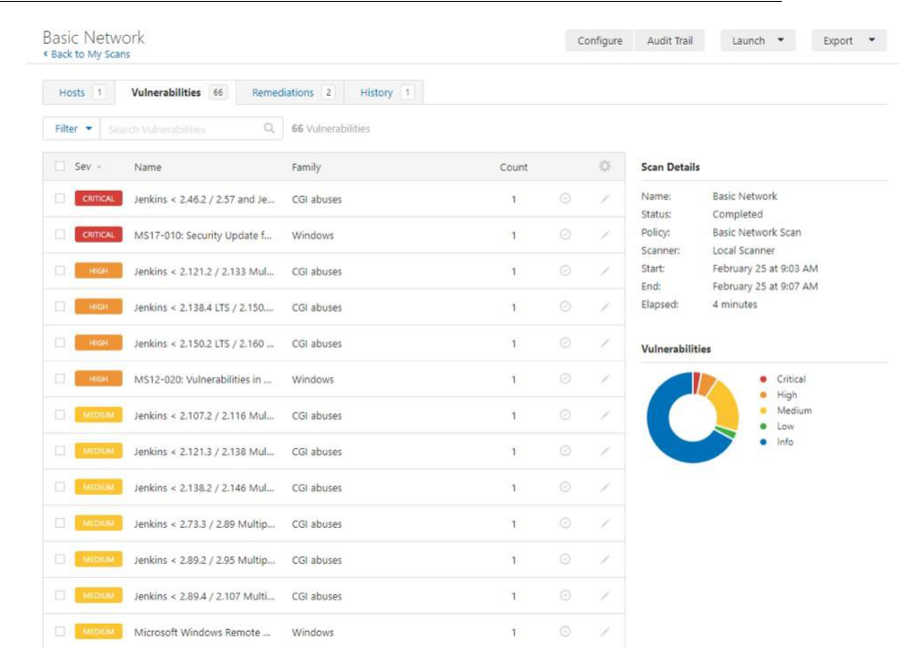

1. **OpenVas**

OpenVAS is a full-featured vulnerability scanner. Its capabilities include unauthenticated and authenticated testing, various high-level and low-level internet and industrial protocols, performance tuning for large-scale scans and a powerful internal programming language to implement any type of vulnerability test.

The scanner obtains the tests for detecting vulnerabilities from a [feed](https://www.greenbone.net/en/feed-comparison/) that has a long history anddaily updates.

OpenVAS has been developed and driven forward by the company [Greenbone Networks](https://www.openvas.org/) since 2006. As part of the commercial vulnerability management product family Greenbone Enterprise Appliance, the scanner forms the [Greenbone Community Edition](https://greenbone.github.io/docs/latest/background.html#architecture) together with other open-source modules.

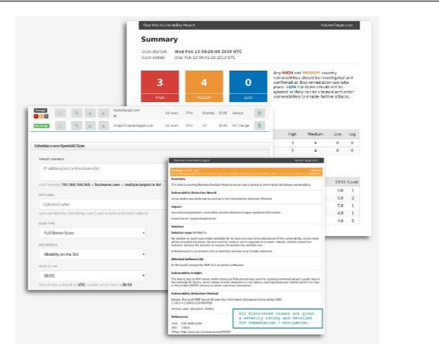

**Practical No. 4**

**a. Perform mobile network scanning using NESSUS**

Nessus has implemented new features to help users combat mobile threats. Network-based scanning is not the right approach to identify vulnerabilities on mobile devices, due in large part to the fact that most devices are in "sleep" mode and/or using a 3G/4G network. However, MDM (Mobile Device Management) technologies maintain information about the devices, including information about security vulnerabilities.

With Nessus Manager, the Nessus Mobile Devices plugin family allows you to obtain information from devices registered in a Mobile Device Manager (MDM) and from Active Directory servers that contain information from Microsoft Exchange Servers.

* To query for information, the Nessus scanner must be able to reach the Mobile DeviceMan-agement servers. Ensure no screening devices block traffic to these systems fromthe Nessus scanner. In addition, you must give Nessus administrative credentials (for example, domain administrator) to the Active Directory servers.
* To scan for mobile devices, you must configure Nessus with authentication information for the management server and the mobile plugins. Since Nessus authenticates directly tothe management servers, you do not need to configure a scan policy to scan specific hosts.
* For ActiveSync scans that access data from Microsoft Exchange servers, Nessus retrieves information from phones that have been updated in the last 365 days.

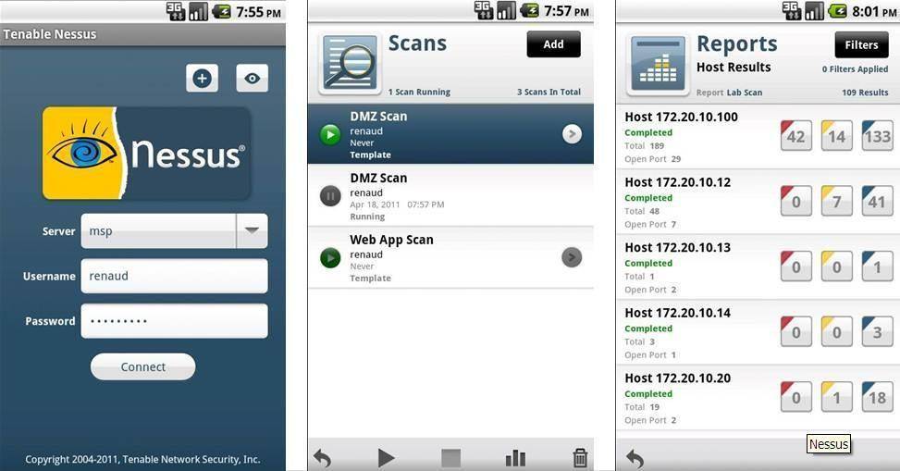

1. **Perform the System Hacking using the following tools:**
2. **Winrtgen**

In this article, we will go through the process of generating rainbow tables using WinRTGen.

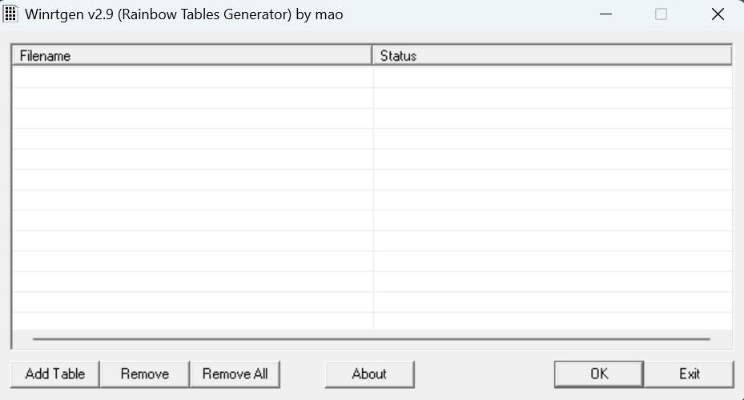

To generate rainbow tables first we will have to modify the properties of WinRTGen according to our need, and to do so Click on “**Add Table**“. After this, a new box will appear named “**Rainbow Table Properties**”

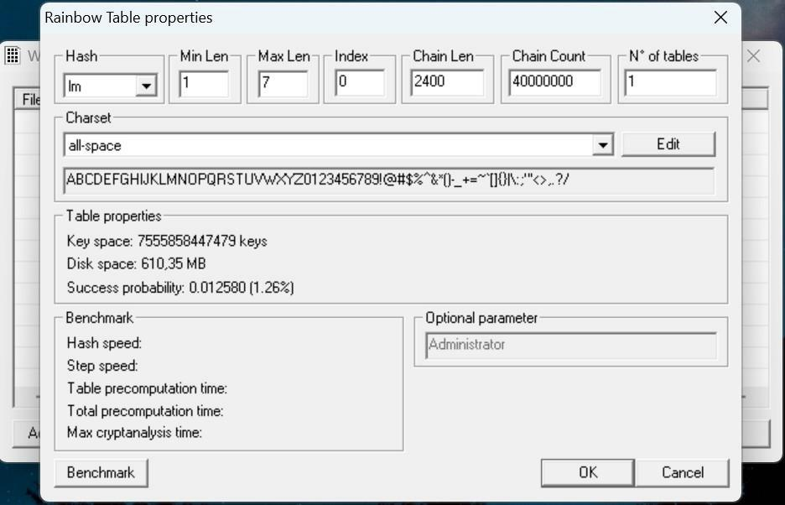

In the “**Rainbow Table Properties**” window we have the option to modify settings in order to generate rainbow tables according to our needs. The following properties can be modified:

 **Hash**: The type of encryption we want the rainbow table to be generated. For exampleMD5, MD4, SHA1, etc.

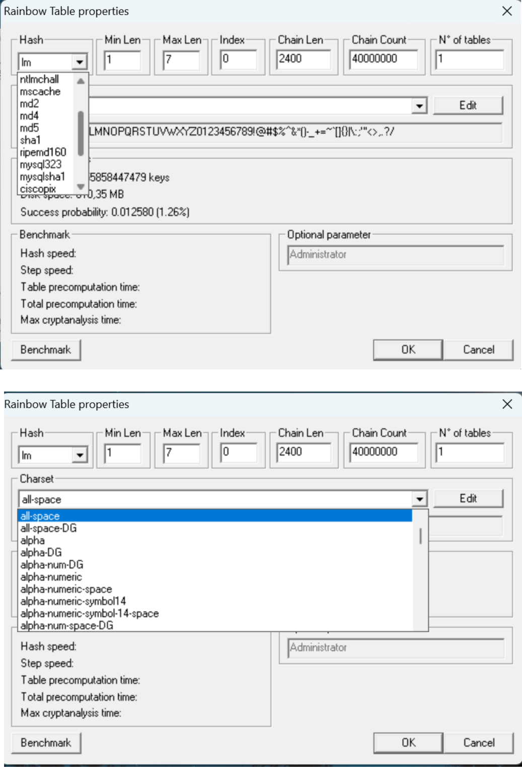

64

After assigning the values to the properties according to our needs click on “Benchmarks”. This will show the estimated time, Hash speed, Step speed, Table Pre-computing time, etc. that will be required to generate the Rainbow Table according to assigned properties.

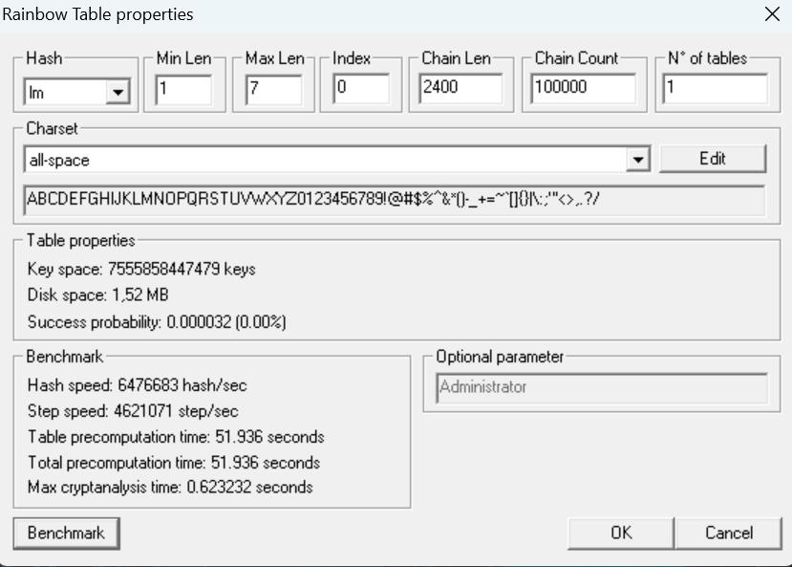

After “Benchmark” click on “Ok”. This will add the Rainbow Table to the queue in the main window of WinRTGen

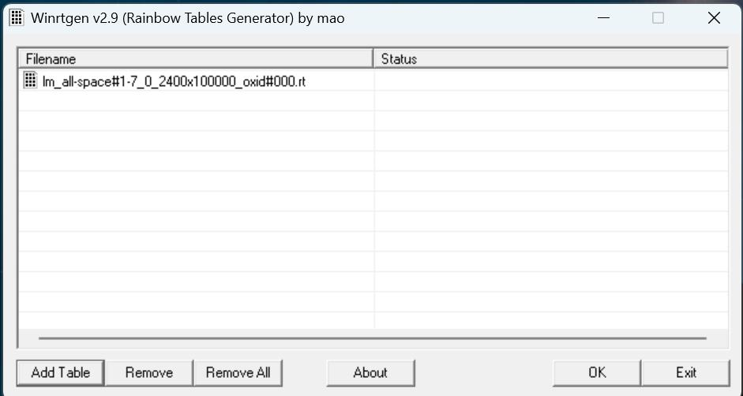

After this click on “Rainbow Table” You want to start processing and click “OK” .

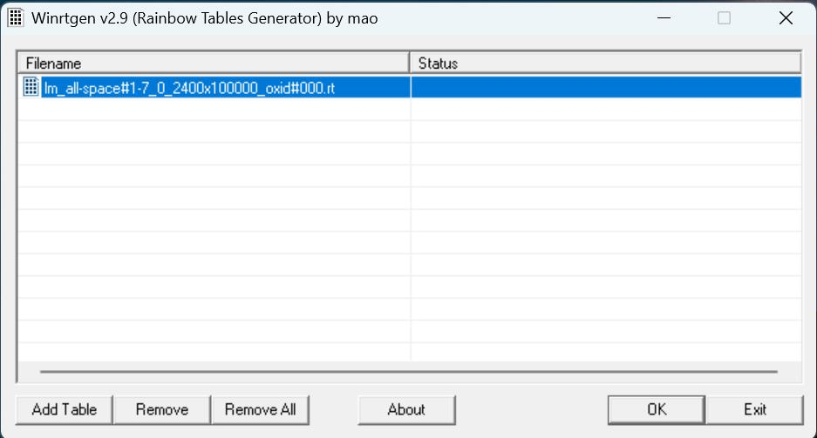

After clicking on ‘OK’ the WinRTGen” will start generating a rainbow table.

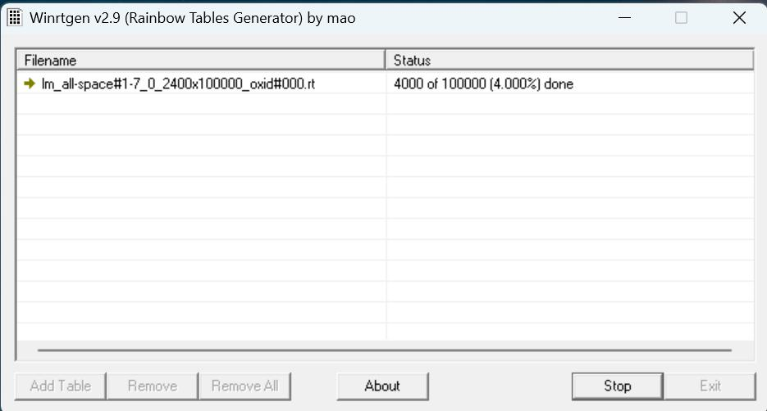

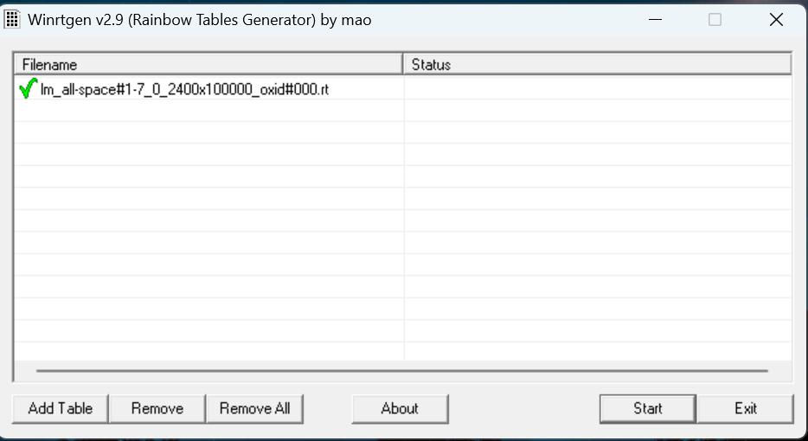After completion, the window will appear as follows.

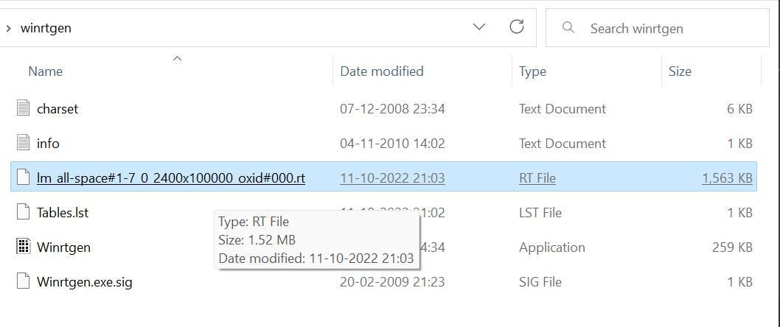This table will be saved to your WinRTGen Directory.

1. **PWDump**

The Security Account Manager, or SAM for short, controls all user accounts and passwords. Every password is hashed before being saved in SAM. Passwords that are hashed and saved in SAM can be retrieved in the registry; simply open the Registry Editor and navigate to HKEY LOCAL MACHINESAM. SAM is located in C:\Windows\System32\config.

This utility was created by Tarasco. This utility dumps the system’s SAM file’s credentials after extracting it.

This utility was created by Tarasco. This utility dumps the system’s SAM file’s credentials after extracting it. Simply enter the following line on the command prompt after downloading to use this tool:

*PwDump7.exe*

As a result, it will spill all the hashes kept in the SAM file. The next step is to use the commands below to save the registry values for the SAM file and system file in a system file:

*reg save hklm\sam c:\sam*

*reg save hklm\system c:\system*

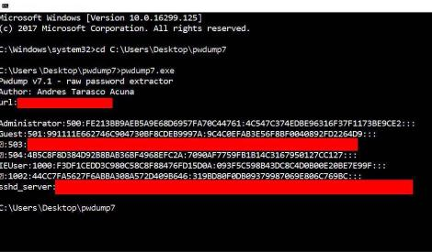

1. **Ophcrack**

When it comes to free Windows password crackers, users usually opt for Ophcrack as it is free and easily available.

**Step 1**: Since we are assuming that your Windows PC is locked and you do not know the password, the first step needs to be carried out on a different PC with internet access and administrator privileges.

**Step 2** : Download the correct version of Ophcrack Live CD from the official website to the second PC.

**Step 3** : [Burn the ISO file to a USB](https://www.passmoz.com/burn-iso-image-to-usb-in-3-ways.html) or CD. To do this, you will need an ISO burning application. Now proceed to the next step of the password reset process.

**Step 4** : Remove the bootable media from the second PC and insert it into your locked

Windows machine. Let the computer boot up from this media instead of the native

Windowsinstallation. This is made possible by the fact that Ophcrack itself contains a small

operatingsystem that can run independently of your Windows OS. In a few moments, you will see theOphcrack interface on your computer.

**Step 5** : You will now see a menu with 4 options. Leave it on the default option, which is

automatic. After a few seconds, you will see the Ophcrack Live CD loading and then the disk partition information being displayed as Ophcrack identifies the one with the SAM file.

**Step 6** : Once the process has been complete, you will see a window with several user accounts and their passwords displayed in column format. Against the previously locked username, look for an entry in the NT Pwd column.

**Step 7**: This will be your recovered password, so note it down. You can now remove the Live CD from the drive and restart your computer. You will be able to login to your user account using the password that was recovered by Ophcrack.

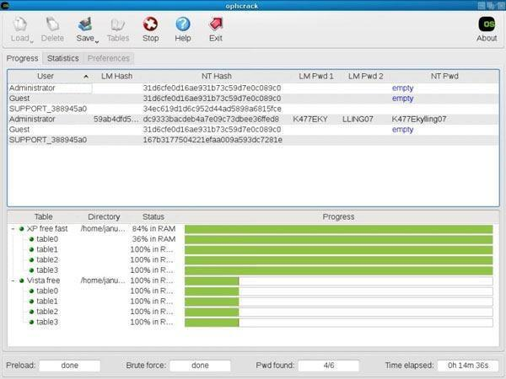

1. **Flexispy**

FlexiSPY is a phone application which comes with an android keylogger for the phone as a feature. It will always appear in the list whenever one is speaking about the world’s best spy phone applications. This app comes with everything you expect when looking for a monitoring system for your phone.

It will help you record phone calls, capture SMS, WhatsApp messages, even capture keystrokes, allow you to read emails, read Facebook messages.

The app will as well track the device and you know what, from where you are you can turn on its recorder and record conversations without the owner noticing.

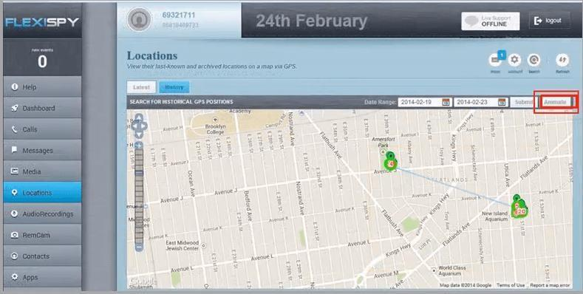

1. **NTFS Stream Manipulation**

NTFS is a filesystem that stores files utilizing two data streams known as NTFS data streams, as well as file attributes. The first data stream contains the security descriptor for the file to be stored, such as permissions, while the second contains the data contained within a file. Anotherform of the data stream that can be found within each file is an alternate data stream (ADS).

ADS is a file attribute available solely in NTFS, and it refers to any type of data associated witha file but not in the file itself on an NTFS system. NTFS ADS is a Windows hidden stream that stores file metadata such as properties, word count, access and author name, and modification timings.

ADSs can fork data into existing files without changing or altering their functionality, size, or display to file-browsing utilities. They enable an attacker to inject malicious code into files on a vulnerable system and execute them without the user knowing. Attackers use ADS to hide rootkits or hacker tools on a breached system and allow users to execute them while hiding fromthe system administrator.

Once the ADS is attached to a file, the size of the original file will not change. One can only identify the changes in files through modification of timestamps, which can be innocuous.

Creation of NTFS streams:

When the user reads or writes a file, their only manipulation in the main data stream by default. The following is the syntax of ADSs

filename.extension:alternativeNmae

Open the terminal and type the following command to create a file named file_1.txt. echo "this is file no 1" > file_1.txt

Now, type the following command to write to the stream named secret.txt. echo "this is a hidden file inside the file_1.txt" > file_1.txt:secret.txt

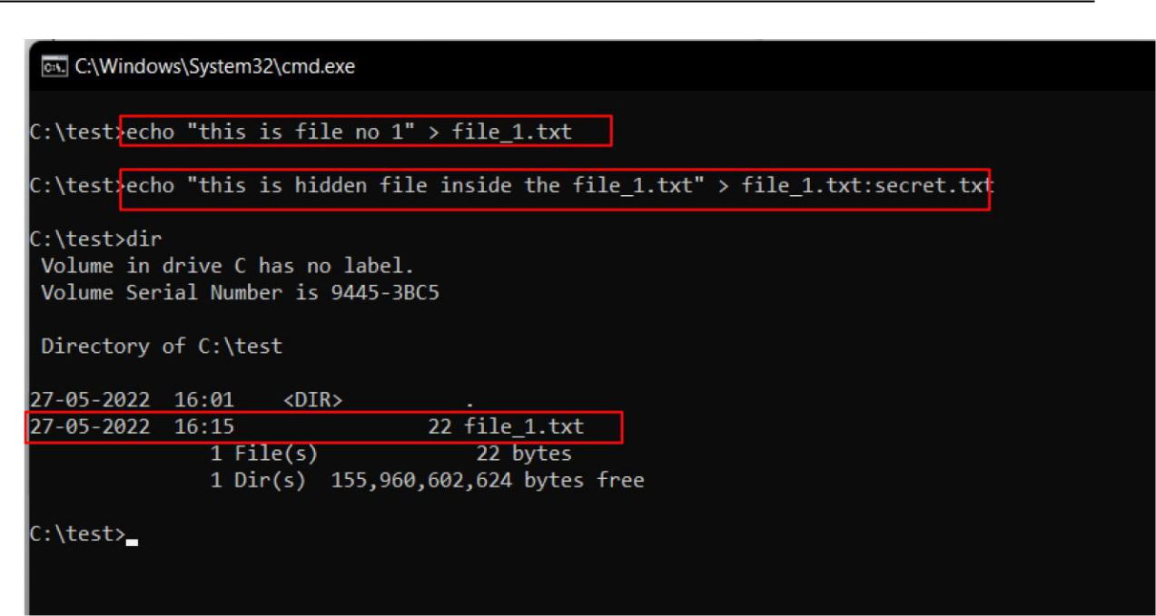

We’ve just created a stream named secret.txt that is associated with file_1.txt and when you look at the file_1.txtyou will only find the data present in file_1.txt. And also stream willnot be shown in the directory as well.

The following command can be used to view or modify the stream hidden in file_1.txt notepad file_1.txt:secret.txt

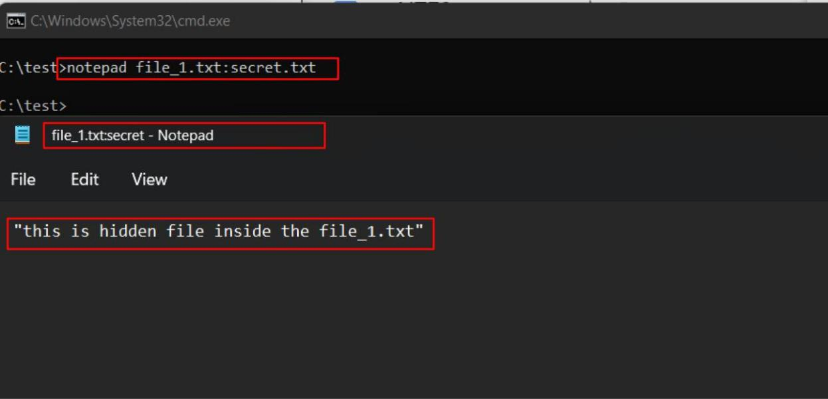

**Note:** Notepad is a stream-compliant application. Never use alternative streams to store sensitiveinformation.

Hiding Trojan.exe in note.txt file stream:

The following command has used the copy the trojan.exe into a note.txt(stream)

C:\test>type Trojan.exe > note.txt:Trojan.exe

Here type command is used to hide trojan in the ADS inside an existing file.

After hiding trojan.exe behind note.txt, we need to create a link to launch the trojan.exe file fromthe stream. The following command is used to create a shortcut in the stream.

C:\test>mklink game.exe note.txt:Trojan.exe

Type game.exe to run the trojan that is hidden behind the note.txt. Here, game.exeis the shortcut created to launch trojan.exe.

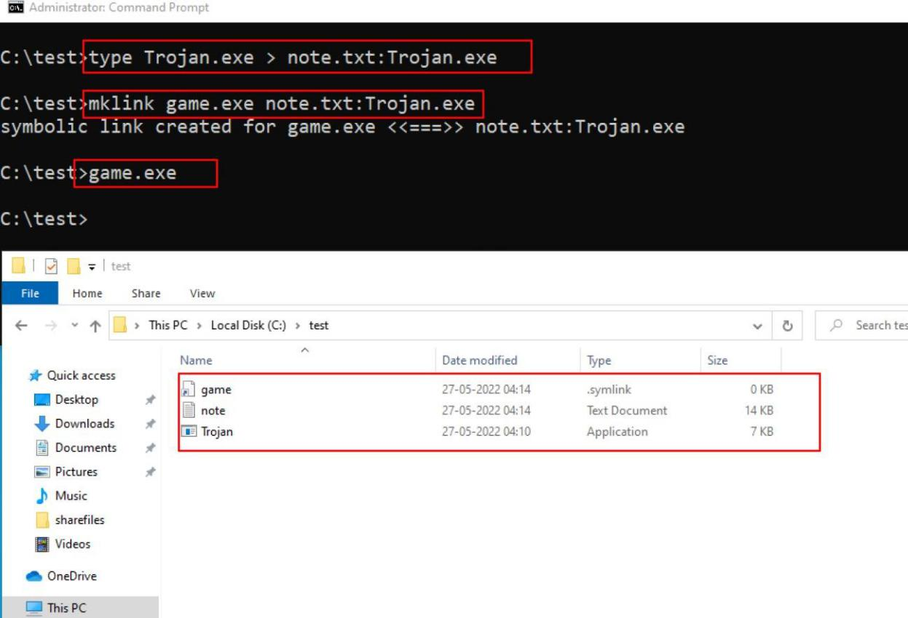

1. **ADS Spy**

AdSpy offers the most search options of any Ad Intelligence Tool, so you can find the data you want, how you want. Search in the usual way: ad text, URL, page name. Search true data from user reactions in advert comments. Be as rigorous as you need to: search or filter by affiliate network, affiliate ID, Offer ID, landing page technologies - whatever helps you find the information you can work with. Open ADS Spy application and select the option if you want to:

 Quick Scan

 Full Scan

 Scan Specific Folder

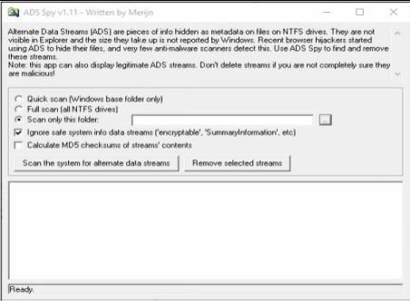

As we store the file in the Document folder, Selecting Document folder to scan particular folder only.

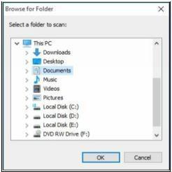

Select an Option, if you want to scan for ADS, click “**Scan the system for ADS**”/ or click

**removes** button to remove the file

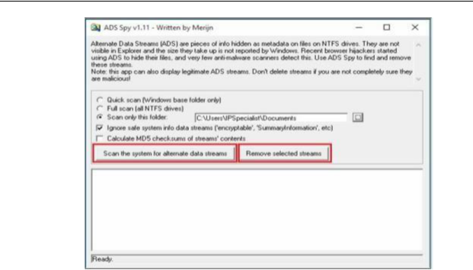

As shown in the figure below, ADS Spy has detected the **Testfile.txt:hidden.txt** file from the directory.

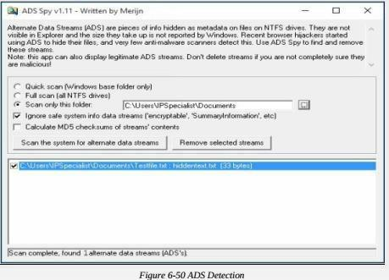

1. **Snow**

Create a text file with some data in the same directory where Snow Tool is installed.

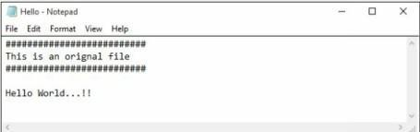

Go to Command Prompt

Change the directory to run Snow tool

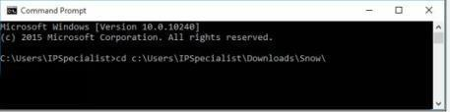

Type the command

**Snow –C –m “text to be hide” –p “password” <Sourcefile> <Destinationfile>**

The source file is a Hello.txt file as shown above. Destination file will be the exact copy of source file containing hidden information.

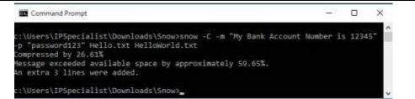

Go to the directory; you will a new file **HelloWorld.txt**. Open the File

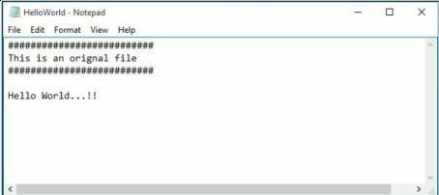

New File has the same text as an original file without any hidden information. This file can be sent to the target.

***Recovering Hidden Information***

On destination, Receiver can reveal information by using the command

**Snow –C –p “password123” HelloWorld.txt**

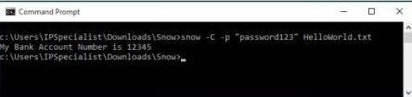

As shown in the above figure, File decrypted, showing hidden information encrypted in the previous section.

1. **Quickstego**

**Image Steganography using QuickStego**

1. Open QuickStego Application

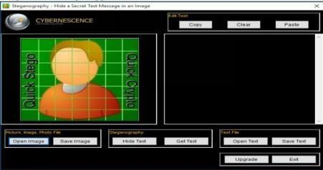

1. Upload an Image. This Image is term as **Cover**, as it will hide the text.

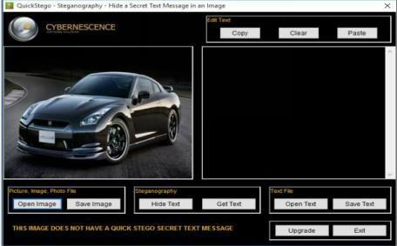

1. Enter the Text or Upload Text File

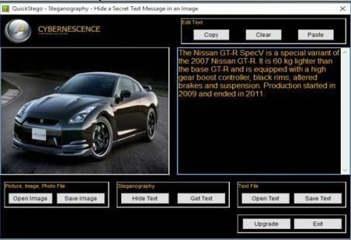

1. Click Hide Text Button

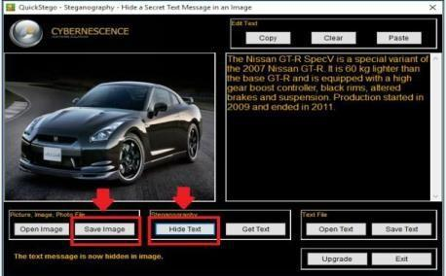

1. Save Image

This Saved Image containing Hidden information is termed as Stego Object.

**Recovering Data from Image Steganography using QuickStego**

1. Open QuickStego
2. Click Get Text

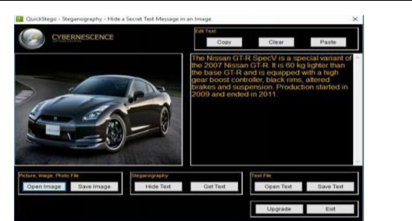

1. Open and Compare Both Images

Left Image is without Hidden Text; Right Image is with hidden text



1. **Clearing Audit Policies**

***Enabling and Clearing Audit Policies***

To check command’s available option Enter

C:\Windows\system32> **auditpol /?**

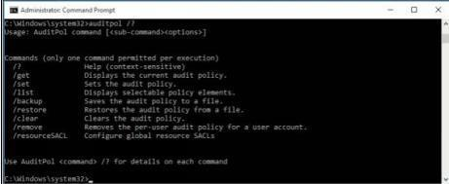

Enter the following command to enable auditing for System and Account logon: - C:\Windows\system32>**auditpol /set /category:"System","Account**

**logon" /success:enable /failure:enable**

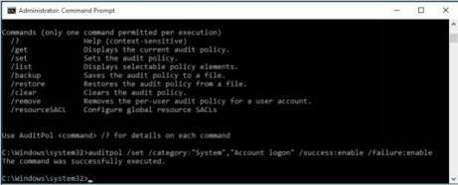

To check Auditing is enabled, enter the command

C:\Windows\system32>**auditpol logon","System"/get /category:"Account**

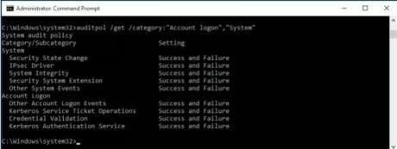

To clear Audit Policies, Enter the following command

C:\Windows\system32>**auditpol /clear**

Are you sure (Press N to cancel or any other key to continue)?**Y**

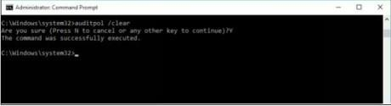

Enter the following command to enable auditing for System and Account logon: - C:\Windows\system32>**auditpol /set /category:"System","Account**

**logon" /success:enable /failure:enable**



To check Auditing is enabled, enter the command

C:\Windows\system32>**auditpol logon","System"/get /category:"Account**



To clear Audit Policies, Enter the following command

C:\Windows\system32>**auditpol /clear**

Are you sure (Press N to cancel or any other key to continue)?**Y**



To check Auditing, enter the command

C:\Windows\system32>**auditpol /get /category:"Account logon","System"**



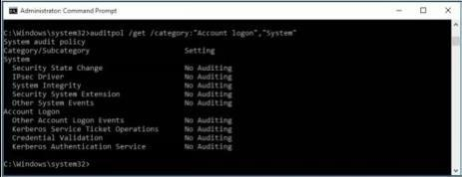

1. **Clearing Logs**

1. Go to Kali Linux Machine & Open the /**var** directory:

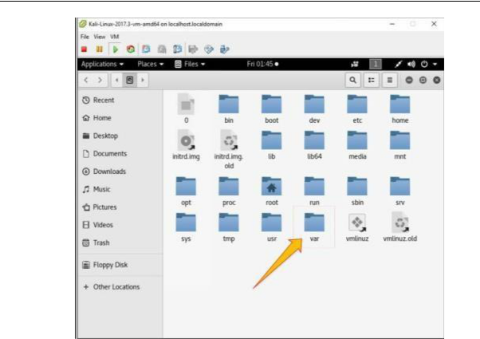

2.Go to **Logs** folder:

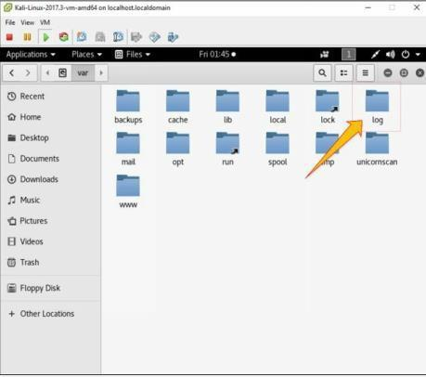

4. Select any log file:

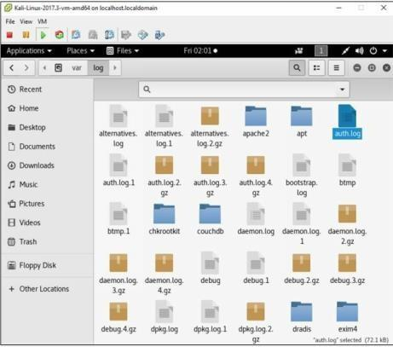

5. Open any log file; you can delete

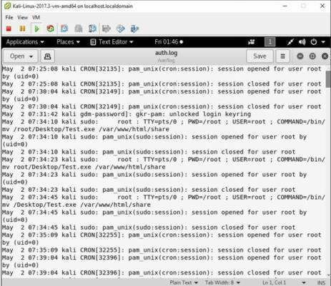

**Practical No. 5**

**a.Use wireshark to sniff the network.**

Wireshark is a GUI-based packet capture program. As noted, it comes with some command-line programs. There are a lot of advantages to using Wireshark. First, it gives us a way to view the packets easily, moving around the complete capture. Unlike with tcpdump and tshark, we see theentire network stack in Wireshark, which technically makes what we have captured frames ratherthan packets.

* Start Wireshark. Under the “Capture” header, select the “Interface List” option; orclick on the “Interfaces” button on the toolbar:

This will bring up a list of network interfaces that Wireshark is able to capturepackets from:

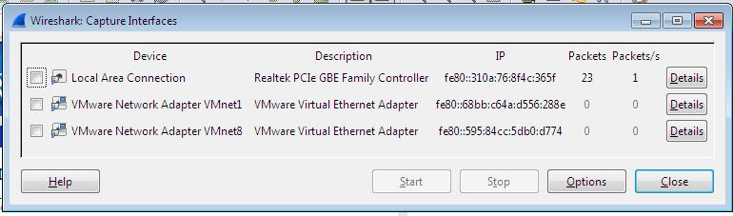

List of available capture interfaces

Select the network adapter (wired or wireless) that you are currently using to connect tothe

Internet, and hit the “Start” button. This will take you to the main window:

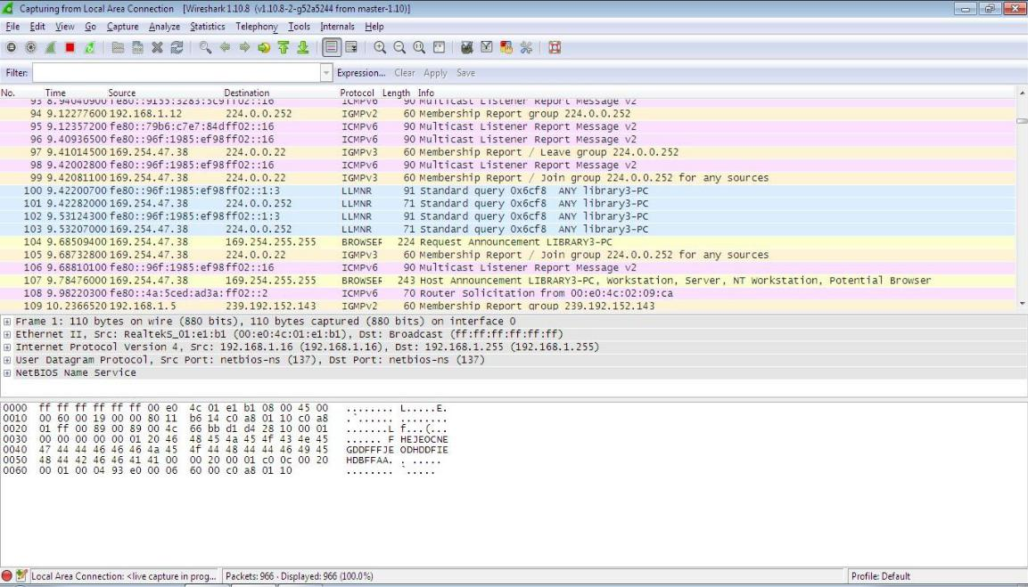

86

Wireshark is now capturing live network activity on your network interface. Notice that the list of packets is color-coded to highlight different types of network traffic.

* Open your web browser and navigate to a few random web pages - observe that the network packets corresponding to your web browsing activity are captured and show up in Wireshark as well.
* By default, the list of captured packets will keep scrolling automatically during a live



capture. You can toggle this on/off using the AutoScroll toggle button in the toolbar.



• After letting the capture run for a couple of minutes, press the stop capture

button. Do not close this capture session.

**Filtering the Packet List**

Capturing network traffic for a couple minutes could include traffic on many different protocols such as ARP, TCP, UDP, DNS, HTTP, etc.

We may not be interested in all of these, depending on what we are trying to achieve. Fortunately, Wireshark allows us to filter the list based on different criteria using the “Filter” toolbar:



**Filter toolbar**

Let us take a look at the HTTP traffic that occurs when we browse the web.

In the filter toolbar, type “http” and then click on “Apply”. The window willnow list only captured packets related to HTTP traffic:

87

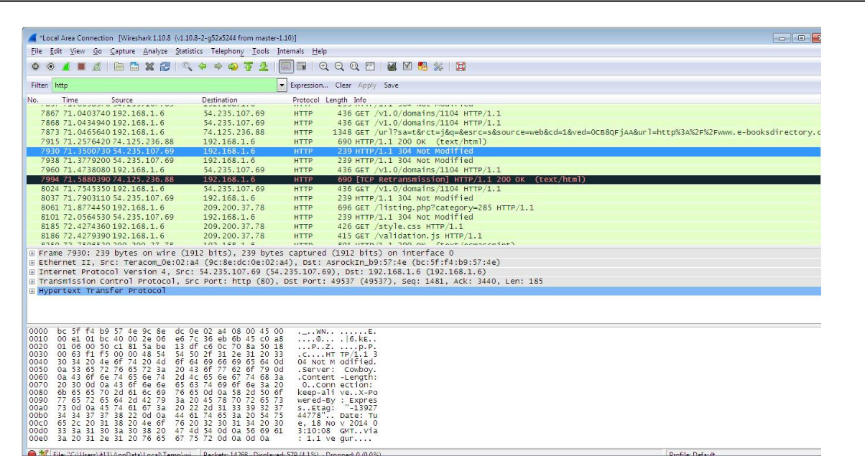

**Examining HTTP Traffic**

The HTTP traffic that occurs during web browsing.

* Stop and close any capture that you may have open, and start a new capture.
* Set the filter to show only HTTP traffic.

Start with the HTTP request sent from your web browser.

* In your web browser, navigate to some webpage like [http://www-scf.usc.edu/~csci571/Special/HTTP/proxy.html.](http://www-scf.usc.edu/~csci571/Special/HTTP/proxy.html)
* In the top frame of the Wireshark main window, look for the packet that corresponds to your request. This contains the URL in the “Info” section. Selectthis packet.
* In the middle frame of the Wireshark window, expand the “Hypertext Transfer Protocol” section. Notice the details given for the:

o GET request o Host

o User-Agent o Accepts o cookie

o etc

88

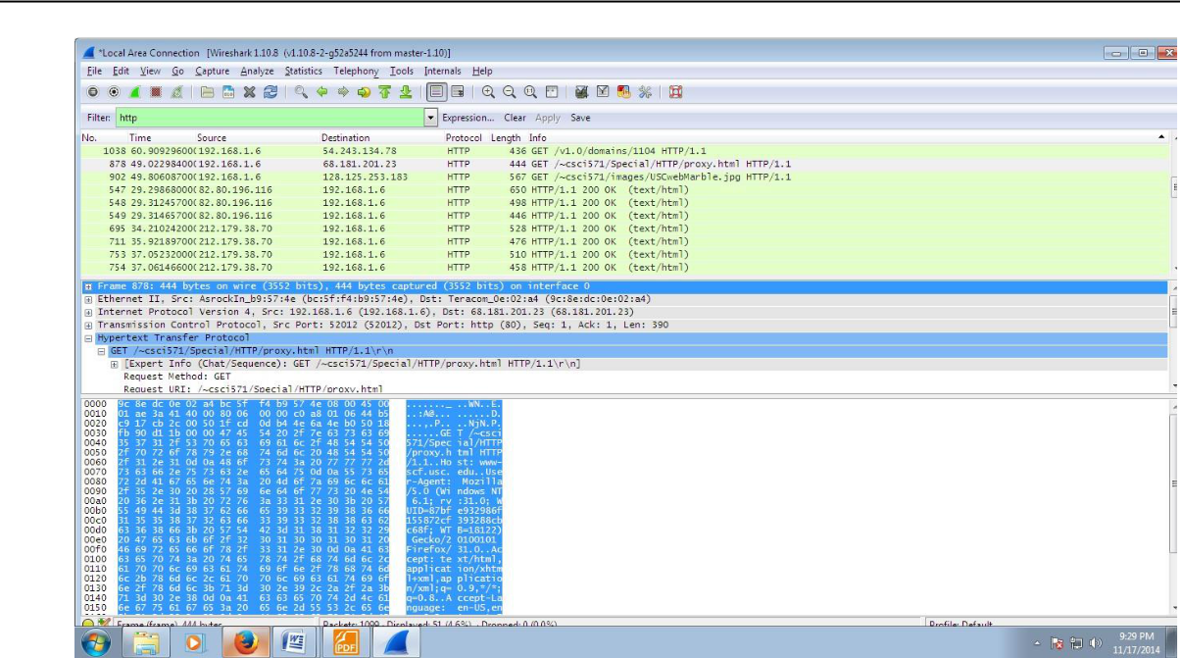

Take a look at the HTTP response to the above request.

In the top frame of the Wireshark main window, find and select the “HTTP/1.1 200 OK” packet immediately below the request for proxy.html. This is the response containing therequested web page.

Again, expand the “Hypertext Transfer Protocol” section. Notice the details given for

1. Cache-Control o Content-Type o Server

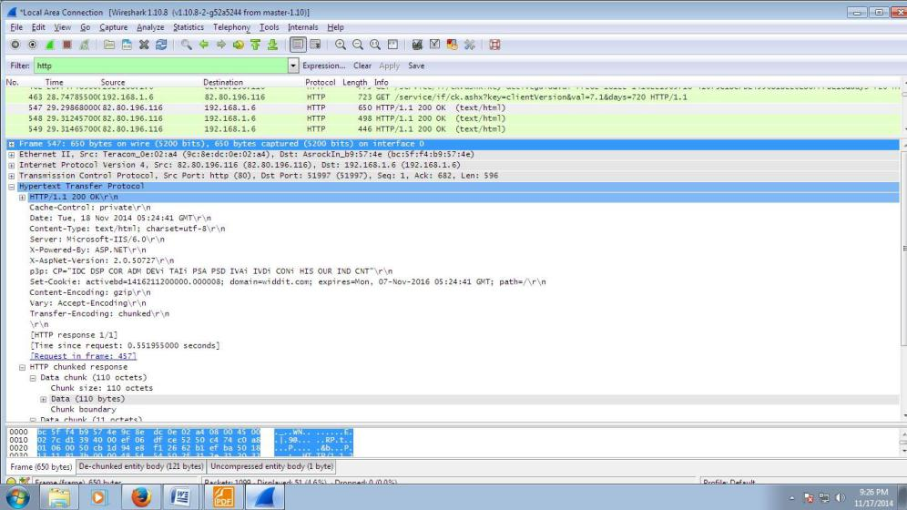

Details of incoming HTTP response corresponding to proxy.html

89

1. **Use SMAC for MAC Spoofing.**

SMAC is a MAC address changer that has a simple-to-use graphical interface that enables the less experienced user all the way up to the guru to change a piece of hardware’s MAC address.

The less experienced user will appreciate the random generator whereas the guru will appreciatethe ability to hand enter a new MAC address.

Once it is installed, you will find the application launcher in a Start Menu subdirectory called KLC. Click on that folder and you will see SMAC 2.0. Click on that launcher and the SMACmain window (**Figure A**) will open.

Using SMAC can be very simple, depending on how you want to use it. The simplest way to use SMAC is to assign a random MAC address to a piece of hardware. Before we actually assign a new address, let’s take a look at the other hardware on the machine. In the main window there is a check box that tells SMAC to show only active hardware. This checkbox is checked by default. Uncheck that box and your listing will grow, depending on the hardware on your machine. Take a look at **Figure B** to see how much the listing grows on my laptop that includes wireless, wired, and dial-up connections.

*Figure A*

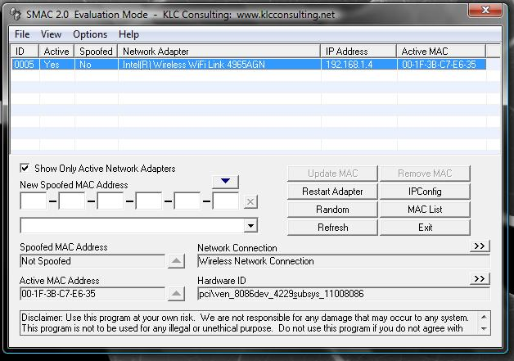

90

*Figure B*

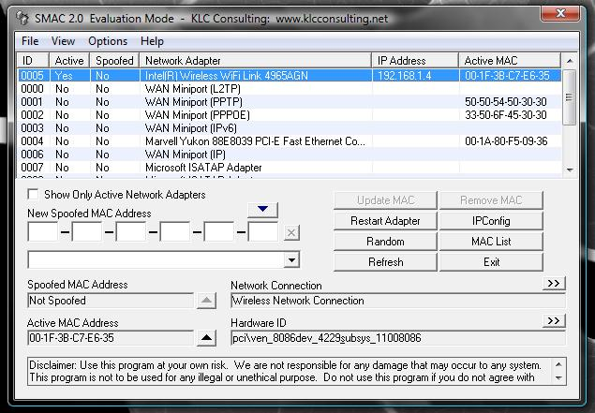

When you click on a different listing, the information about that hardware will be displayed below.

Let’s change the MAC address of the Wired Marvell Yukon PCI-E Faster Ethernet Controller. To do this, select that entry from the list and click the Random button. As you can see in **FigureC**, the new, random MAC address is displayed in the New Spoofed MAC Address section.

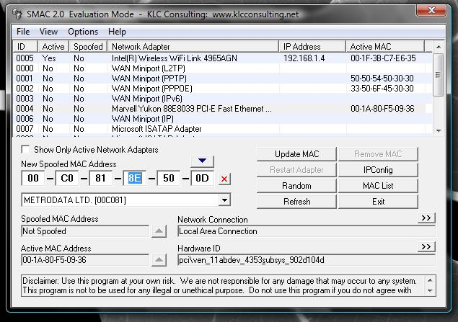

*Figure C*

The address listed will correspond to a manufacturer list that you can choose from.

If you know you want to spoof your MAC address to that of a specific manufacturer you can select a different manufacturer from the drop-down list. When you make this selection, the address listed will change. You can keep hitting Random until you get an address you like (or you can just take the first random address you get).

Once you have your address, select the Options menu and make sure Automatically Restart Adapter is checked. Once that is checked, hit the Update MAC Address button and the new MAC address will be applied.

1. **Use Caspa Network Analyser.**

When we correctly deployed Capsa, we cannot wait to start our first capture right away.

Capsa7's new Start Page guides us start an accurate capture mission step by step:

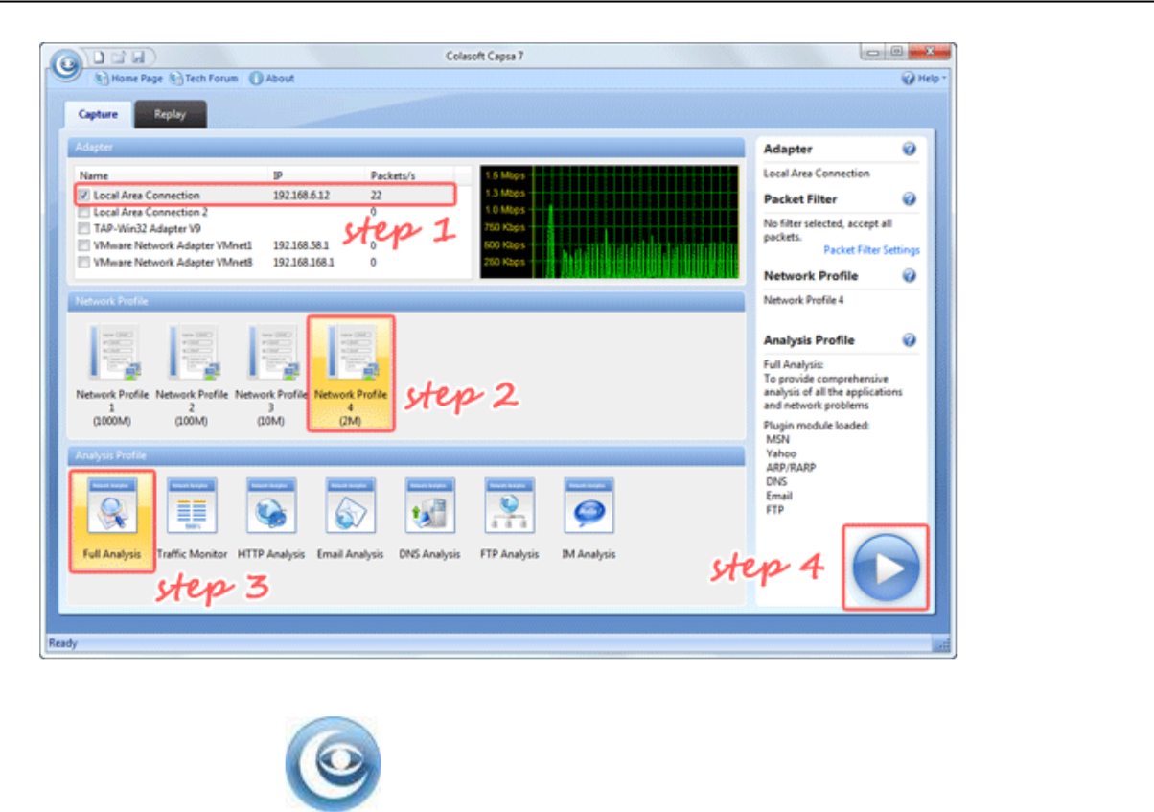

1. Double-click icon on the desktop.

1. In the Start Page, select your NICs (multiple selections available) in the Capture panel first.

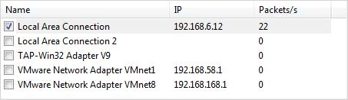

1. Select any Network Profile in the Network Profile panel.

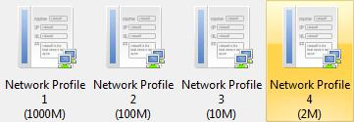

1. Select Full Analysis in the Analysis Profile panel.

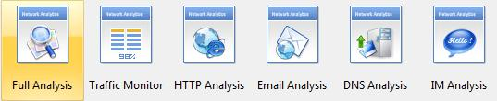

1. Click the big Run button to start a capture right away.



This is the common procedure to start a capture, which helps us get accurate and useful analysisdata: Select NIC -> Select Network Profile -> Select Analysis Profile -> Run.

1. **Use Omnipeek Network Analyzer.**

Omnipeek is a high-performance network protocol analyzer, capable of decoding thousands ofprotocols for fast network troubleshooting and diagnostics, anywhere network issues happen.

Real-Time Network Protocol Analyzer

Omnipeek provides real-time analysis for every type of network segment – 1/10/40/100 Gigabit, 802.11, and voice and video over IP – and for every level of network traffic.

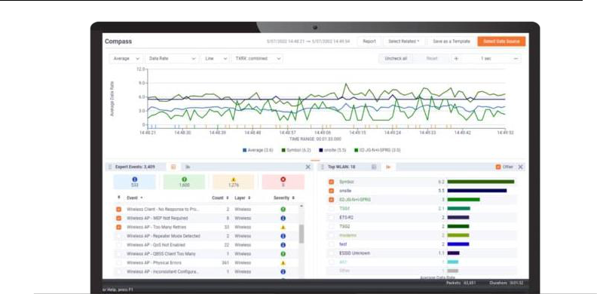

Intuitive Graphic Displays and Visualization

Omnipeek delivers intuitive visualization and effective forensics for faster resolution of network and application performance issues and security investigations.

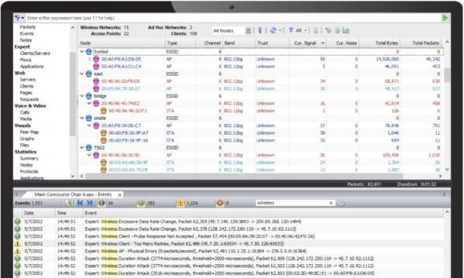

95

Best-In-Class Network Analysis Workflow

Widely recognized as the best network analysis workflow in the industry, we make it easy to drill down to a single packet – all from a single pane of glass.

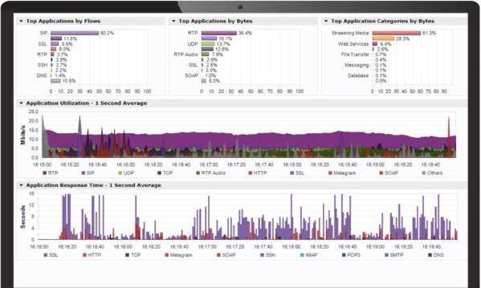

WiFi Troubleshooting

The Omnipeek WiFi adaptor is a USB-connected WLAN device designed for wireless packet capture. The 802.11ac adapter supports 802.11ac capture up to 2 transmit/receive streams (866Mbps wireless traffic) and supports 20MHz, 40MHz, and 80MHz channel operation.

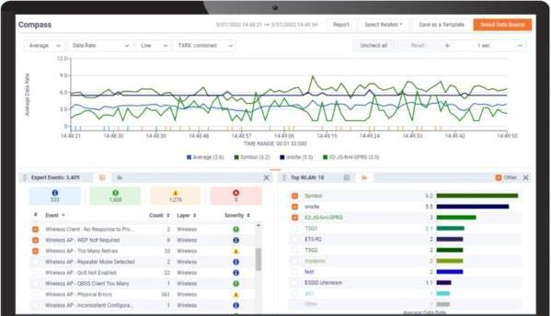

96

Monitor Distributed Networks Remotely

Integrating with LiveCapture, Omnipeek extends network monitoring and visibility for troubleshooting application-level issues at remote sites and branches, WAN links, and data centers.

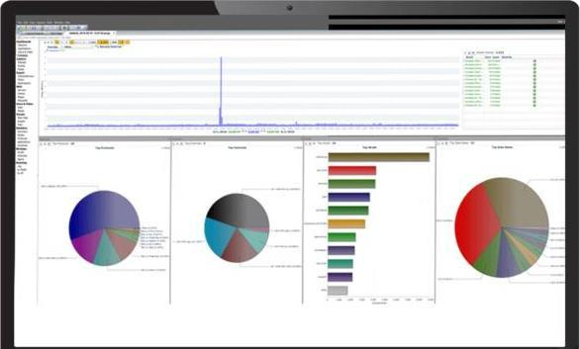

Voice and Video Monitoring and Troubleshooting

Monitor and troubleshoot voice and video over IP traffic in real-time with high-level multi-media summary statistics, call playback, and comprehensive signaling and media analyses.

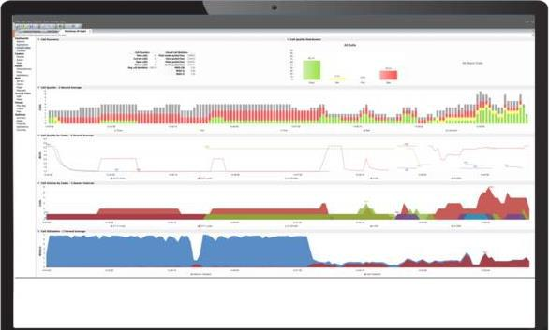

Simplify Troubleshooting Remote Devices

Easily troubleshoot end-user devices remotely and securely with encrypted files, avoiding the need to travel to a user’s location.

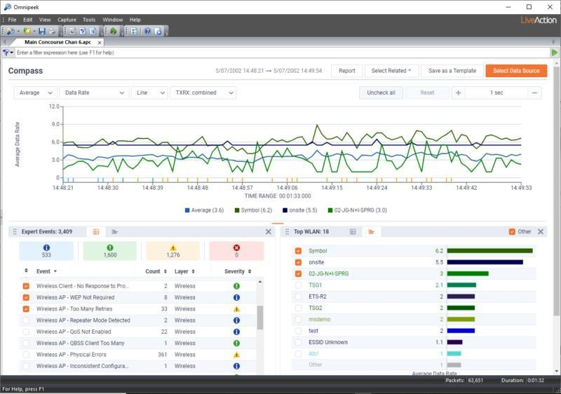

**Section III**

**Practical No: 6**

**Section 3A**

**a. Aim: Use Social Engineering Toolkit on Kali Linux.**

**Step 1:** Select social engineering toolkit in the Kali Linux.

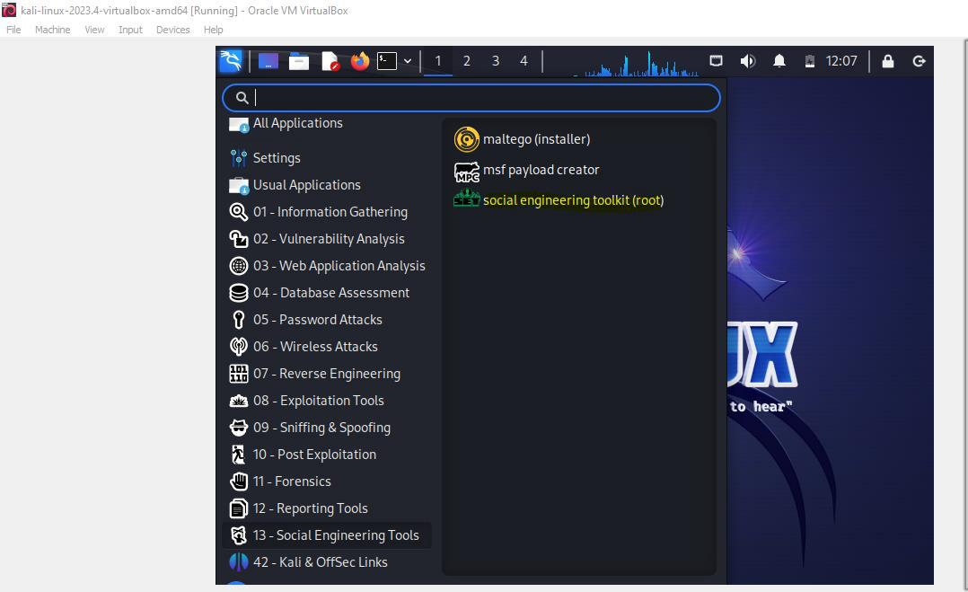

**Step 2: Select option 1. Social engineering attack**

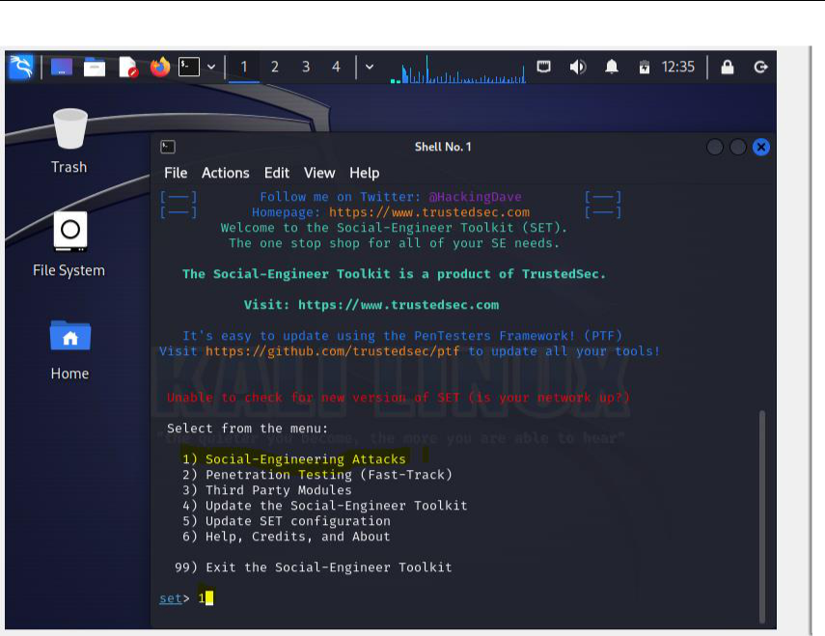

                                                                99

**Step 3: Select option 3, website attack vectors**

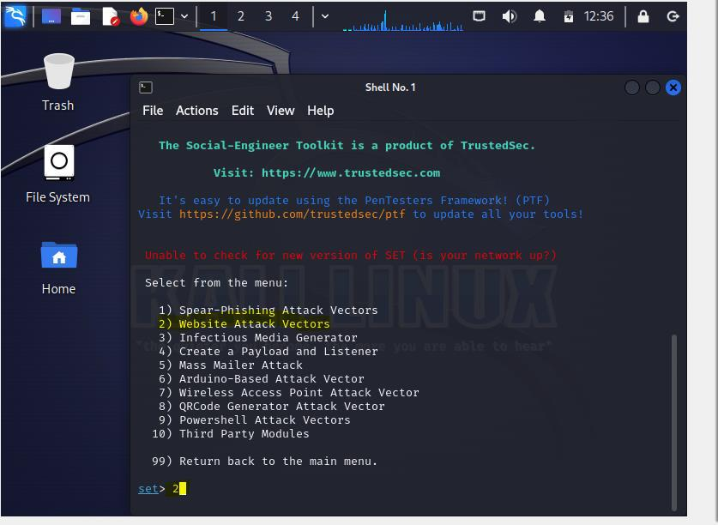

**Step 4: Select Credential Harvester attack method**

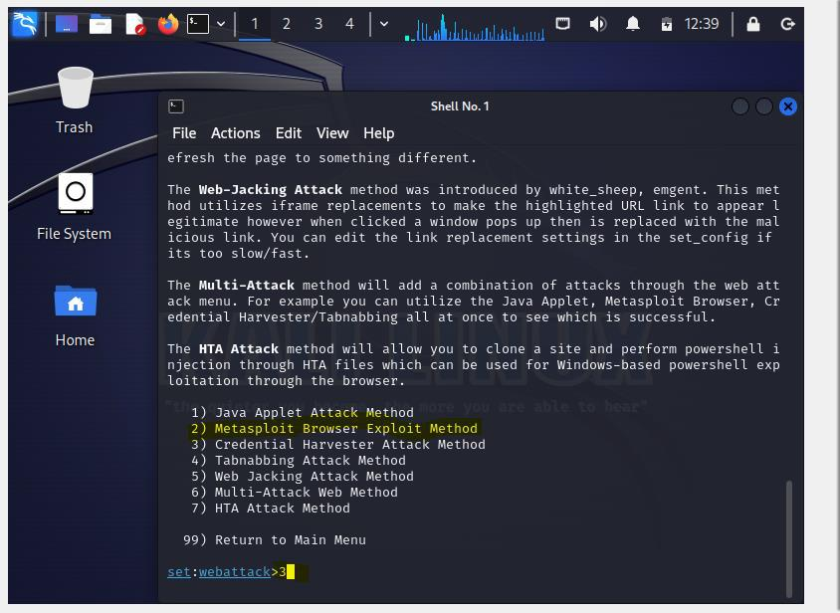

**Step4: Select option 2 Site cloner.**

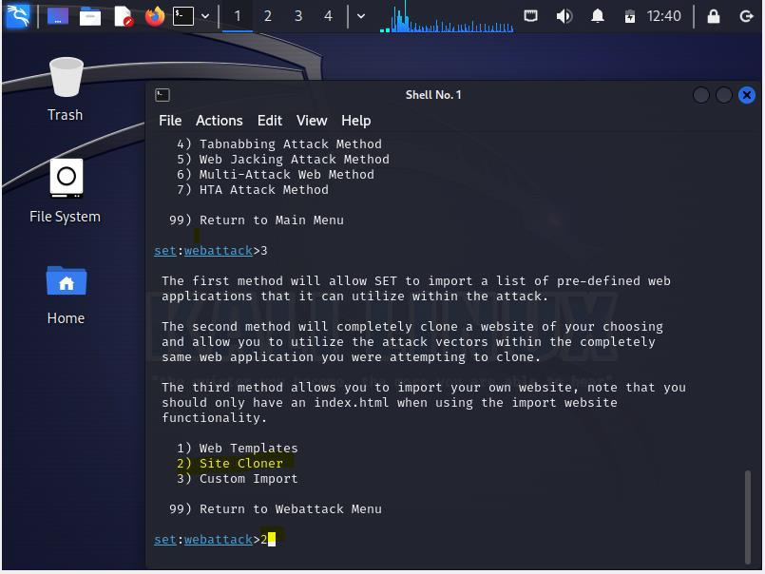

**Step 5: Enter IP of the local server and URL of the attacking site**

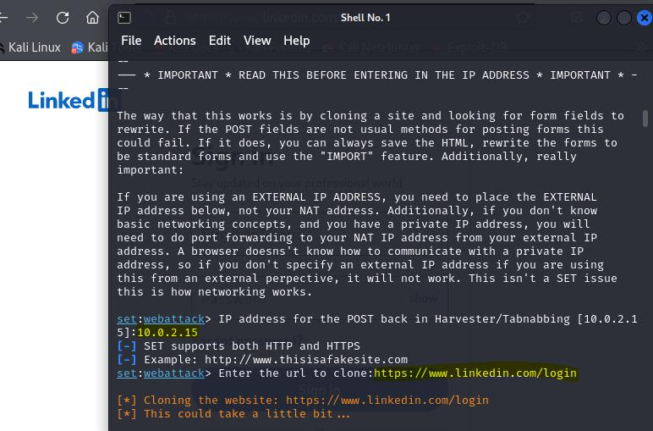

**Step 6: now enter the ip in the browser, you will find clone website:**

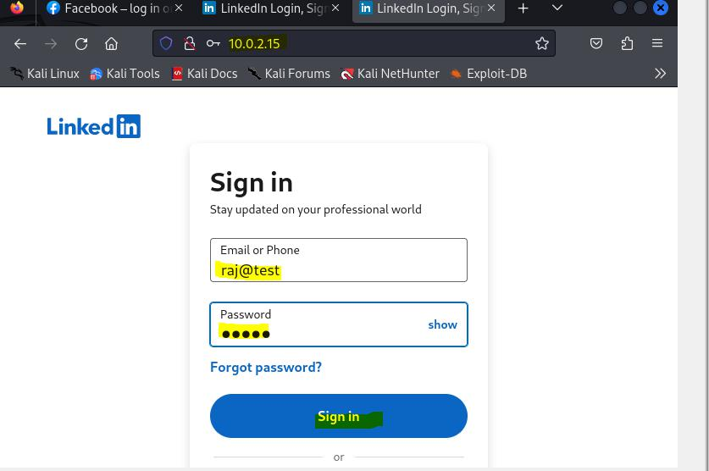

**Step 7: You can see in the terminal the user id and password is being displayed.**

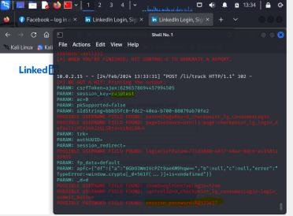

**Step 8: Post the attack user is redirected to the original site:**

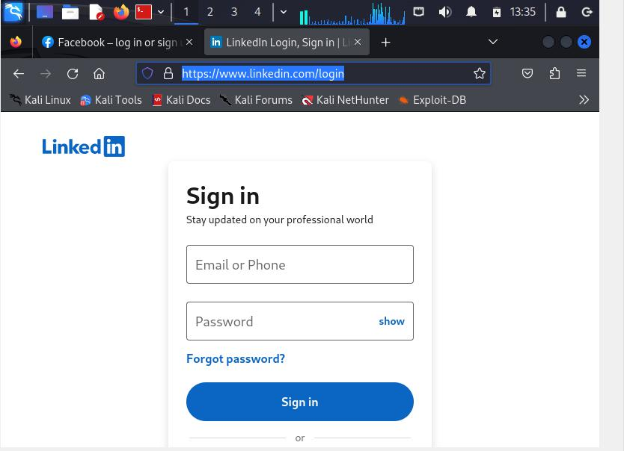

**b. Aim: Perform the DDOS attack using the following tools**

1. **HOIC**

Step 1. Open hoic2.1.exe, once it open click on the “+” button

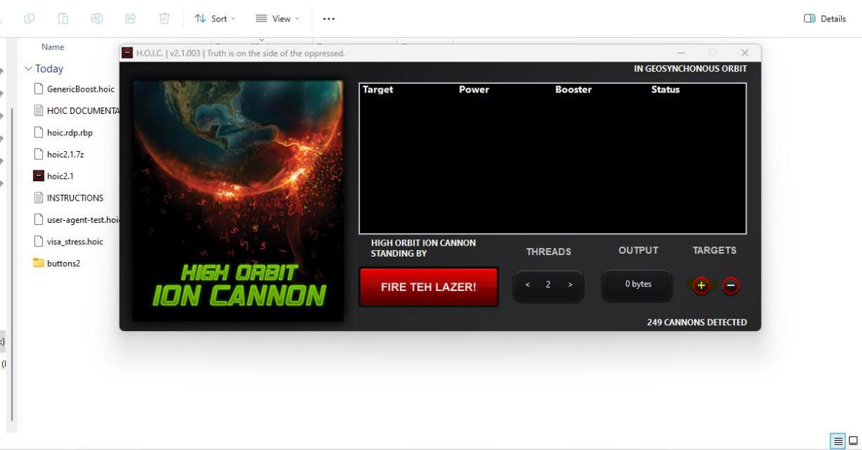

**Step2:** enter the url you want to attack, then click on add button.

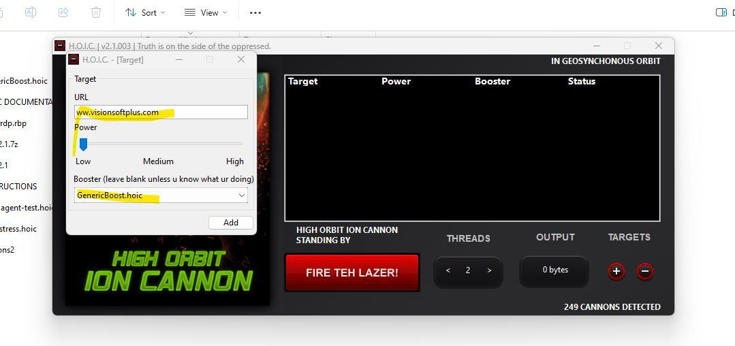

**Step 3: Click on fire button to attack**

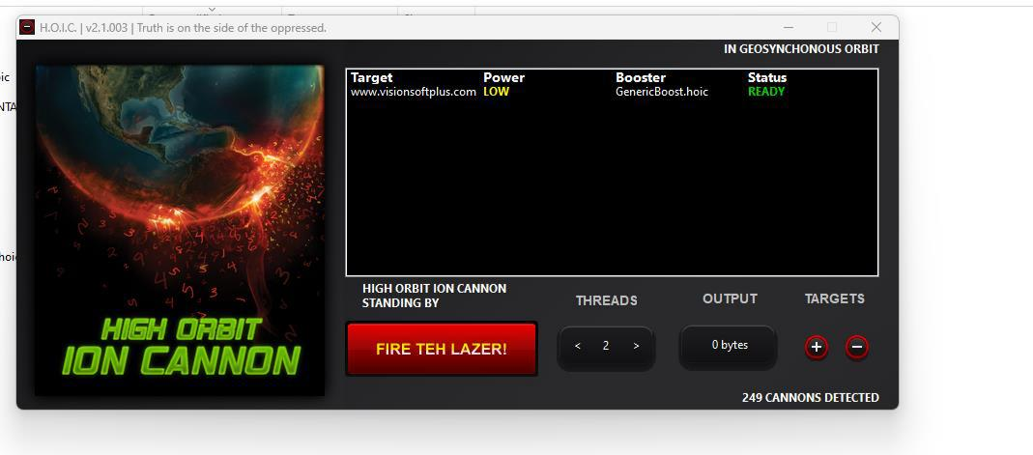

**Step 4:** you can see the attack is carried on and check the same on wire shark also

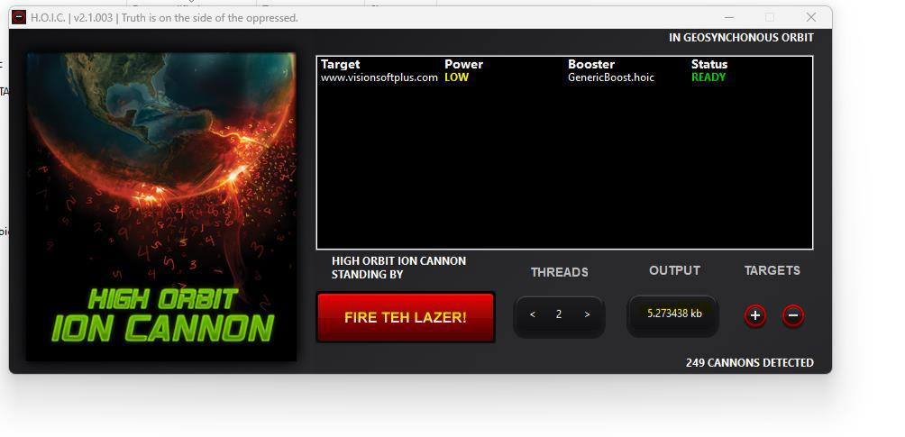

**Step 5:** To stop the attack again click on the Fire button.

1. **LOIC**

**Step 1. Click on the loic.exe:**

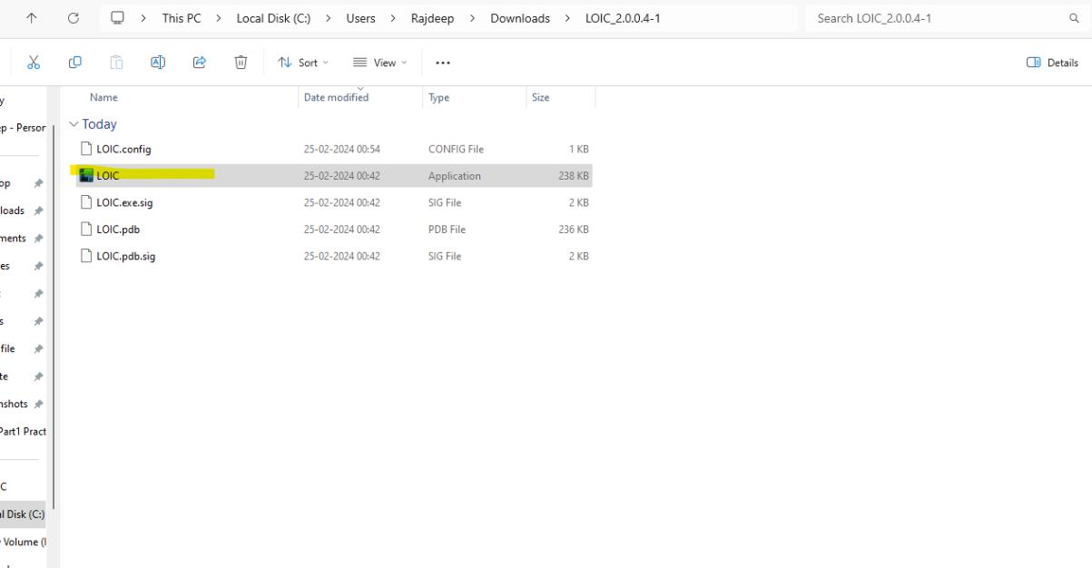

**Step 2**. Enter the URL click on Lock On button, change the parameter Like speed, method, number of thread, timeout. And the click on IMMA Chargin button.

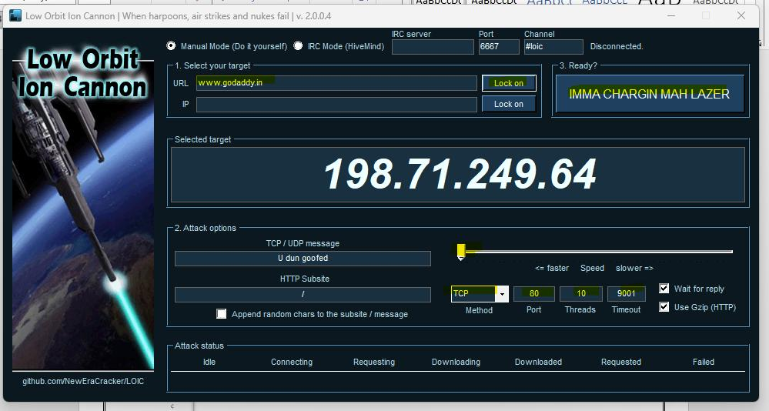

**Step 3: You can see the number of requests getting hit. Click on Stop button to stop the DDOS attack.**

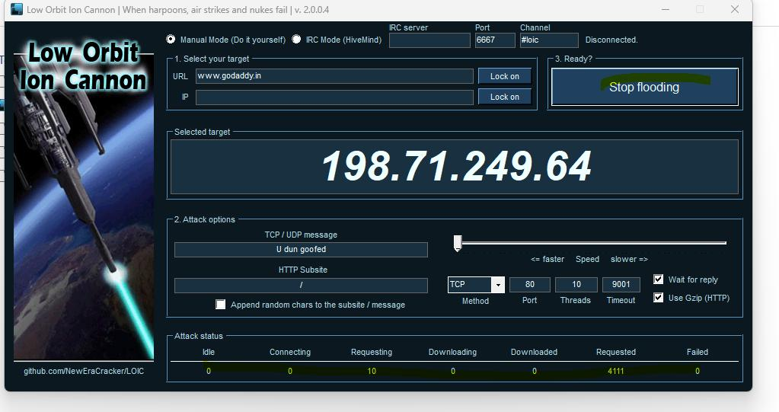

**C. Aim**: Using Burp Suite to inspect and modify traffic between the browser and target application

**Application name** : Burp tool

1. Open Burp Tool: Click on next

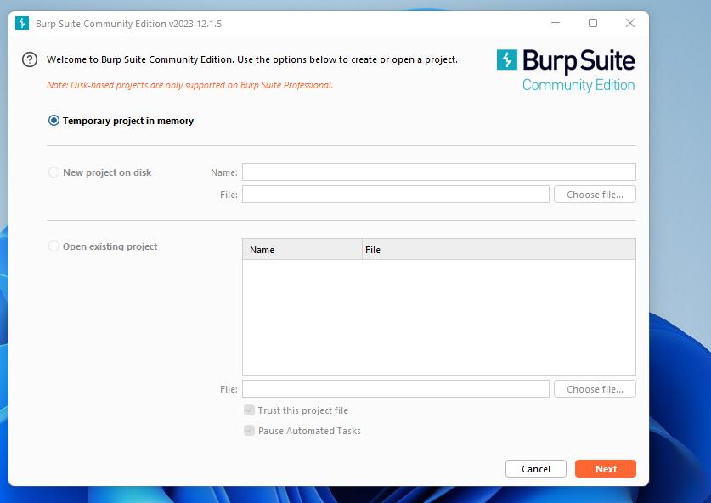

2. Click on start Burp

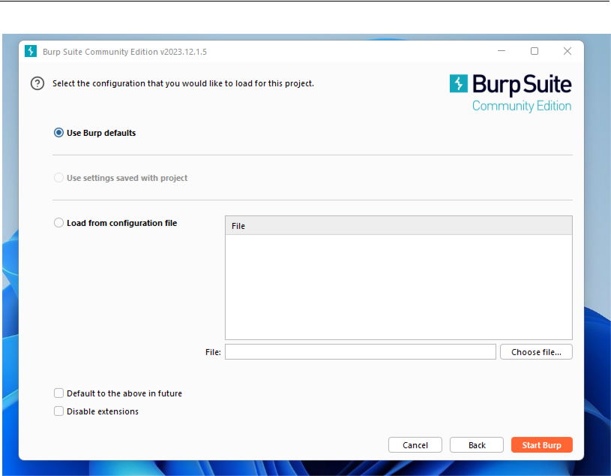

3. Select Proxy in the tab:

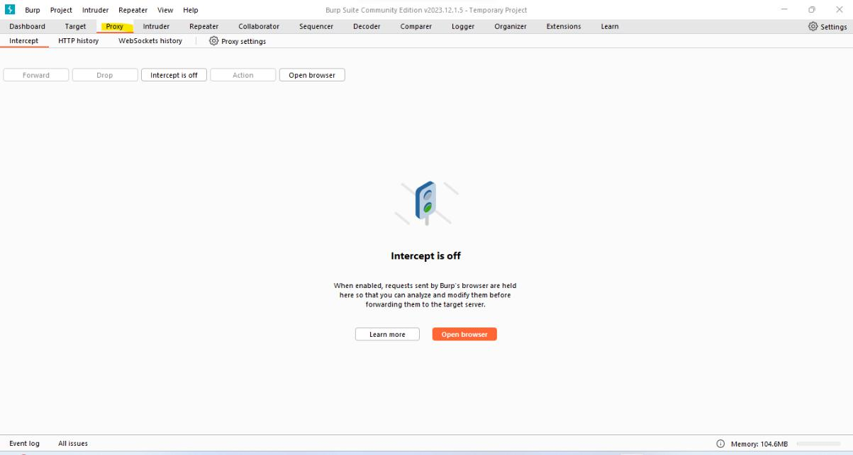

4. Go to proxy setting:

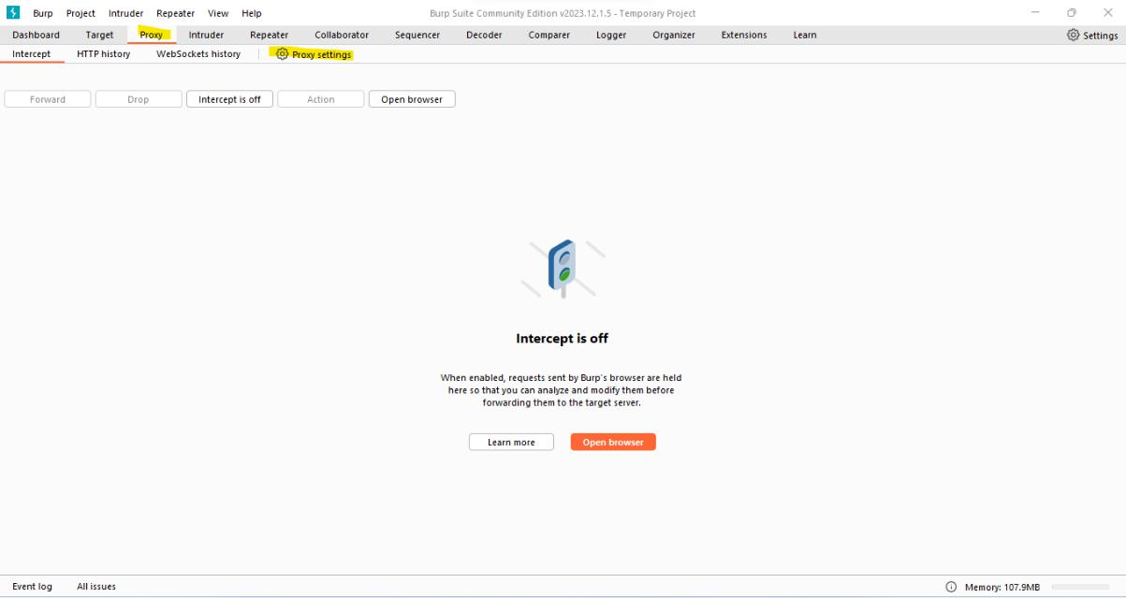

5. Click on Edit:

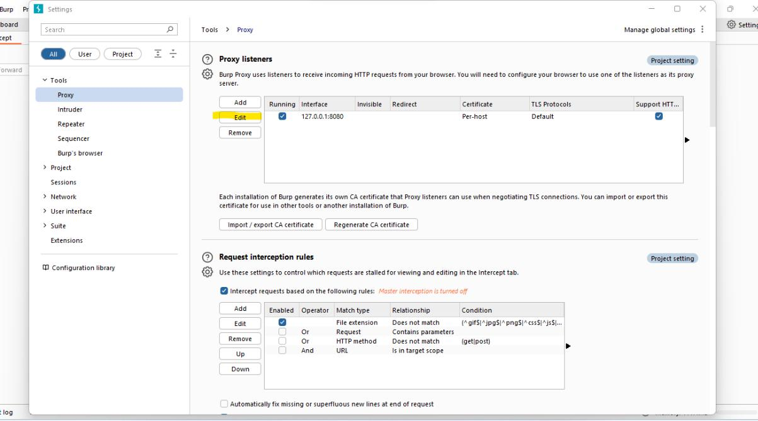

1. Change the port number in our case its change from 8080 to 9000. And then click on OK.

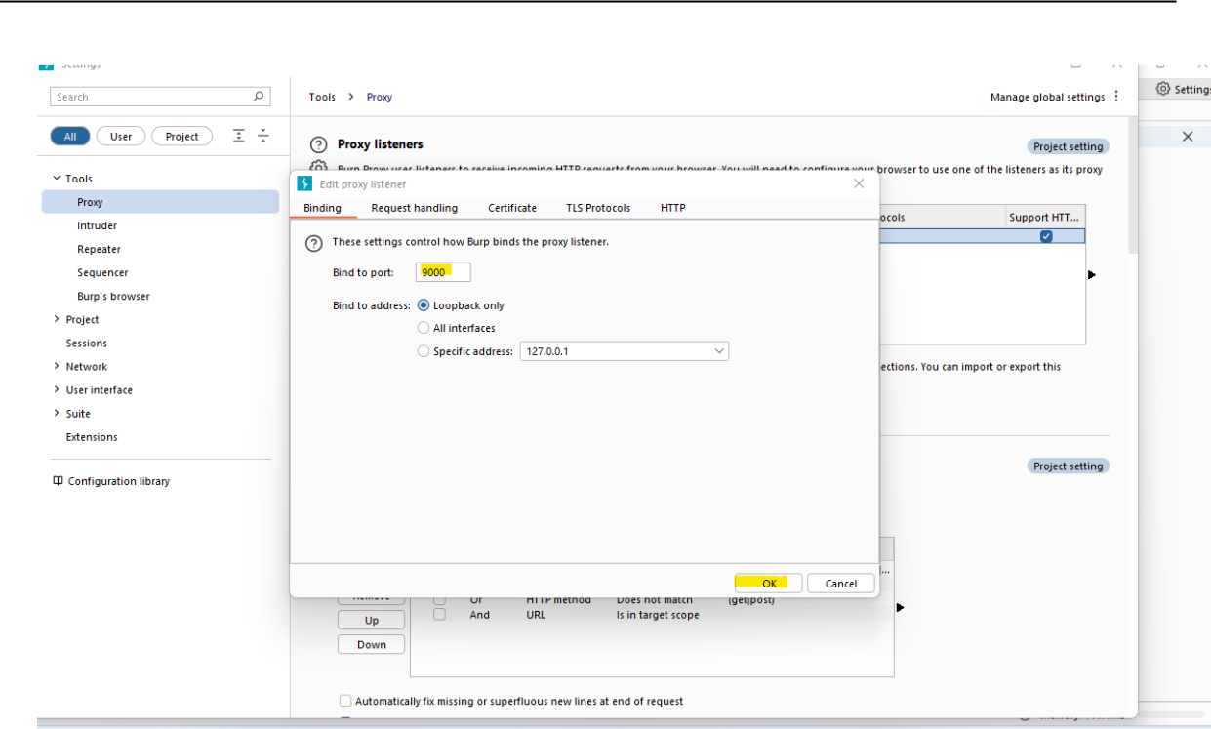

1. Now go to the firefox browser: goto settings or preference depending on the version:

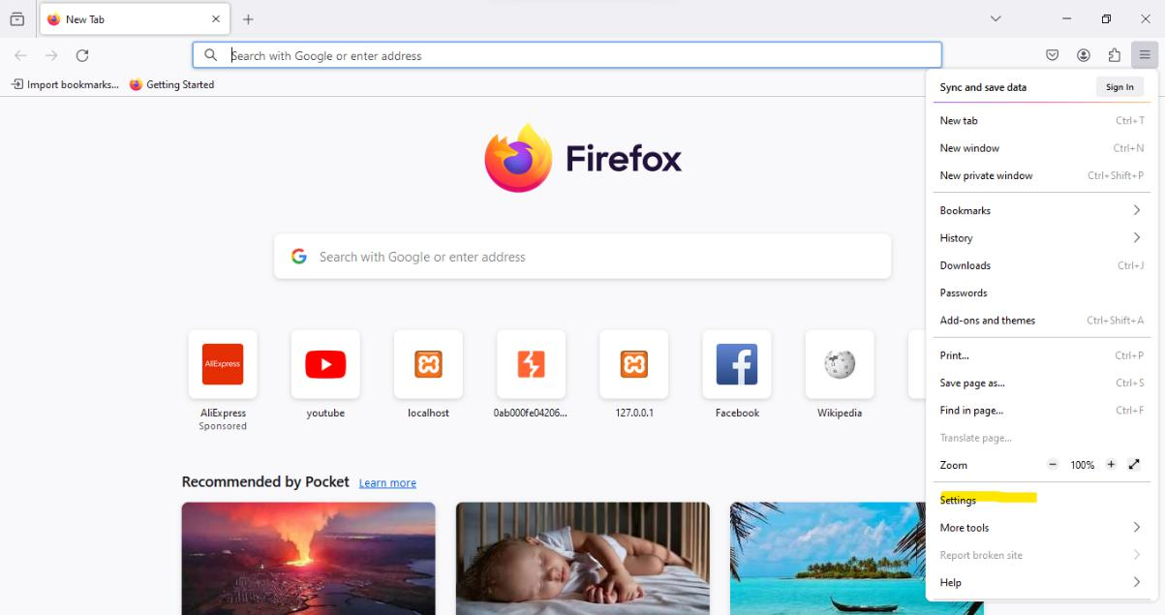

1. Search for proxy in the search bar and then click on setting:

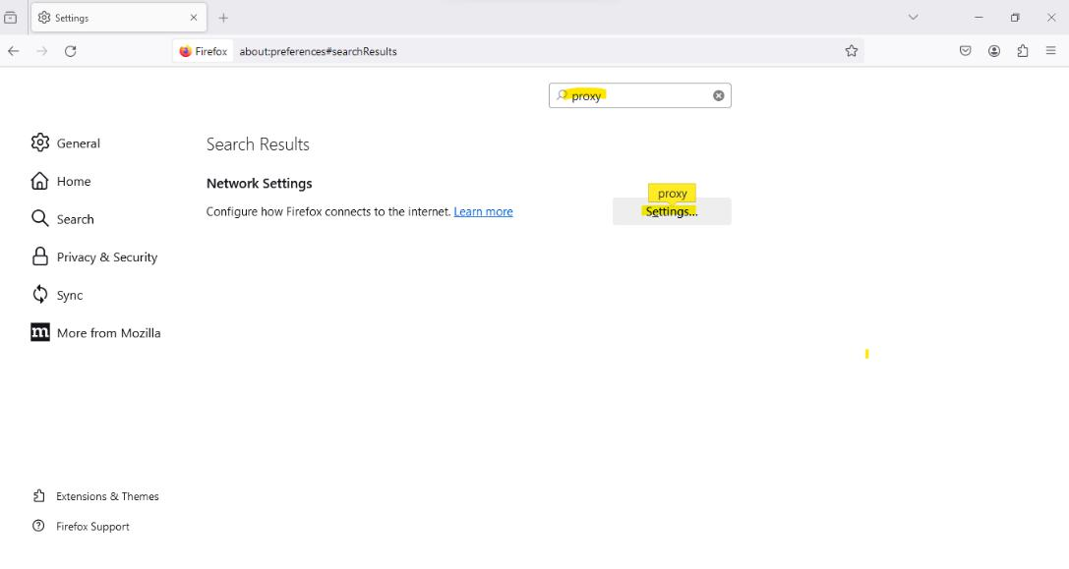

1. Now do the following steps: a. select manual

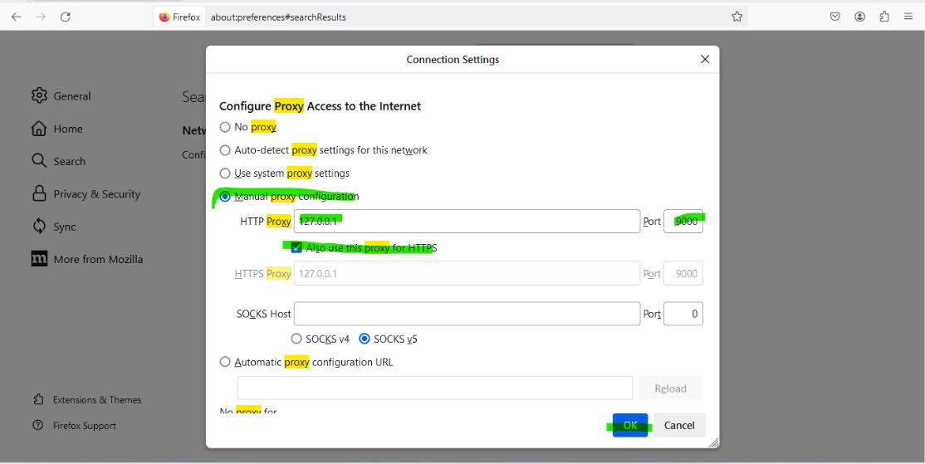b. Enter ip as 127.0.0.1 and port as 9000. c. select option also use this proxy for HTTPS d. click on ok

1. Now go to firefox search bar and type “about:config”. In the screen click on “Accept the Risk and Continue”.

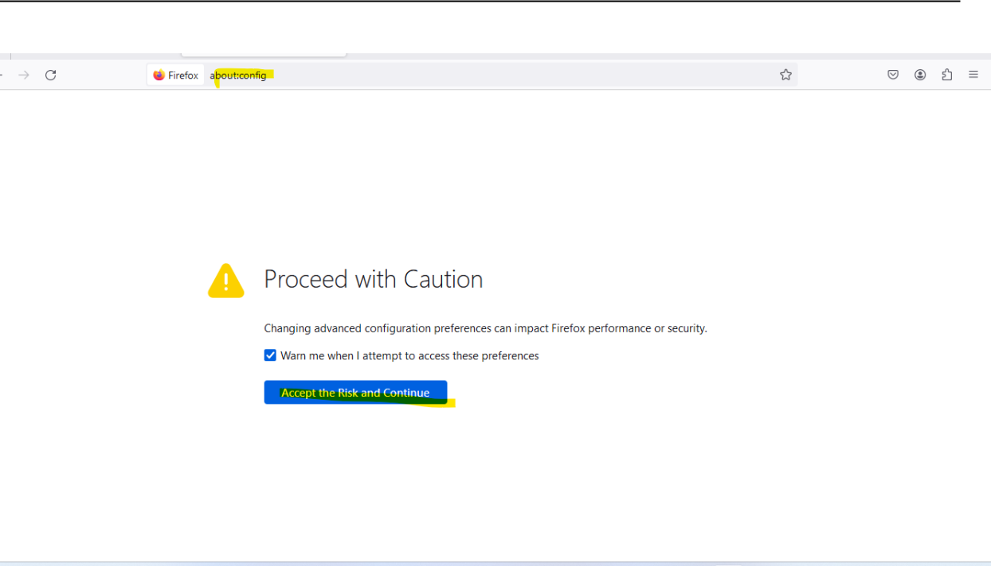

1. Enter: “network.proxy” and select the option as per the image below, click on the right side button to make the value true:

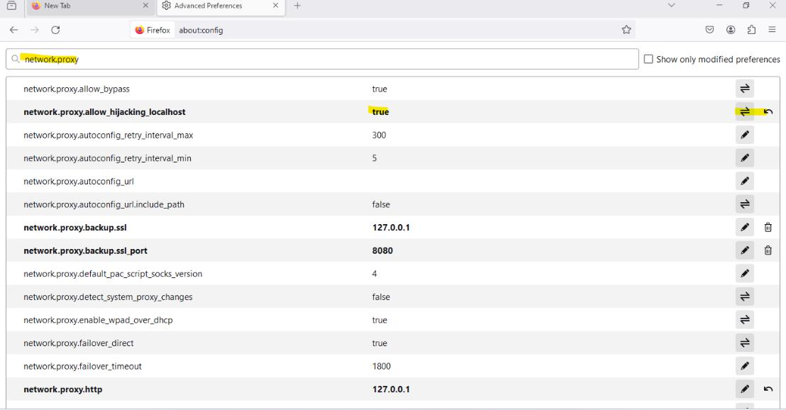

1. go to web security academy, login and select academy go to:
2. scroll dow click on all path button:

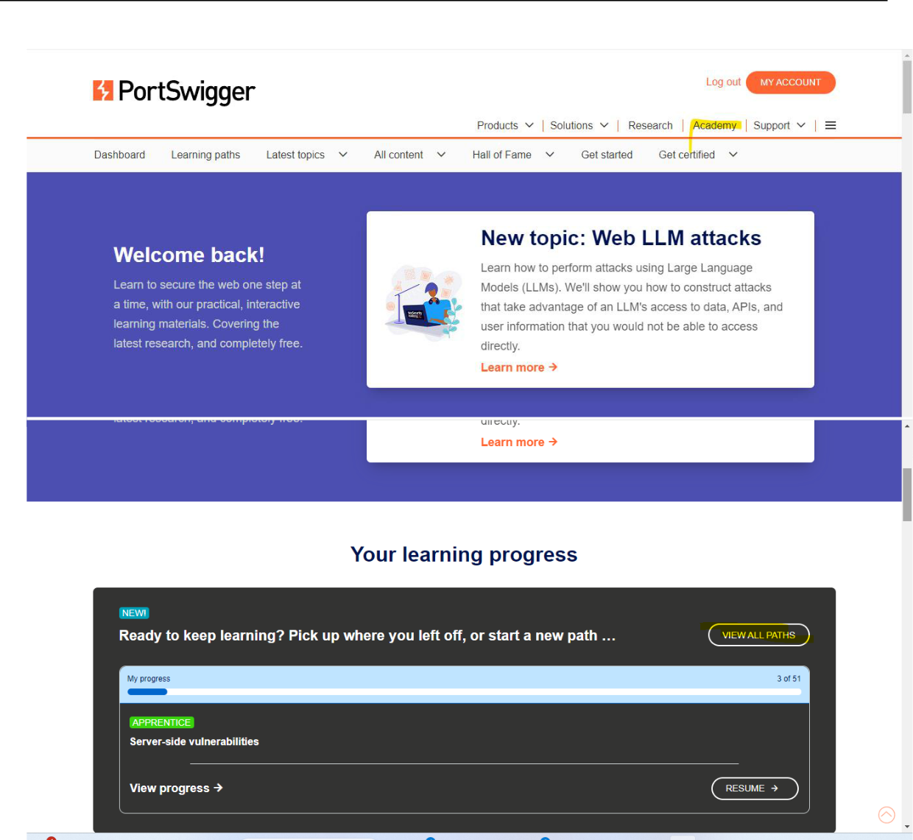

14. click on button “resume” on server side validation section:



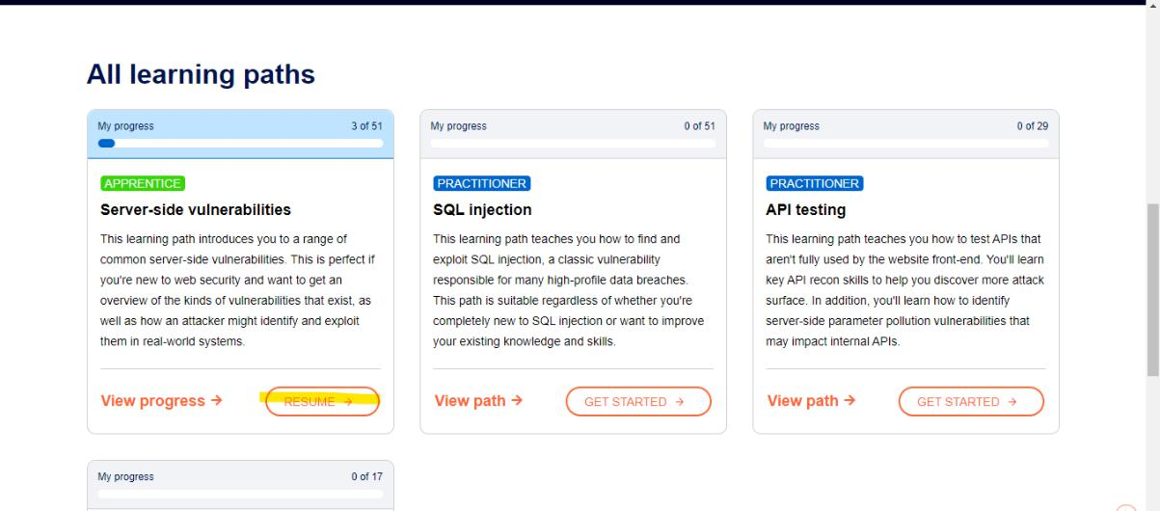

15. click on access Lab:

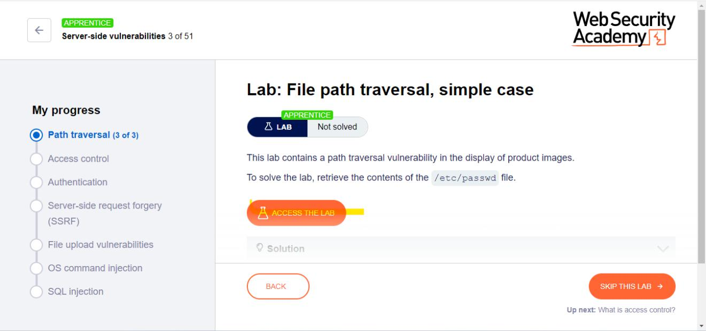

1. Once the lab is open click on start the interception on in the burp tool. Note in he browser you will find page is not loading.

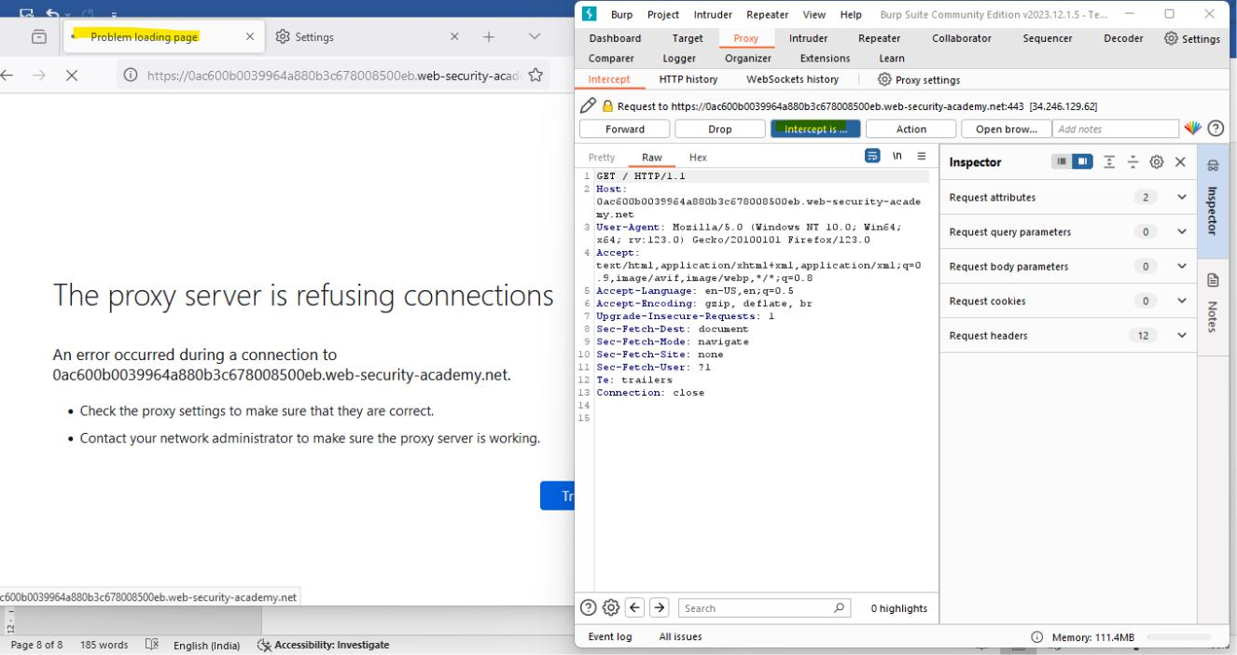

17. To load the field click on forward button.

Note you will have to click multiple time to load the entire page.

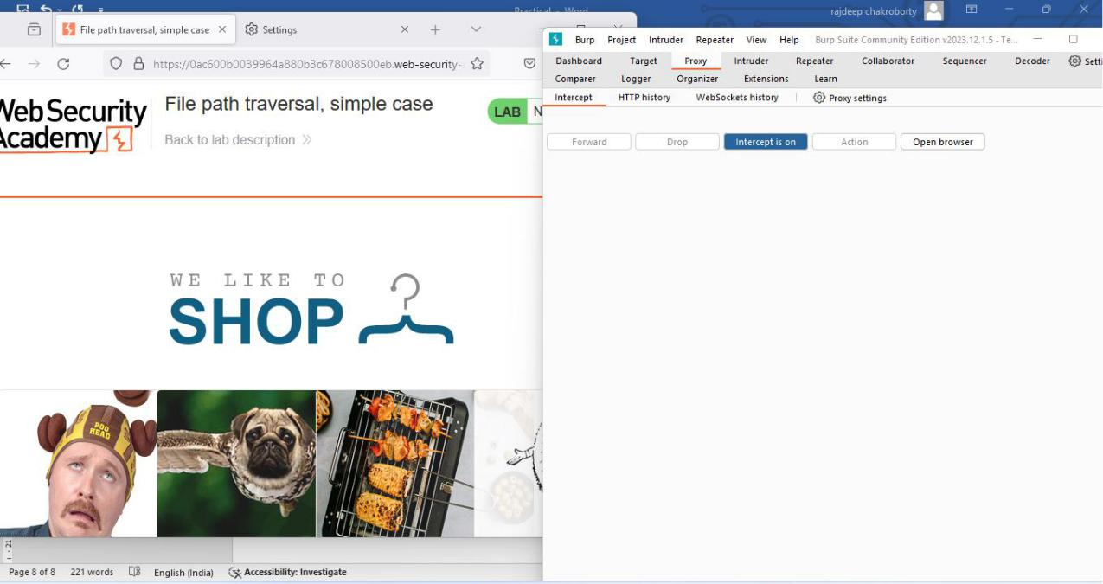

18. click on the first grid view details button:

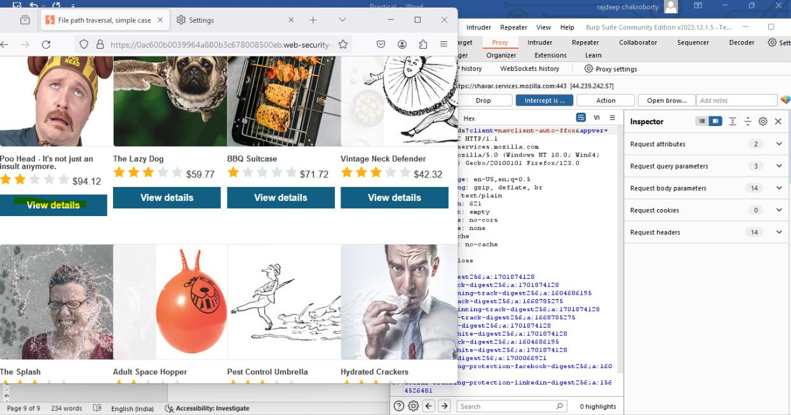

19. Click forward on the burb application, go to request query parameter:

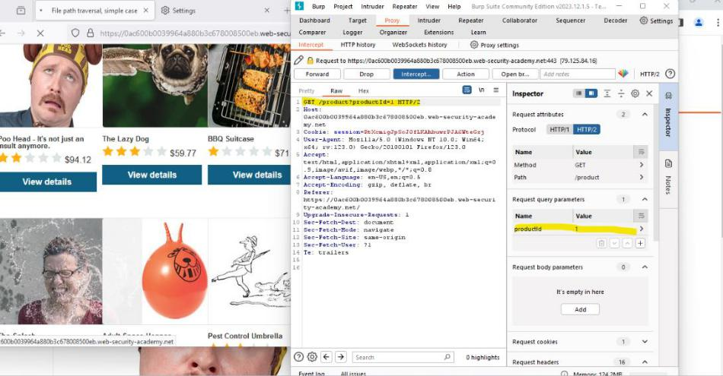

20.change the value of the productid to 3. Click on apply changes:

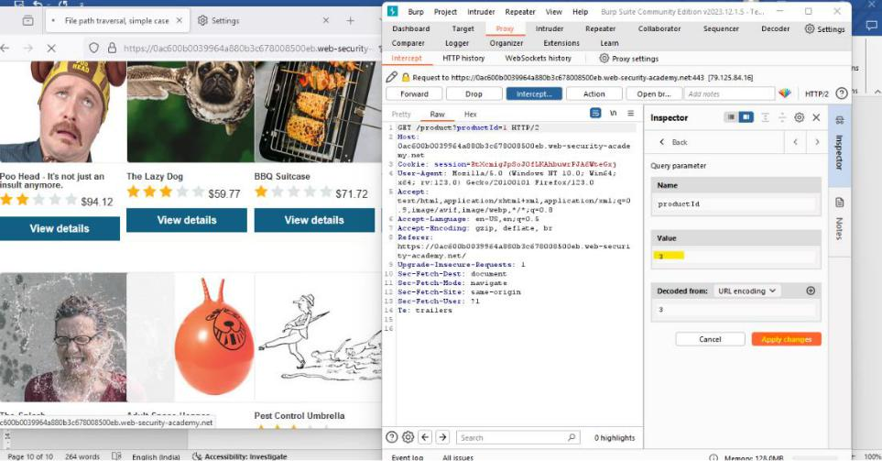

21.Then click on forward you will observe, page for item 3 will open instead of 1.

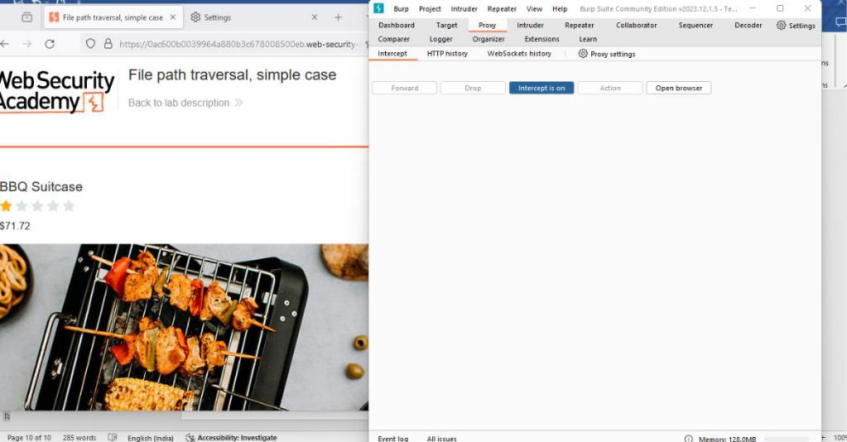

**Section 3 B.**

1. a. Perform Web App Scanning using OWASP Zed Proxy.

**Step 1. Open** Zed Proxy, click on quick start enter he URL and click on attack.

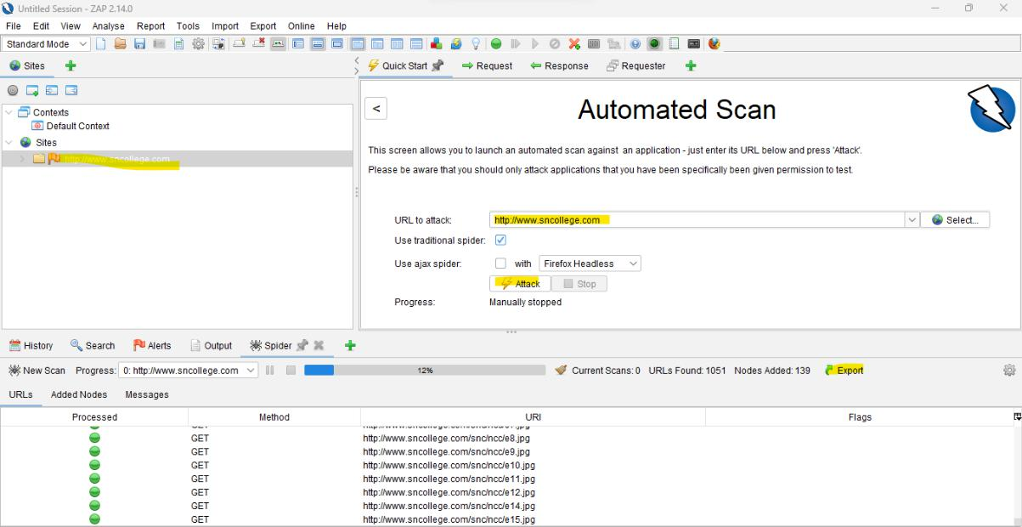

**Step 2:** go to report generate report, click on generate report:

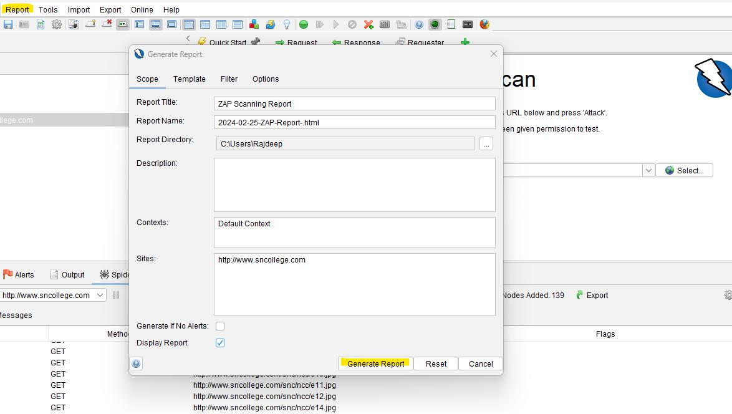

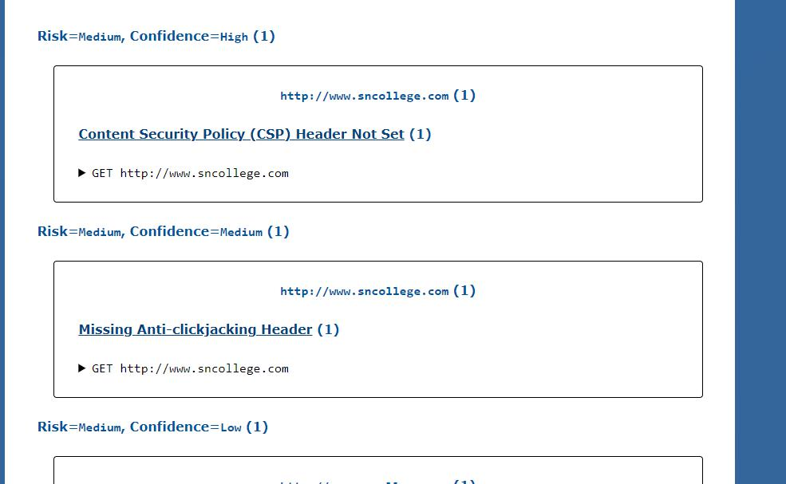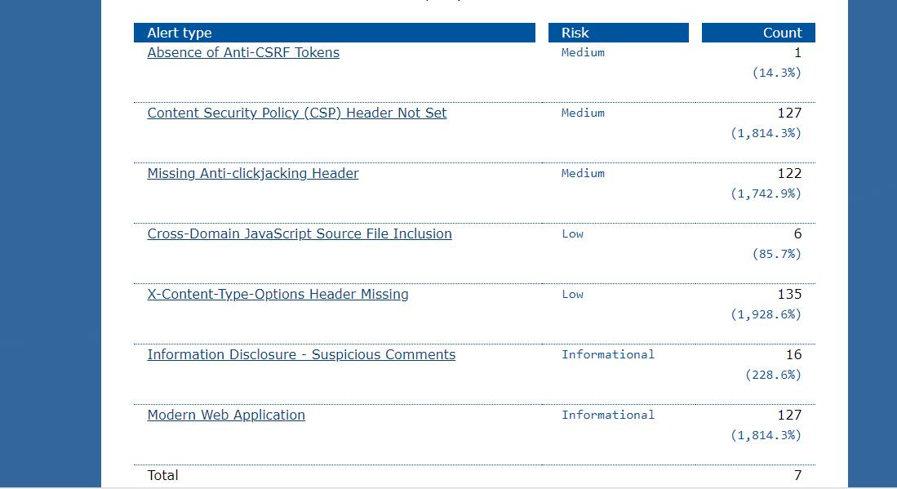

                                                                119

1. **Demonstrate the use of the following firewalls**
   1. **AIM: Zonealarm and analyse using Firewall Analyzer.**

**Step1:** Open zone alarm, click on firewall:

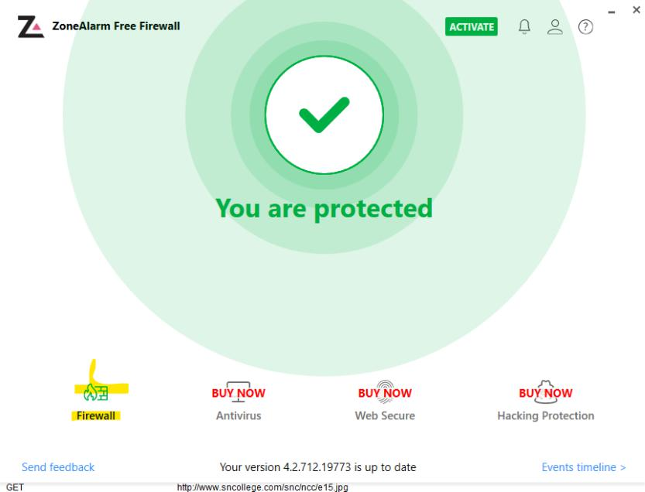

**Step 2:** Select Zone Rule: You can add/update new rule:

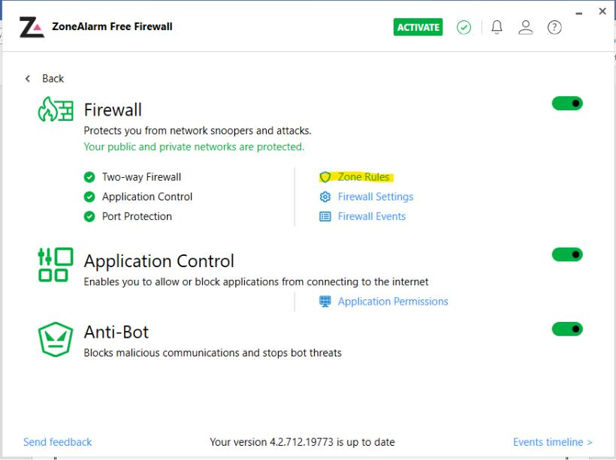

                                                                120

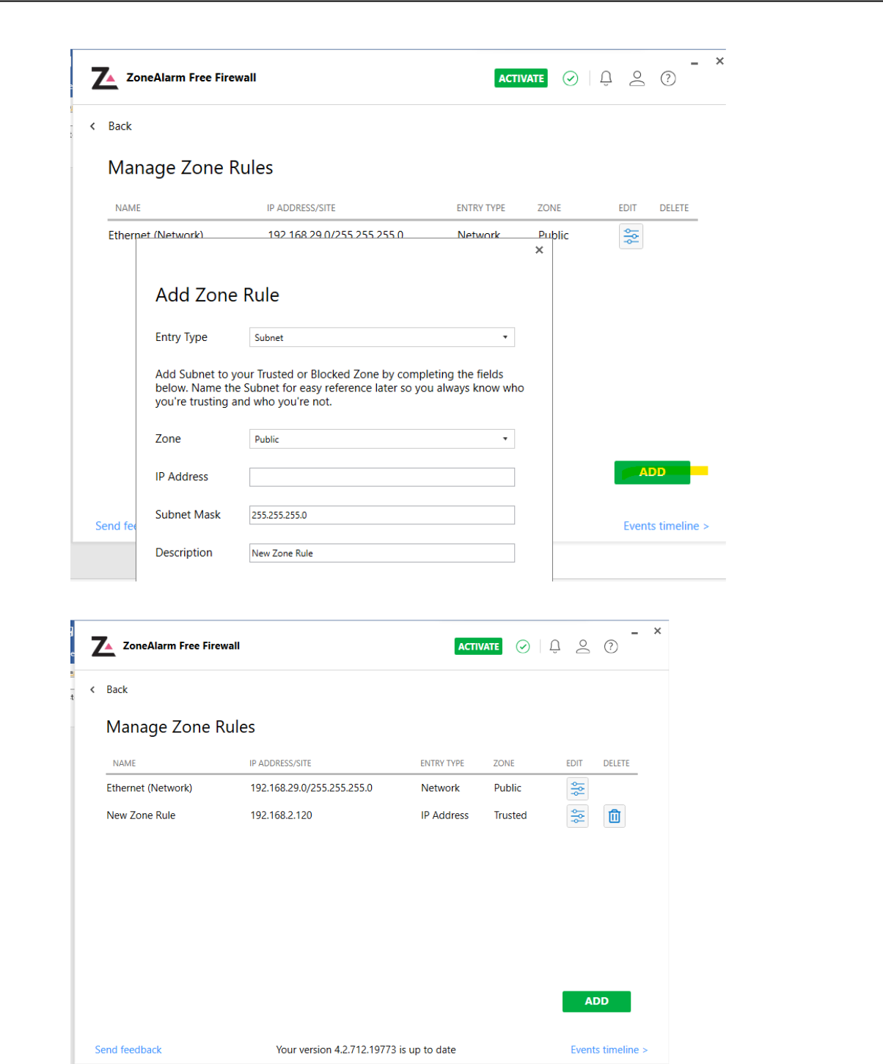

Step 3: You can select Firewall setting:

                                                                121

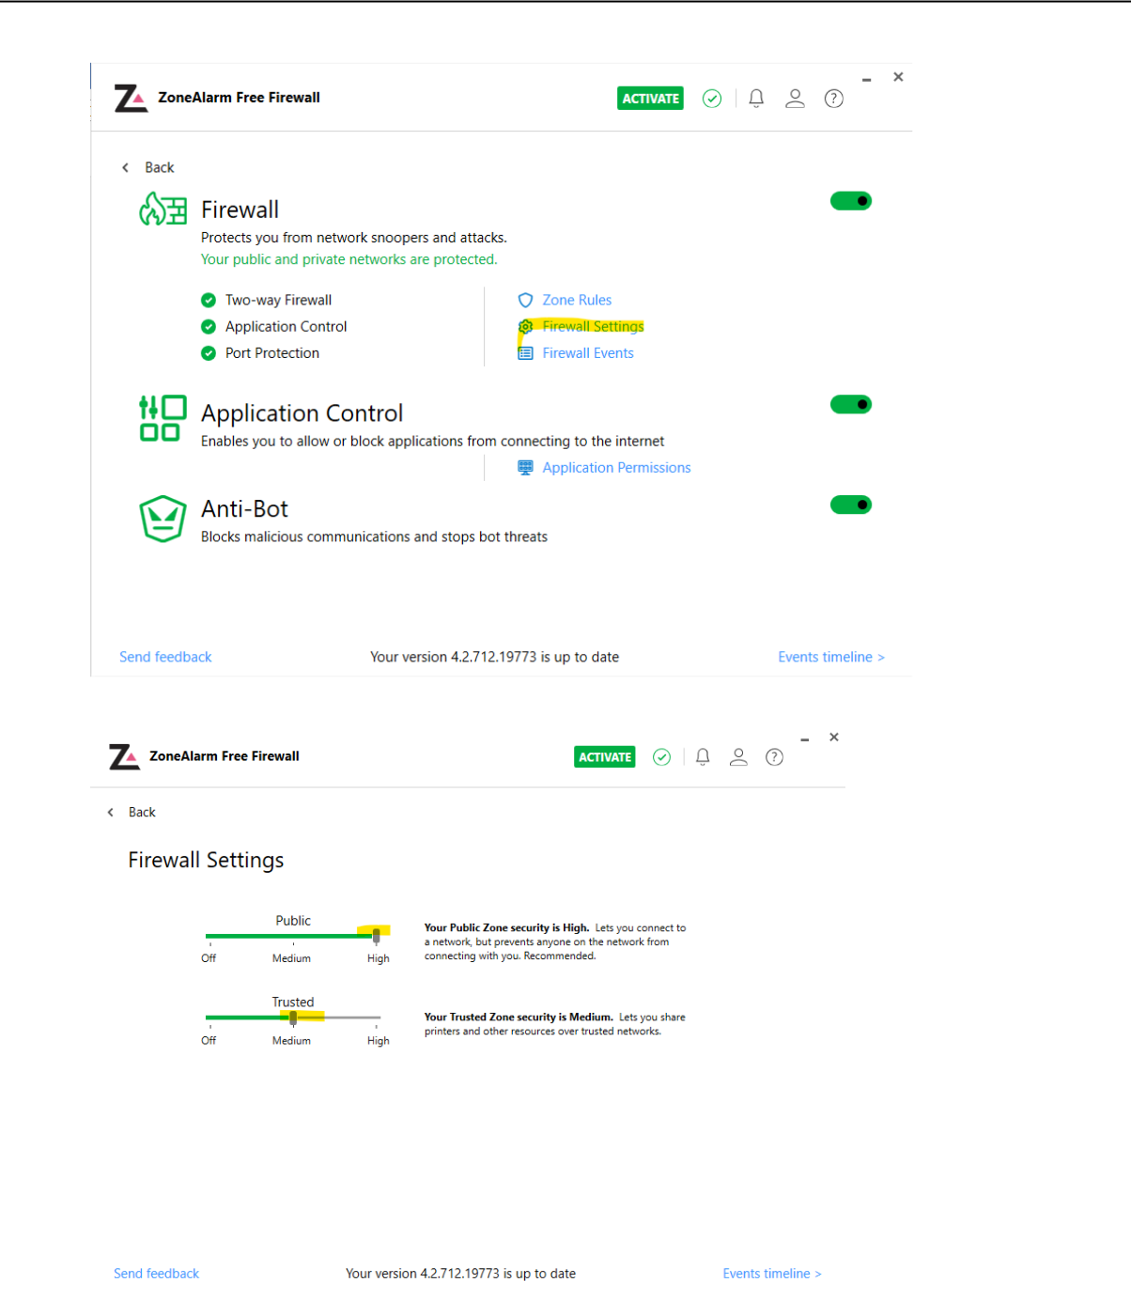

                                                                122

1. **Comodo Firewall:**

**Step 1: Open comodo-> go to firewall.**

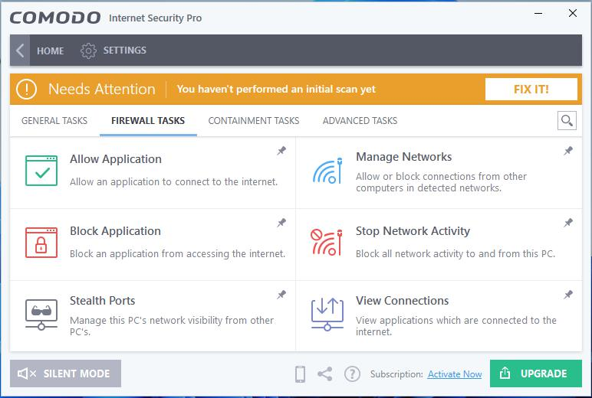

**Step 2** : You can select and perform different Network activity like

a. Manage network: Like trust or block any network:

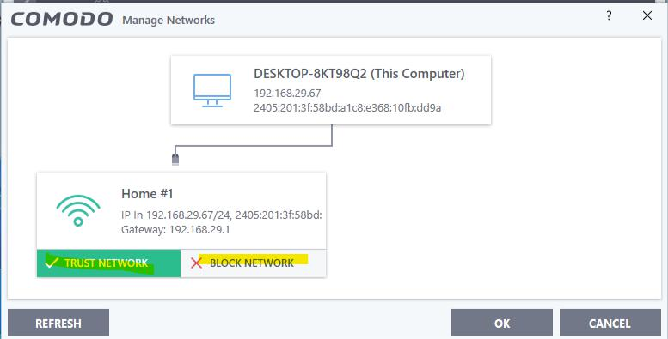

B. allow or block any application by selecting application path:

                                                                123

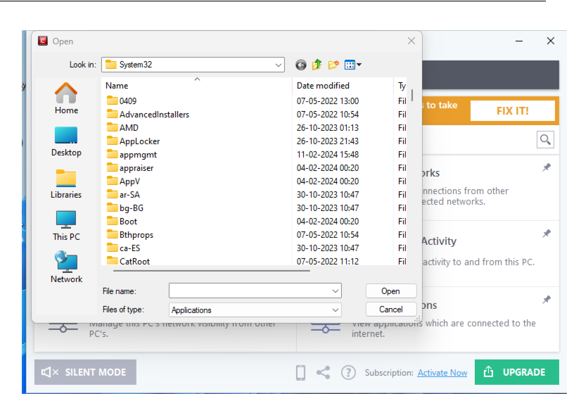

c. Allow or block network traffic in our machine:

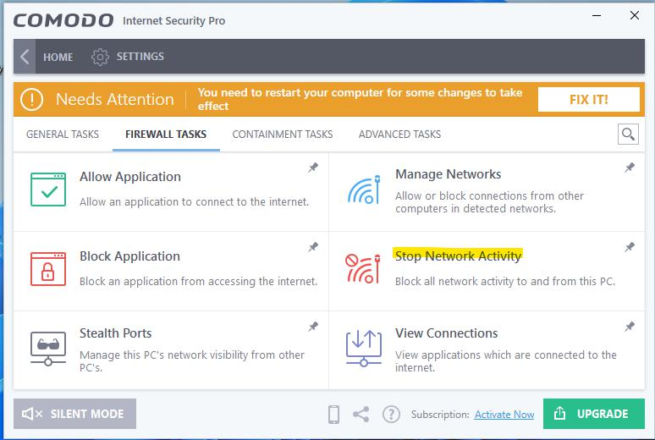

d. Sealth mode: allow or block on incoming network:

                                                                124

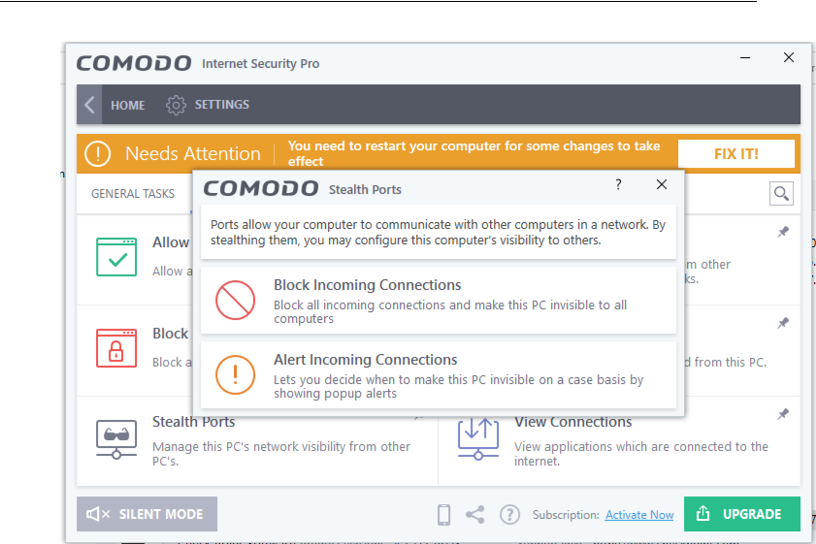

e. View Connection: View all the connection in the network:

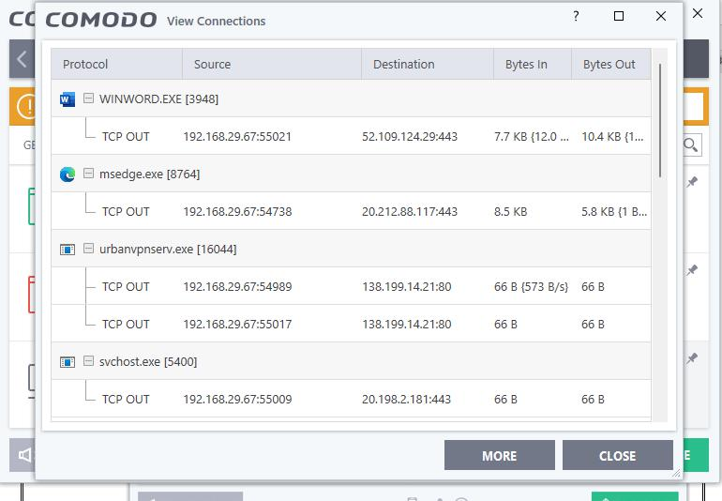

                                                                125

**Step 3:** Go to firewall setting:

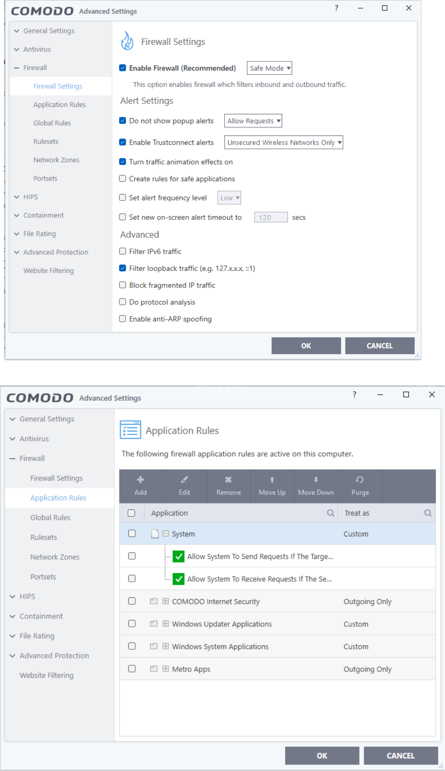

**Aim:** Use HoneyBOT to capture malicious network traffic.

1. Open HoneyBot click on start icon.

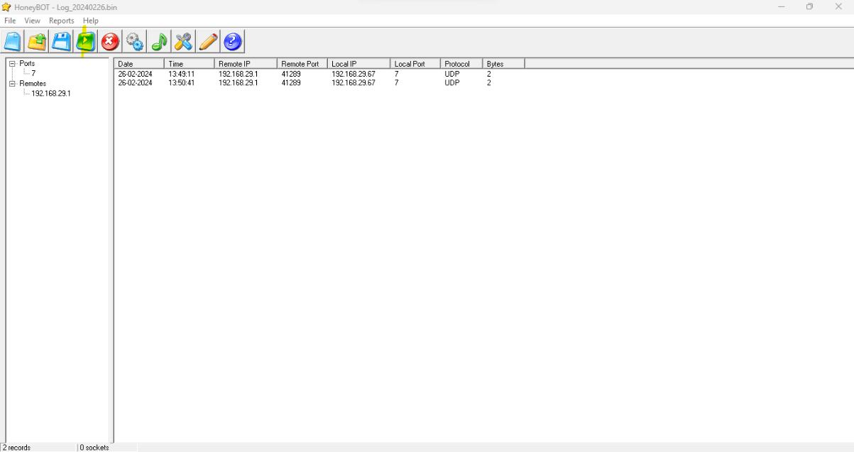

Step 2 :Double click on any one of the ip list:

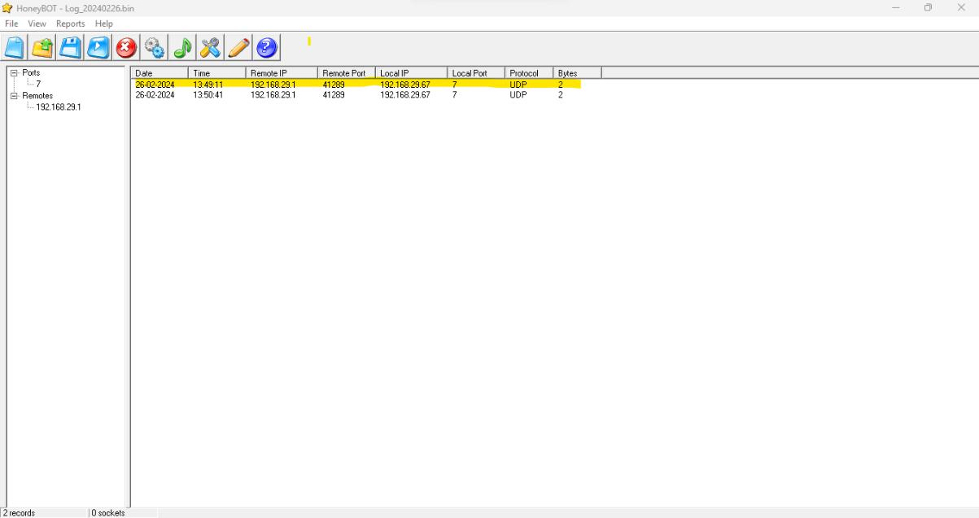

Step 3: Select any of the packet , then select from the option of text or hex format to see the output.

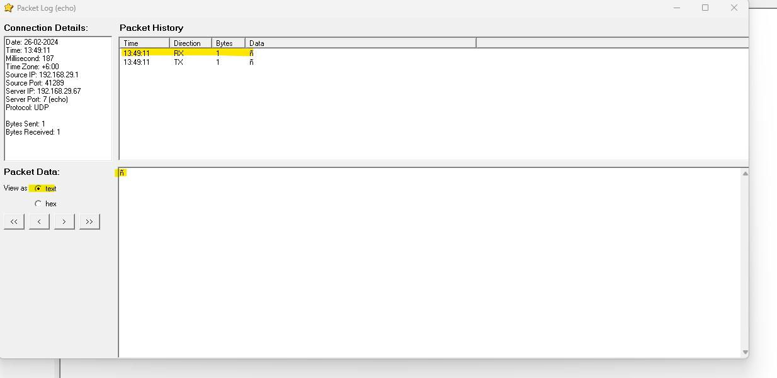

**D.Use the following tools to protect attacks on the web servers:**

1. **ID Server**

**Step 1.** Open ID server. Click on “**Query the Server**” button and you will get the server details.

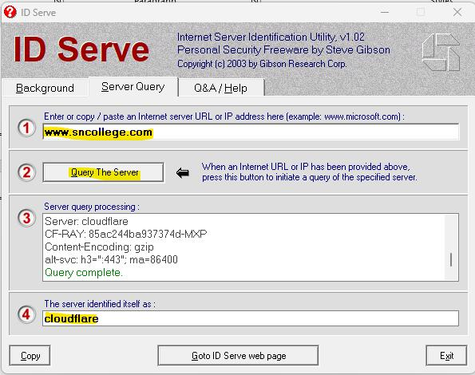

1. **Aim:** Microsoft Baseline Security Analyzer

**Step 1.** Open Microsoft Baseline Security application and click on scan a computer:

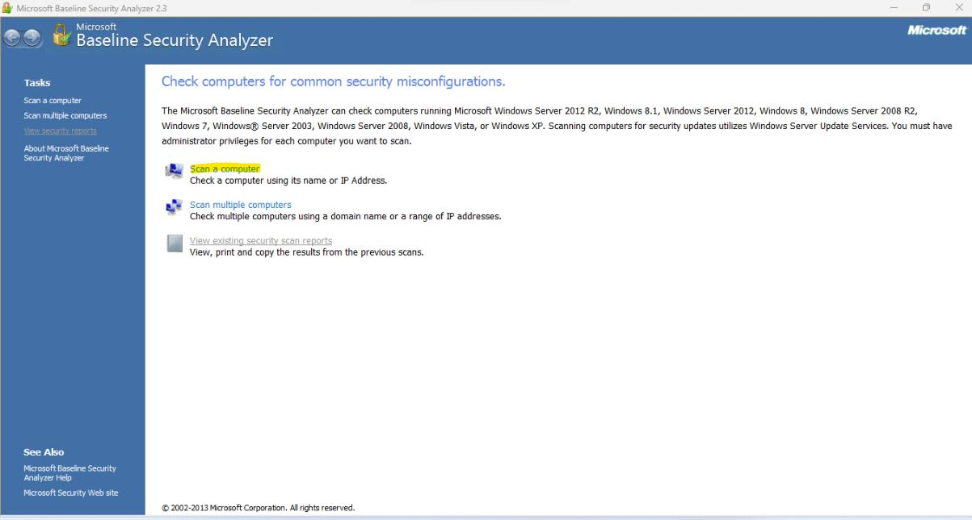

Step 2: Scan the computer or any computer in the network by providing IP, and giving report name. then click on start scan button:

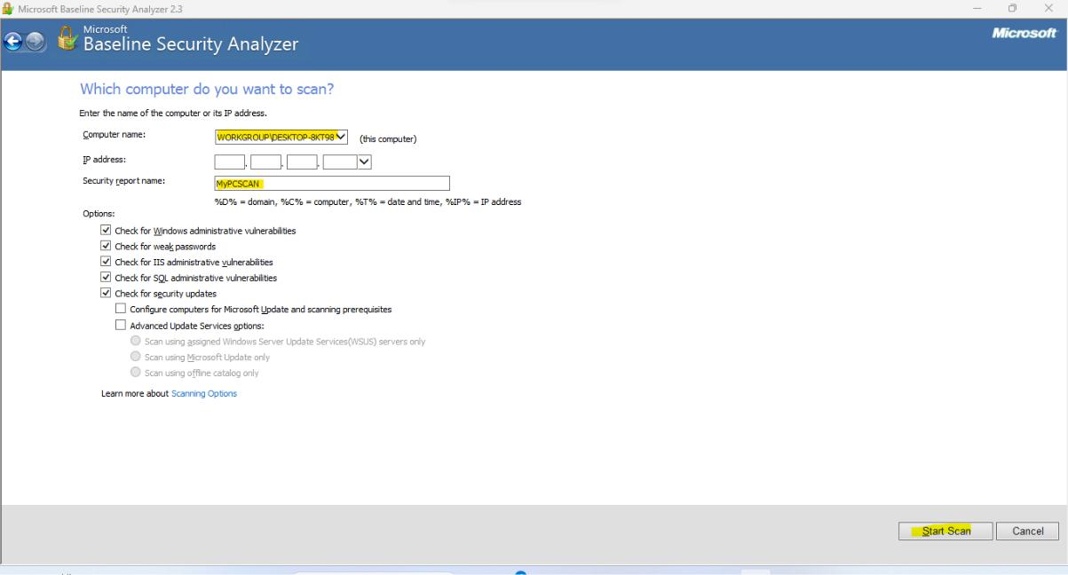

**Output**: You will get Report for the Scan:

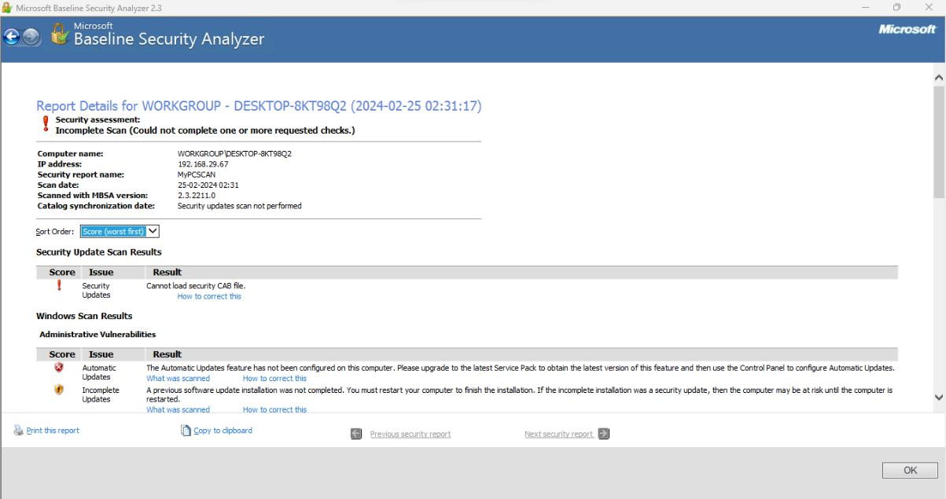

1. **Syhunt Hybri**

**Step 1:** Open Syhunt hunt Appliation -> go to Dynamic Scanner,

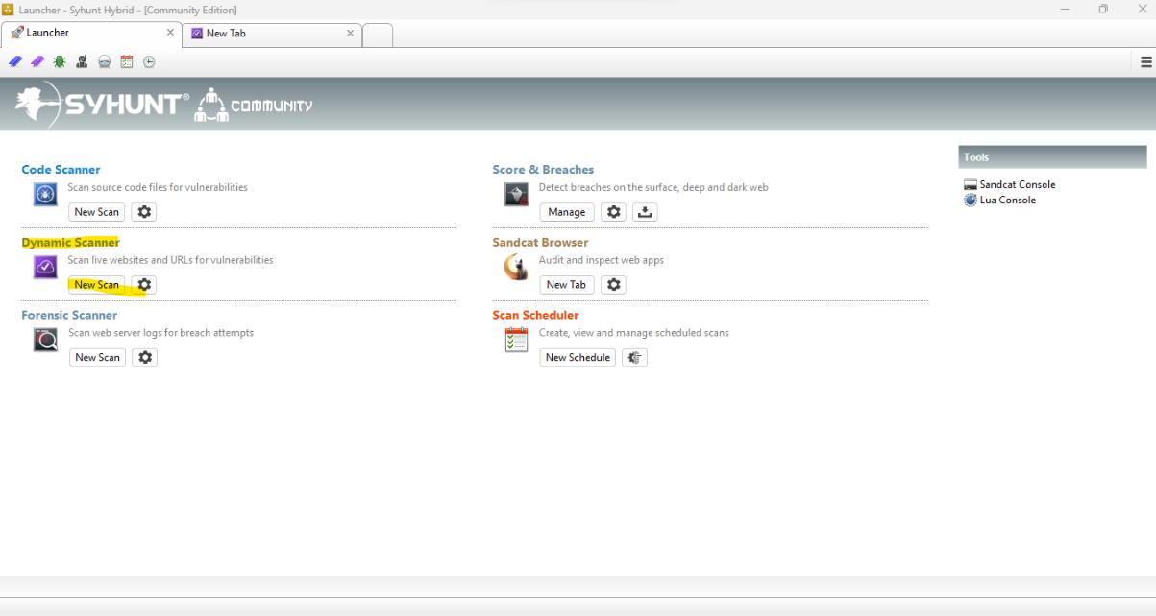

Step 2: Insert URL you need to scan and click on “Start” button:

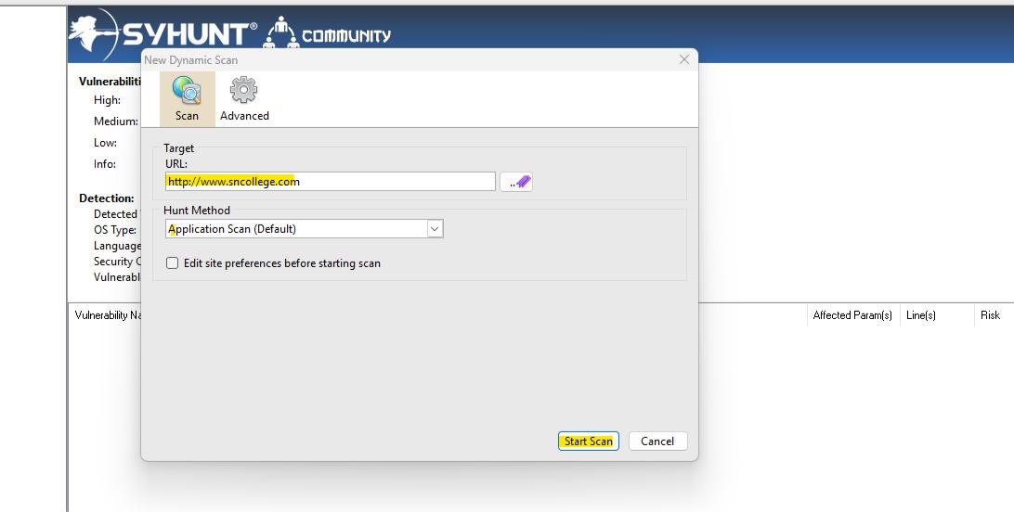

Step 3: Scanning in progress can be seen:

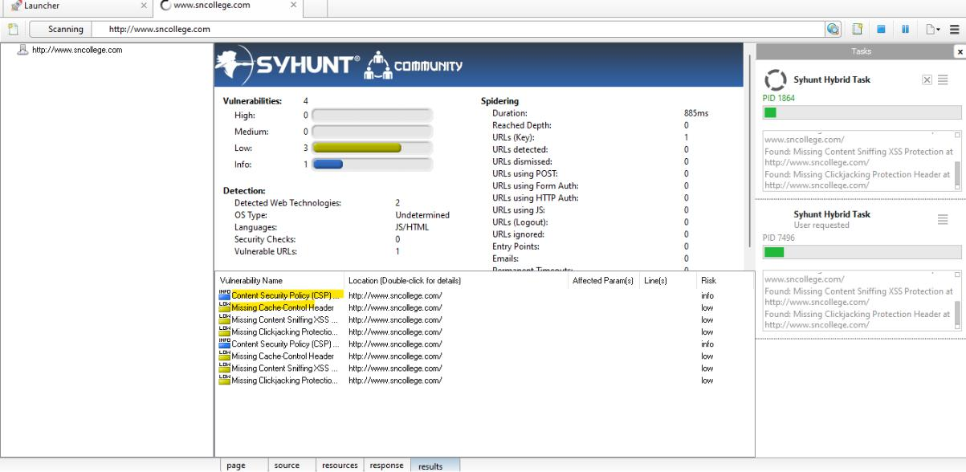

Step 4: Generate report by clicking on “generate Report” button:

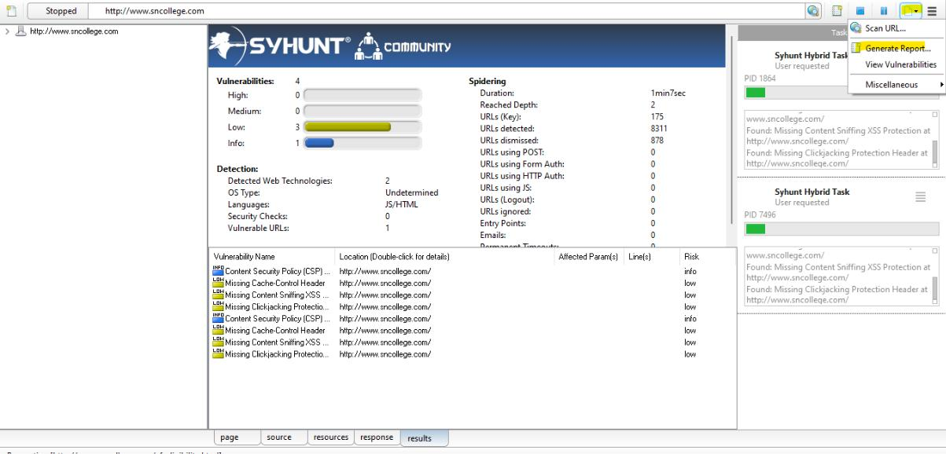

Step 5: Select the format or repot and click on Save:

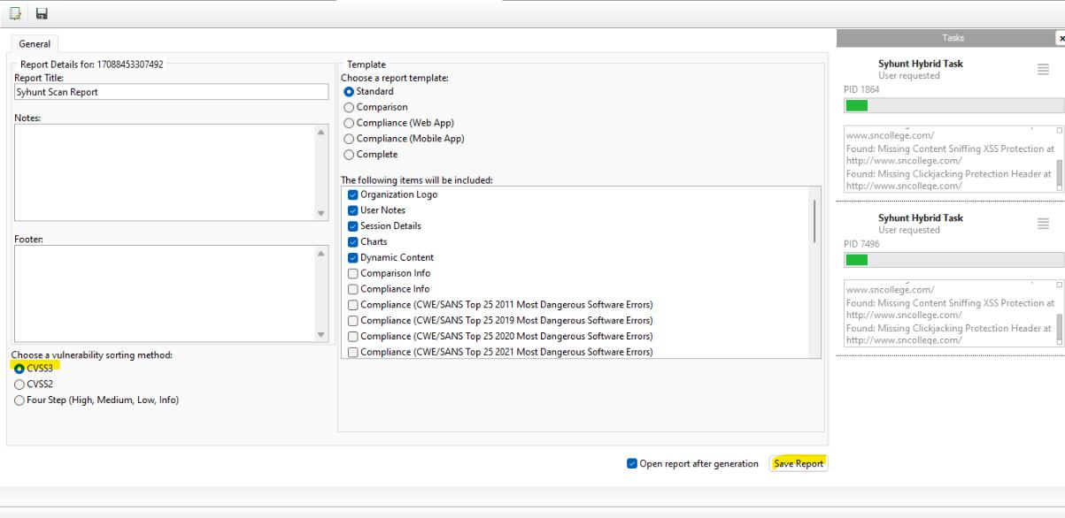

                                                                135

**Section 3 C**

1. Tyrant SQL

Tyrant SQL is a Havij based cross-platform. It's Sqlmap's gui version. Follow the below process to run the Tyrant SQL :

Step 1. Install below software and package:

->Python 2.7 Site: <http://www.python.org/download/releases/2.7.5/>

->PySide 1.2.0 Site: <http://qt-project.org/wiki/Category:LanguageBindings::PySide::Downloads>

Step 2: Run the file from command promp

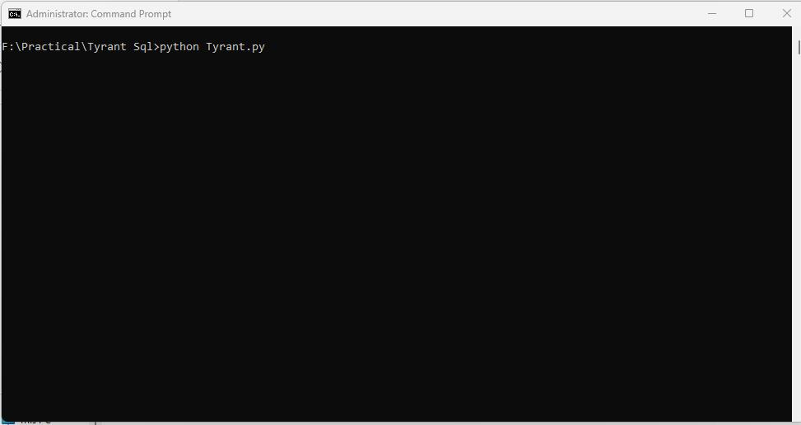

Step 3: Use the vulnerable URL in target :

Example: http://redtiger.labs.overthewire.org/level1.php?cat=1

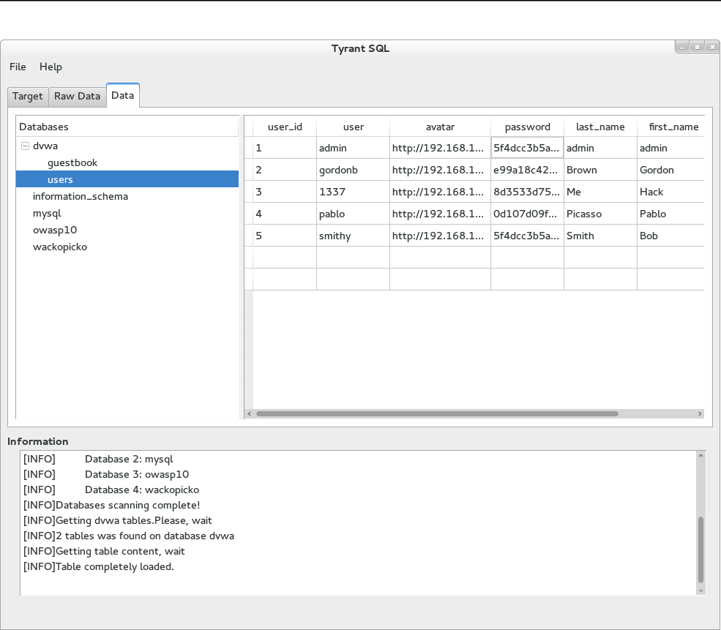

**vij** : Open the Havij Application, in the target add any of the vulnerabilities site. We will be using below venerable URL: http://redtiger.labs.overthewire.org/level1.php?cat=1

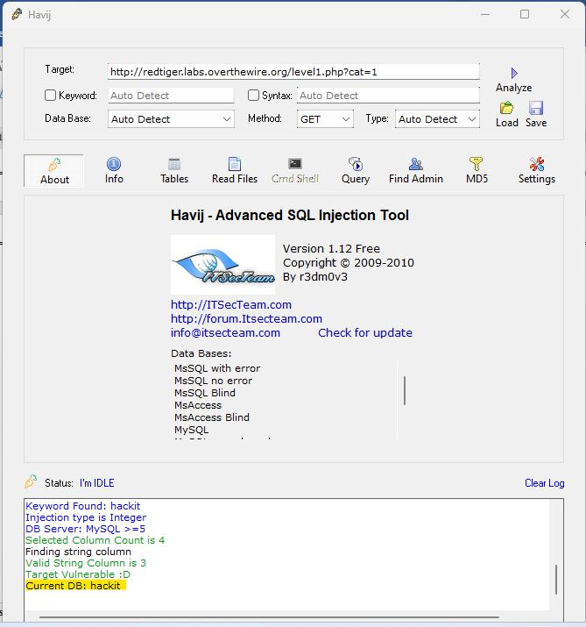

c. BBQSQL

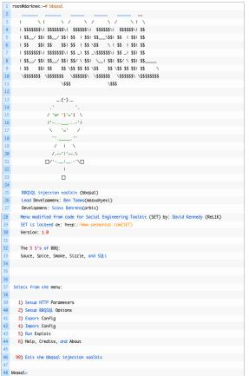

                                                                139

**Section 3D**

Aim: Use the following tools for cryptography.

i. HashCalc

Calculating MD5 value using HashCalc

1. Open HashCalc tool

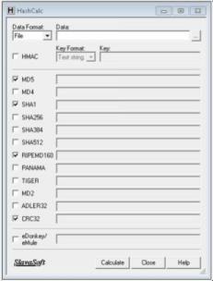

\

2. Create a new file with some content in it as shown below.

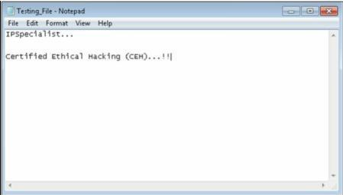

1. Select Data Format as “File” and upload your file

                                                                140

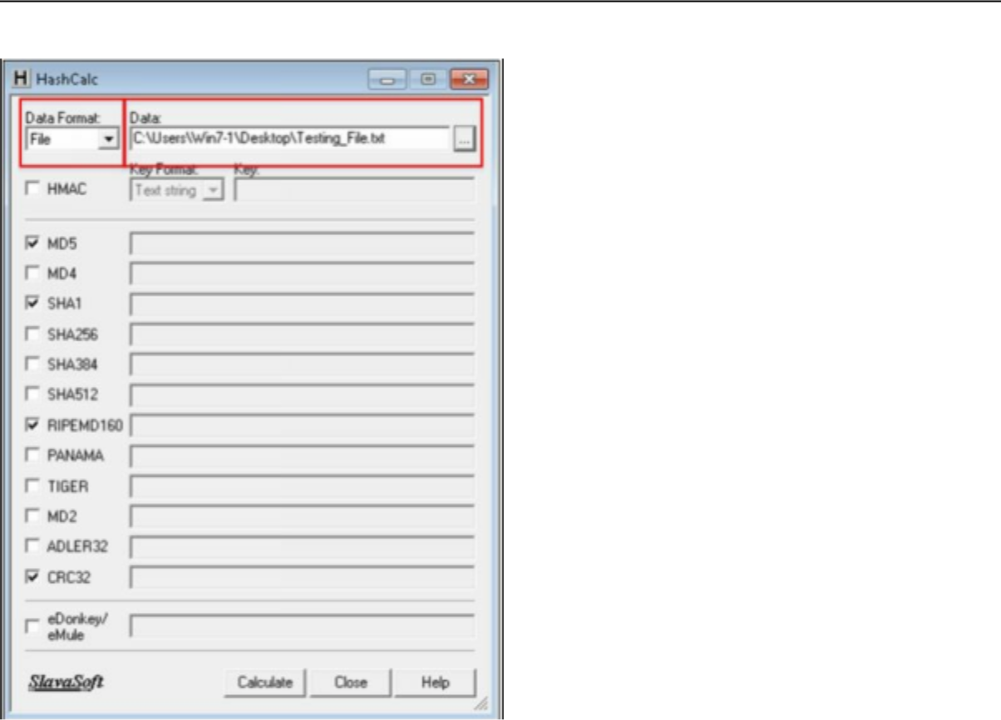

4. Select Hashing Algorithm and Click Calculate

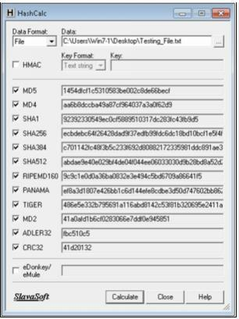

1. Now Select the Data Format to “**Text String**” and Type “**IPSpecialist…**” into Data filed and calculated MD5.

                                                                141

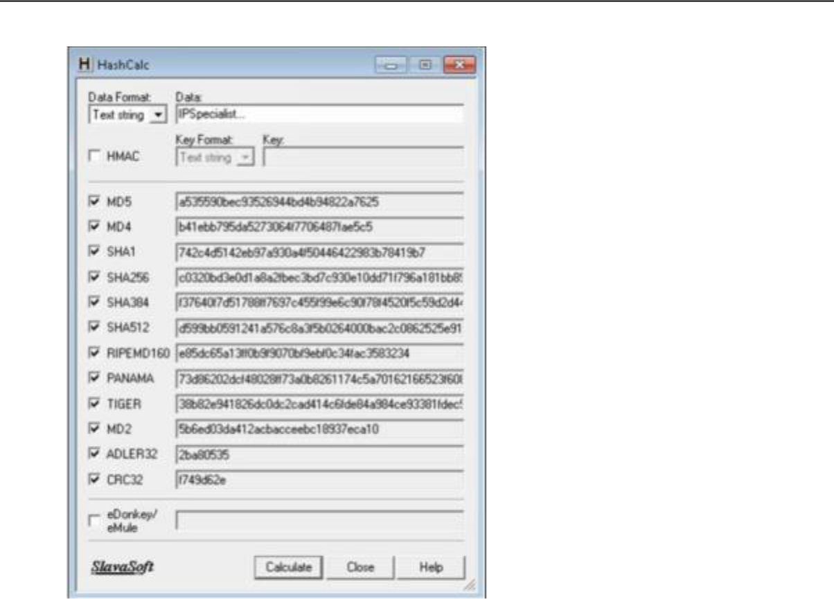

MD5 Calculated for the text string “**IPSpecialist…**” is “**a535590bec93526944bd4b94822a7625**”

6. Now, let's see how MD5 value is changed from minor change.

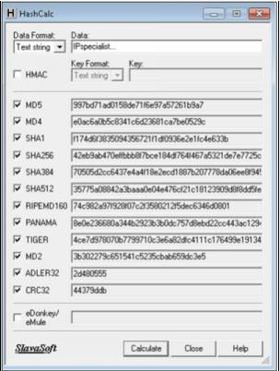

Just lowering the case of single alphabet changes entire hashing value. MD5 Calculated for the text string “**IPspecialist…**”“**997bd71ad0158de71f6e97a57261b9a7”**

                                                                142

1. **Advanced Encryption Package**
   1. Download and Install Advance Encryption Package Latest Version. In this Lab, we are using Advanced Encryption Package 2014 and 2017 to ensure compatibilities on Windows 7 and Windows 10.

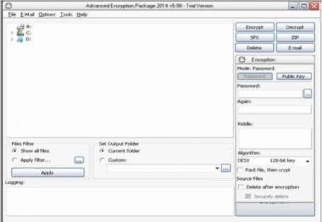

1. Select the File you want to Encrypt.
2. Set password
3. Select Algorithm

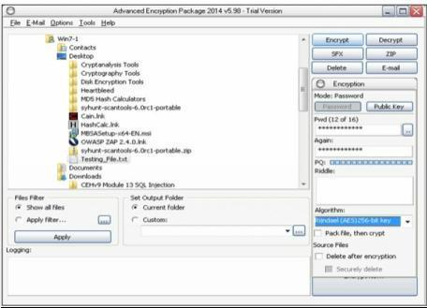

5. Click Encrypt

                                                                143

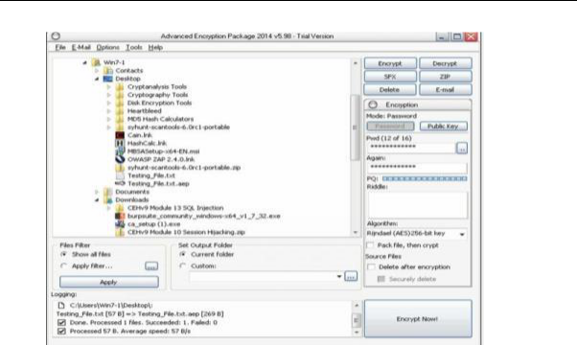

7. Compare both Files

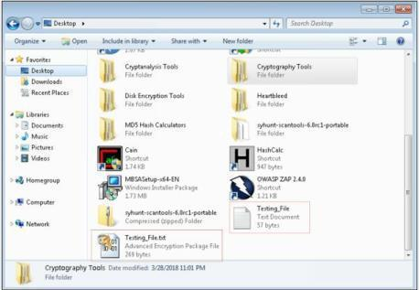

1. Now, After forwarding it to another PC, in our case, in Windows 10 PC, decrypting it using Advanced Encryption package 2017.
   1. Enter password

                                                                144

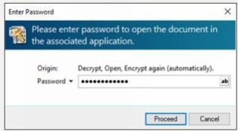

1. File Successfully decrypted.

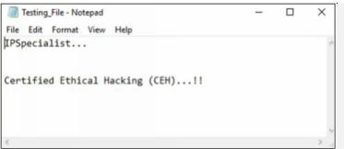

**TrueCrypt:**

**TrueCrypt is the tool to protect your data.**

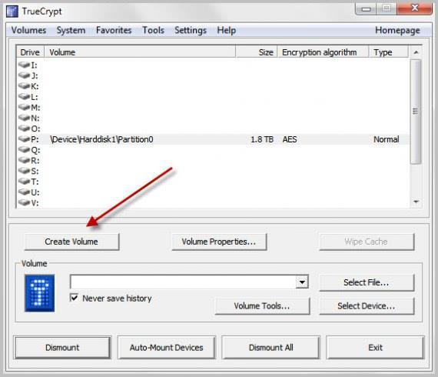

                                                                145

**iv. CrypTool**

Cryptool is a free e-learning tool to illustrate the concepts of cryptography. Try Various Encryption/Decryption algorithms.

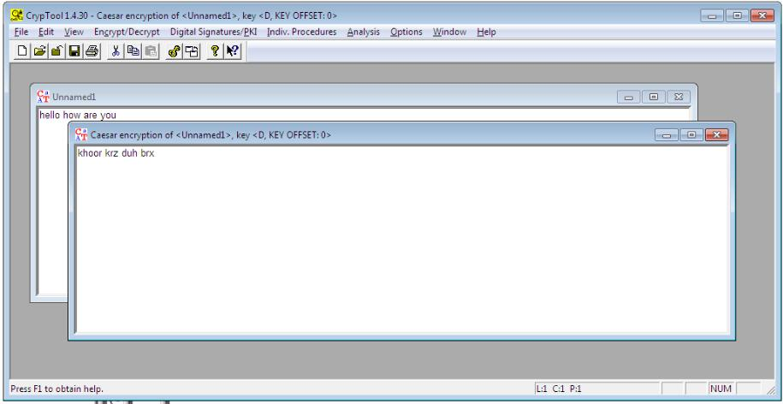

                                                                146